CHAPTER 1 |  | BLM 1–13
OVERHEAD MASTER/  SKILL BUILDER | Sample WHMIS Label

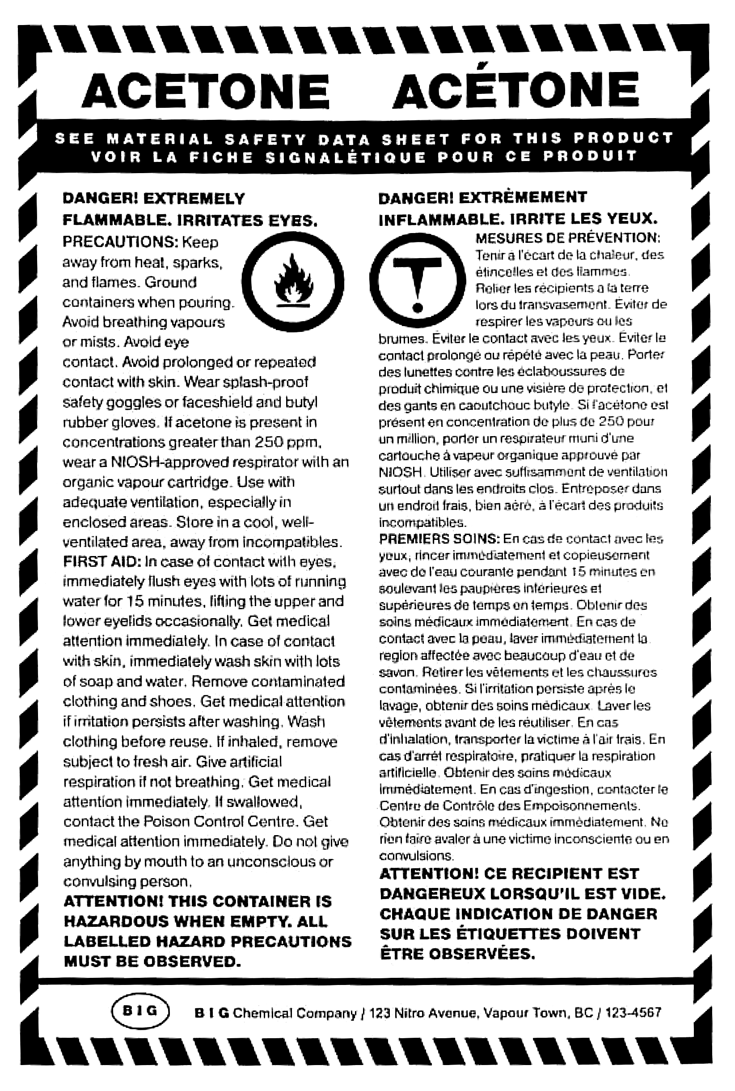
{AB.Sc24.A.K.1.i} {AB.Sc24.A.K.1.ii} {AB.Sc24.A.S.2.vi}

CHAPTER 1 |  | BLM 1–14
OVERHEAD MASTER/  SKILL BUILDER | MSDS — Sodium Chloride

{AB.Sc24.A.K.1.i} {AB.Sc24.A.K.1.ii} {AB.Sc24.A.S.2.vi}
