Lesson 4: Subtracting Polynomials
1. Use algebra tiles. Sketch your tile model. Record your answer symbolically.
a) (4x + 2) – (2x + 1) b) (4x + 2) – (–2x +1)

c) (4x + 2) – (2x – 1) d) (4x + 2) – (–2x – 1)

2. Use algebra tiles to model find each difference. Sketch your tile model. Record your answer symbolically.
a) (2s² + 3s + 6) – (s² + s + 2) b) (2s² + 3s – 6) – (s² + s – 2)

c) (–2s² + 3s + 6) – (–s² + s + 2) d) (2s² – 3s + 6) – (s² – s + 2)

3. Use a personal strategy to subtract. Check your answers by adding.
a) (2x + 3) – (5x + 4) b) (4 – 8w) – (7w + 1)

c) (x² + 2x – 4) – (4x² + 2x – 2) d) (–9z² – z – 2) – (3z² – z – 3)

4. A student subtracted
(3y² + 5y + 2) – (4y² + 3y + 2) like this:
= 3y² – 5y – 2 – 4y² – 3y – 2
= 3y² – 4y² – 5y – 3y – 2 – 2
= –y² – 8y – 4
a) Explain why the student’s solution is incorrect.

b) What is the correct answer? Show your work.

5. The difference between two polynomials is (5x + 3). One of the two polynomials is
(4x + 1 – 3x²). What is the other polynomial? Explain how you found your answer.

6. Subtract.
a) (mn – 5m – 7) – (–6n + 2m + 1)

b) (2a + 3b – 3a² + b²) – (–a² + 8b² + 3a – b)

c) (xy – x – 5y + 4y²) – (6y² + 9y – xy)

Lesson 5: Multiplying and Dividing a Polynomial by a Constant
1. Multiply. Sketch the tiles for one product.
a) 2(3b) b) –2(6h) c) 4(2b²)

d) –2(2x²) e) –2(–y²) f) –3(–2f)

2. Divide. Sketch the tiles for one division statement.
a) 12d ÷ 4 b) –20d ÷ 5 c) 8d ÷ –4

d) 12y² ÷ 4 e) –14x² ÷ 2 f) –10q ÷ –5

3. Determine each product.
a) 4(3a + 2) b) (d² + 2d)(–3)

c) 2(4c² – 2c + 3) d) (–2n² + n – 1)(6)

e) –3(–5m² + 6m + 7)

4. Here is a student’s solution for a multiplication question.
(–5k² – k – 3)(–2)
= –2(5k²) – 2(k) –2(3)
= –10k² – 2k – 6
a) Explain why the student’s solution is incorrect.

b) What is the correct answer? Show your work.

5. Determine each quotient.
a) (16v + 16) ÷ (8) b) (25k² – 15k) ÷ (5)

c) (20 – 8n) ÷ (–4) d) (18x² – 6x + 6) ÷ (6)

e) (7 – 7y + 14y²) ÷ (–7)

6. Here is a student’s solution for a division question.
(–12r² – 8r – 16) ÷ (–4)
=
= –3r² – 2r + 4
a) Explain why the student’s solution is incorrect.

b) What is the correct answer? Show your work.

Lesson 5.6 Multiplying and Dividing a Polynomial by a Monomial
1. Write the multiplication sentence modelled by each set of algebra tiles.
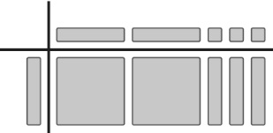
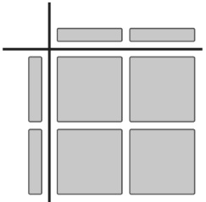
a) b)

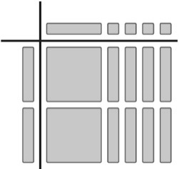
c)

2. For each set of algebra tiles in question 1, write a division sentence.

3. Write the multiplication sentence modelled by each rectangle.
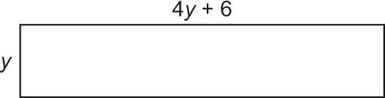
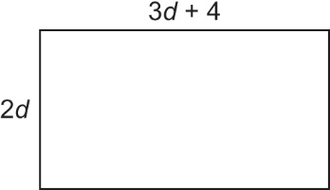
a) b)

4. For each rectangle in question 3, write a division sentence.

5. Multiply.
a) v(3v + 1) b) 3c(5c + 2) c) (8 + 4y)(6y)

d) 5p(–5 – 2p) e) (7k – 3)(–m) f) (–1 – 10r)( –r)

6. Divide.
a) (6x + 3) ÷ 3 b) (14w – 7) ÷ –7 c) (–15 – 10q) ÷ 5

d) (8z² + 4z) ÷ 2z e) (12c² – 6c) ÷ 3c f) (9xy – 6x) ÷ –3x

7. Here is a student’s solution for a division question.
(–12x² – 9x – 12xy) ÷ (–3x)
=
= 4x² – 3 + 4xy
a) Explain why the student’s solution is incorrect.
b) What is the correct answer?

