Lesson 1: Modelling Polynomials
1. Identify the polynomials in the following expressions.
a) 2m² + 1 b)
c) –4x d) $\frac{1}{x2+ x}$
e) 0.25y²
2. Name the coefficients, variable, degree, and constant term of each polynomial.
a) –8y b) 12
c) –2b² – b + 10 d) –4 – b
3. Identify each polynomial as a monomial, binomial, or trinomial.
a) 19t b) g – 4g² + 5
c) –1 + xy + y² d) 4 – 11w
4. Identify the equivalent polynomials.
a) –h² – 3 + 4h b) –3 + 4h – h²
c) 5m – 3 d) –2 + y² + 5xy
e) y² + 5xy – 2 f) –3 + 5m
5. Use algebra tiles to model each polynomial. Sketch the tiles.
a) –5 + y² b) 2x – 1

c) –3a² – 2a + 1 d) 3z

e) v² – 4v

6. Write a polynomial to match the following conditions.
a) 2 terms, degree 1, with a constant term of 4

b) 3 terms, degree 2, with the coefficient on the 2nd degree term –2

Lesson 2: Like Terms and Unlike Terms
1. From the list, identify terms that are like 2w². Explain how you know they are like terms.
–5w, –6w², –2, 4w, 3w², –w², 11w, 2

2. Use algebra tiles to model each polynomial, then combine like terms.
Sketch the tiles for the simplified polynomial.
a) 4 + x + 1 + 5x + 1 b)–3y² + 3y – 2
c) 2x² + 8 – 11 – 4x² + 5x² d) 3y + 7y² + 1 – y – 2y – 3y²

3. Simplify each polynomial.
a) 7d – 2d + 1 – 6 b) –5 – 3 – k – 5k
c) –4 + 2a + 7 – 4a d) 3p – 6 – 4p + 6
4. Simplify each polynomial.
a) 3a² – 2a – 4 + 2a – 3a² + 5 b) 7z – z² + 3 + z² – 7

c) d² + 3d + 1 + 4d² + 2 d) –6x² + 10x – 4 + 4 – 12x – 7x²

5. Identify the equivalent polynomials. Justify your responses.
a) –5y² – 3y – 4 b) 10x – 1

c) 1 + x – x² d) 2y² – 4 – 16 – 7y² – 3y + 16

e) –7 + 5x – 7x – 8 + 14 + 12x f) 5x² + 7 + 4x – 6x² – 6 – x – 2x

6. Write a polynomial to represent the perimeter of each rectangle.
a)

b)

Lesson 3: Adding Polynomials
1. Use algebra tiles to model each sum. Sketch your tile model.
Record your answer symbolically.
a) (– 4h + 1) + (6h + 3) b)(2a² + a) + (–5a² + 3a)

c) (3y² – 2y + 5) + (–y² + 6y + 3) d) (3 – 2y + y²) + (–1 + y – 3y²)

2. Add these polynomials. Use algebra tiles if it helps.
a) (x – 5) + (2x + 2) b) (b² + 3b) + (b² – 3b)

c) (y² + 6y) + (–7y² + 2y) d)(5n² + 5) + (–1 – 3n²)

3. Add these polynomials. Use algebra tiles if it helps.
a) (–7x + 5) b) (4x² – 3)
+ (2x – 8) + (–8x² – 1)
c) (x² – 4x + 3) d) (3x² – 4x + 1)
+ (–x² – 2x – 3) + (–2x² + 4x + 1)
4. Add.
a) (y² + 6y – 5) + (–7y² + 2y – 2) b) (–2n + 2n² + 2) + (–1 – 7n² + n)
c) (3m² + m) + (–10m² – m – 2) d) (–3d² + 2) + (–2 – 7d² + d)
5. a) For each shape below, write the perimeter as a sum of polynomials and in simplest form.
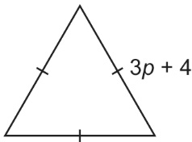
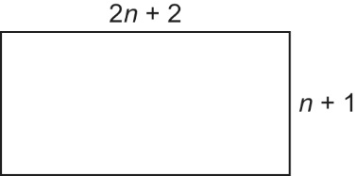
i) ii)

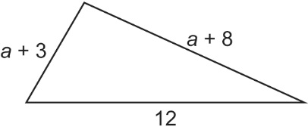
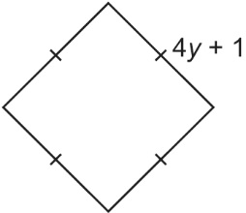
iii) iv)

b) Use substitution to check each answer in part a.
6. The sum of two polynomials is 4r + 5 – 3r². One polynomial is –8 – 2r² + 2r; what is the other polynomial? Explain how you found your answer.

