Unit A- Section 2.0 Review

C:\Documents and Settings\ginaotte\Local Settings\Temporary Internet Files\Content.IE5\TAYX9LI3\MC900334366[1].wmfDescribe each of the following **consumers:**

Carnivores:

________________________________________________________________________________________

________________________________________________________________________________________

Herbivores:

________________________________________________________________________________________

________________________________________________________________________________________

Omnivores:

________________________________________________________________________________________

________________________________________________________________________________________

C:\Documents and Settings\ginaotte\Local Settings\Temporary Internet Files\Content.IE5\TAYX9LI3\MC900334366[1].wmfWrite the word equation for **photosynthesis** here; make sure you put little pictures underneath each word to help you remember the order!

C:\Documents and Settings\ginaotte\Local Settings\Temporary Internet Files\Content.IE5\TAYX9LI3\MC900334366[1].wmfDescribe each one of the steps labeled below: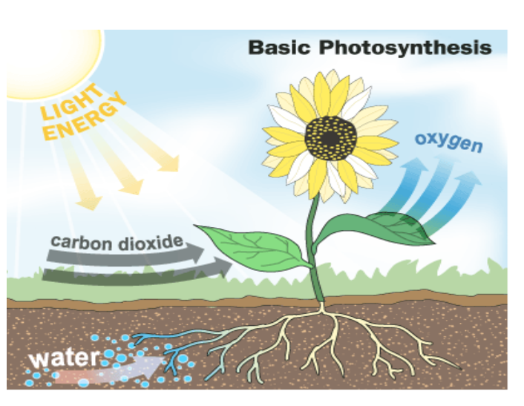

Step 4

Step 3

Step 2

Step 1

1)

2)

3)

4)

C:\Documents and Settings\ginaotte\Local Settings\Temporary Internet Files\Content.IE5\TAYX9LI3\MC900334366[1].wmfWhat are the 2 reasons that photosynthesis is important?

A)

B)

C:\Documents and Settings\ginaotte\Local Settings\Temporary Internet Files\Content.IE5\TAYX9LI3\MC900334366[1].wmfWrite the word equation for **cellular respiration** here; make sure you put little pictures underneath to help you remember the order!

C:\Documents and Settings\ginaotte\Local Settings\Temporary Internet Files\Content.IE5\TAYX9LI3\MC900334366[1].wmfWhat are 2 reasons that cellular respiration is important?

A)

B)

C:\Documents and Settings\ginaotte\Local Settings\Temporary Internet Files\Content.IE5\TAYX9LI3\MC900334366[1].wmfDescribe the interaction/relationship between **photosynthesis** and **cellular respiration**.

________________________________________________________________________________________

­­­­­­­­­­­­­­­­­________________________________________________________________________________________

________________________________________________________________________________________

­­­­­­­­­­­­­­­­­C:\Documents and Settings\ginaotte\Local Settings\Temporary Internet Files\Content.IE5\TAYX9LI3\MC900334366[1].wmfDescribe the difference between **scavengers** and **decomposers**.

________________________________________________________________________________________

­­­­­­­­­­­­­­­­­________________________________________________________________________________________

________________________________________________________________________________________

­­­­­­­­­­­­­­­­­________________________________________________________________________________________

C:\Documents and Settings\ginaotte\Local Settings\Temporary Internet Files\Content.IE5\TAYX9LI3\MC900334366[1].wmfComplete the chart below identifying whether the organism is helpful or harmful and why:

**Scavengers** **Decomposers**

|  |  |
| --- | --- |
| Harmful | Helpful |
|  |  |

|  |  |
| --- | --- |
| Harmful | Helpful |
|  |  |

Crows Baker’s Yeast

Why?______________________________ Why?______________________________

______________________________ ______________________________

|  |  |
| --- | --- |
| Harmful | Helpful |
|  |  |

|  |  |
| --- | --- |
| Harmful | Helpful |
|  |  |

Wolverines Mushrooms

Why?______________________________ Why?______________________________

______________________________ ______________________________

C:\Documents and Settings\ginaotte\Local Settings\Temporary Internet Files\Content.IE5\TAYX9LI3\MC900334366[1].wmf **Food Chains** allow energy (supplied by the Sun) to flow. Illustrate an example of a food chain (**include arrows showing the flow of energy**). Identify the type of organism you are illustrating (eg. **producer, primary consumer, secondary consumer, decomposer, etc.**)

C:\Documents and Settings\ginaotte\Local Settings\Temporary Internet Files\Content.IE5\TAYX9LI3\MC900334366[1].wmfIllustrate the **flow of energy** from **producer** to **primary consumer**, to **secondary consumer**, to **tertiary consumer**, to **scavenger**, to **decomposer**.

C:\Documents and Settings\ginaotte\Local Settings\Temporary Internet Files\Content.IE5\TAYX9LI3\MC900334366[1].wmf **Food Webs** allow energy (supplied by the Sun) to flow. Illustrate a **Meadow Food Web:**

**C:\Documents and Settings\ginaotte\Local Settings\Temporary Internet Files\Content.IE5\TAYX9LI3\MC900334366[1].wmf** Changes in a food web affect all living things in that ecosystem. What would happen if the meadow mice were poisoned and became extinct?

**__________________________________________________________________________________**

**__________________________________________________________________________________**

**__________________________________________________________________________________**

**__________________________________________________________________________________**

**C:\Documents and Settings\ginaotte\Local Settings\Temporary Internet Files\Content.IE5\TAYX9LI3\MC900334366[1].wmf** Matter continuously moves from non-living to living and back to non-living in two cycles: **Water cycle** and **Carbon Cycle.**



What are the three main processes responsible for the water cycle?

1)

2)

3)



|  |
| --- |
| 1. What activities or organisms add carbon to the Atmosphere? |

|  |
| --- |
| 1. What activities or organisms take carbon out of the atmosphere? |