Step-by-Step 1
Lesson 4.1, Question 12
Master 4.26
You will need square dot paper or triangular dot paper.
Step 1 Describe the object in part a.
What shapes are the faces?__________________________________________________
How many faces of each shape are there?
Step 2 Use dot paper. Draw a net for the object. Mark sides of equal length with the same kind of hatch mark. Check that you have drawn the correct number of faces.
Visualize folding your net to make the object. Will sides of equal length meet to form a common edge? ___________________________________________________________
Step 3 Visualize opening up the object in part a by cutting different edges.
Step 4 Repeat Step 3 until you cannot draw any more different nets.
Step 5 Repeat Steps 1 to 4 for the object in part b.
Step-by-Step 2
Lesson 4.2, Question 7
Master 4.27
You will need a copy of Master 4.17 and scissors.
Step 1 What faces must be present in the net of an octagonal prism?
Shape | Quantity

Step 2 Look at the diagram in Question 7.
Are the required faces and quantities present?
If not, which faces are missing?
Step 3 Cut out the diagram in Master 4.17.
Step 4 Fold the faces and try to construct the object.
Is this the net of an octagonal prism?______
Step 5 If not, use scissors to cut and move faces to correct the problem. What did you do?

Step 6 Repeat Step 5 as many times as you can. How many different nets can you make?
Step-by-Step 3
Lesson 4.3, Question 14
Master 4.28
Step 1 Sketch a right rectangular prism with dimensions 2 cm by 4 cm by 6 cm.

Step 2 Find the surface area of the prism in Step 1.

Step 3 Sketch a rectangular prism with dimensions 2 cm by 4 cm by 12 cm.

Step 4 Find the surface area of the prism in Step 3.

Step 5 Look at your answers to Steps 2 and 4.
What happens to the surface area of a rectangular prism when its length is doubled?

Step 6 Sketch a rectangular prism with dimensions 2 cm by 4 cm by 3 cm.

Step 7 Find the surface area of the prism in Step 6.

Step 8 Look at your answers to Steps 2 and 7.
What happens to the surface area of a rectangular prism when its length is halved?

Step-by-Step 4
Lesson 4.4, Question 12
Master 4.29
Step 1 Sketch a right triangular prism with length 6 cm and bases right triangles with legs 3 cm and 4 cm and hypotenuse 5 cm.

Step 2 Find the surface area of the triangular prism in Step 1.
Step 3 Sketch a right triangular prism with length 12 cm and bases right triangles with legs 6 cm and 8 cm and hypotenuse 10 cm.

Step 4 Find the surface area of the triangular prism in Step 3.
Step 5 Look at your answers in Step 2 and Step 4.
What happens to the surface area of a triangular prism when its dimensions are doubled?

Step 6 Is the student correct in saying that when you double all the dimensions of a triangular prism you will double the surface area? How do you know?

Step-by-Step 5
Lesson 4.5, Question 13
Master 4.30
You will need 36 1-cm cubes.
Step 1 Create a right rectangular prism using all 36 cubes.
Sketch the prism on a blank piece of paper and label each dimension.
Step 2 Adjust your arrangement of cubes to create a second rectangular prism using all 36 cubes.
Sketch the second prism and label each dimension.
Step 3 Repeat Step 2 until you have created all the possible rectangular prisms using 36 cubes.
How do you know you have created all possible rectangular prisms?
_______________________________________________________________________
Step 4 Using your sketches, determine the surface area of each prism. Write each surface area below the sketch.
Step 5 Write the dimensions of the rectangular prism with volume 36 cm³ and the greatest surface area.
Length = _________ Width =_________ Height = _________
Step 6 Write the dimensions of the rectangular prism with the least surface area.
Length = _________ Width = _________ Height = _________
Step-by-Step 6
Lesson 4.6, Question 9
Master 4.31
Step 1 Complete the following:
The volume of a triangular prism is the ________________ of the area of its base, A, and its length, l.
Step 2 Fill in the chart below:
Volume | Area of Base | Height
5 cm³
9 m³
8 m³
18 cm³
Step 3 Sketch each prism found above.

Step 4 For each volume, try to find a prism with a different length and base area that still has the required volume. How many can you find for each volume?
Volume | Number of different prisms
5 cm³
9 m³
8 m³
18 cm³
Step 5 What assumptions did you make?

Step-by-Step 7
Lesson 4.7, Question 12
Master 4.32
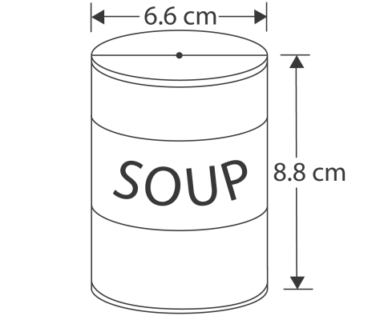

The label is a rectangle. The height of the label is 8.8 cm.
The length of the label is equal to the circumference of the can plus 1 cm.
Step 1 Use C = πd to calculate the circumference of the can.

Step 2 The label overlaps by 1 cm. Add 1 cm to your answer in Step 1.
Step 3 Multiply your answer in Step 2 by the height, 8.8 cm,
to calculate the area of the label.
Step 4 What is the area of the label? ___________________
Step-by-Step 8
Lesson 4.8, Question 11
Master 4.33
Step 1 The radius of the frozen juice can is 3.5 cm.
Use A = πr² to find the area of the base of the cylindrical can.
Area of the base =
Step 2 Multiply the area of the base by the height, 10 cm, to calculate the volume of the can.
Volume =
So, the capacity is:
Step 3 Switch the dimensions of the frozen juice can:___________________________________
The new can has radius 12 cm.
Use A = πr² to find the area of the base of the new can.
Area of the base =
Step 4 Multiply the area of the base (Step 3) by the height, 3.5 cm, to calculate the volume of the new can.
Volume =
So, the capacity is:
Step 5 Compare the answers to Steps 2 and 4. What happens to the capacity of the can when the dimensions are switched?

