Unit 1 Review

Lesson 2
- Reflections (line symmetry)
- Rotational symmetry
  - Order of rotation
  - Angle of rotation
- Translations (slide)

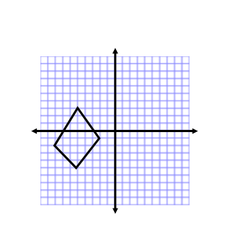
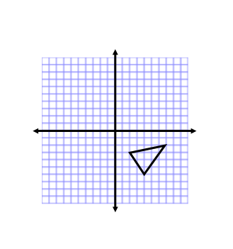
1. Draw a reflection of each over:

- The x-axis b) a horizontal line going through -2 on the y-axis (this is also y = -2)

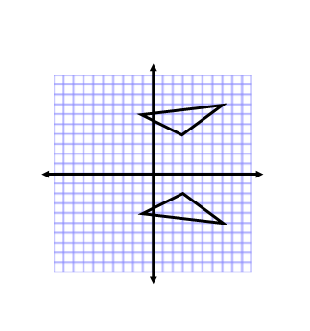
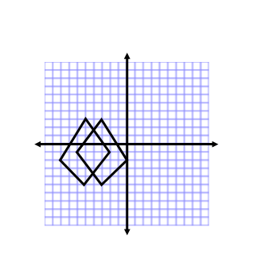

2. What is the line of reflection for each of the following

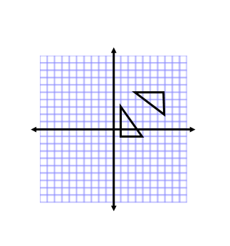

3. Pg 378 #12

4. How many lines of symmetry are there for each of the following shapes

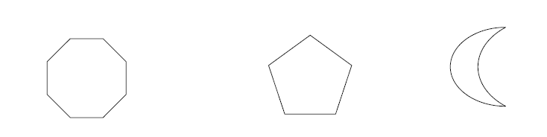

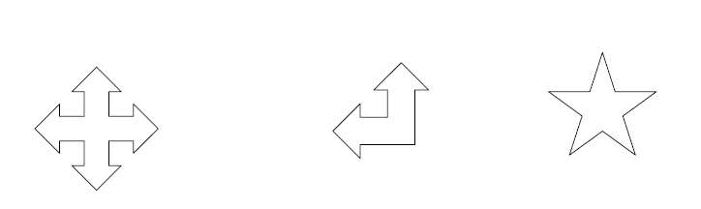

M A T H S

5. translate each of the following shapes
a) (xx - 4, yy + 1) b) (xx +3, yy - 3)

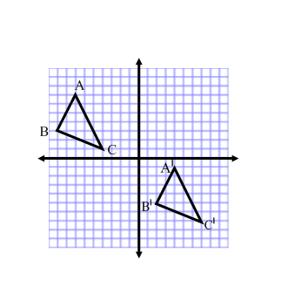
6. What is the translation that occurred below?

Lesson 3
- Rotations
- Rotational symmetry
  - Order of rotation
  - Angle of rotation

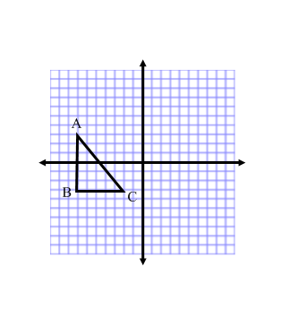
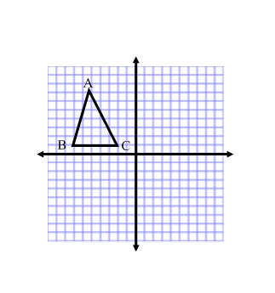
7. Rotate each of the following shapes

a) 90˚ CCW about the origin b) 180˚ CW about vertex C

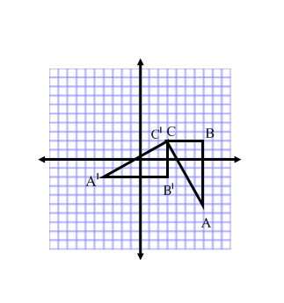
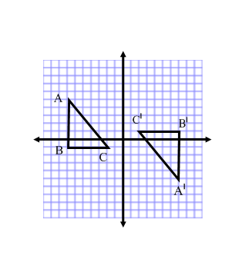
8. What rotation occurred to make each of the following shapes

a) b)

9. For each shape state the order of rotation and the angle of rotation

Order Order Order

Angle Angle Angle

Order Order Order

Angle Angle Angle

Lesson 4
- Scale factor =
- Enlargement: scale factor is greater than 1
- Reduction: scale factor is less than 1
- Scale length = original length × scale factor

10. Measure the lengths for the figure below

a) Draw the shape with a scale factor of 2.5

11. Pg 377 #3

Lesson 5 Similar figures
Lesson 6 Similar triangles
- all corresponding sides in similar figures are proportional
- all corresponding angles are the same

12. Pg 377 #6, 8, 9, 10, 11

