1. Draw the net of this right triangular prism on isometric dot paper.
The base is an equilateral triangle with side length 2 cm
and the length of the prism is 6 cm.

2. Draw a net for each of the following objects on graph paper. You can choose your own dimensions.
a) A square room
b) A cylinder that has no top

4. An open aquarium measures 80 cm by 35 cm by 45 cm.
What is the surface area of the aquarium?
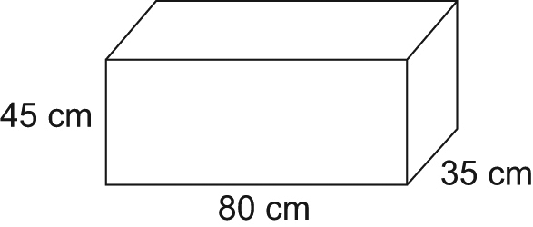
45 cm
35 cm
80cm
5. Find the surface area of each triangular prism. b) 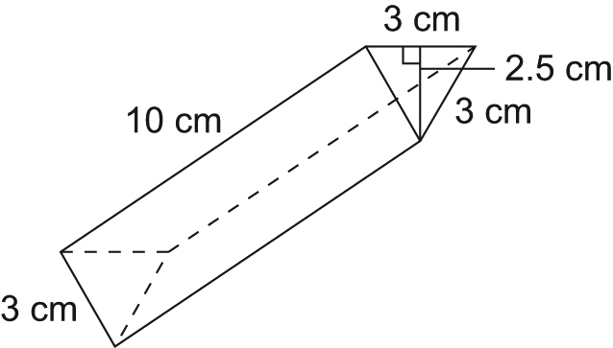
a)
