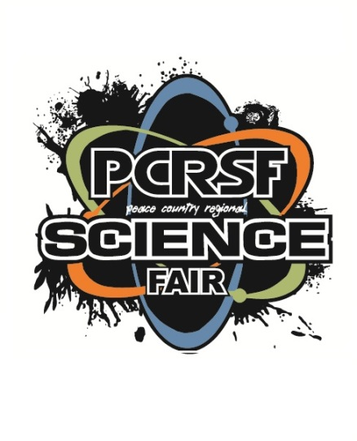
Science Fair Topic Research

Step 1 – Find an idea for your science fair project.
What?
Step 2 – State your idea. What is the idea/Problem?
Why?
Step 3 – Write a paragraph (4-5 sentences) that explains why you picked this idea.
When?
Step 4 – Write a paragraph (4-5 sentences) that explains the history of the idea. What theories are involved to support the idea/problem? What is already known about the idea? Etc…
Who? + How?
Step 5 –Write a paragraph (4-5 sentences) that explains past scientists that previously worked on this idea/problem. What did these scientists do?
Conclusion
Summarize how you will do this science fair project?

