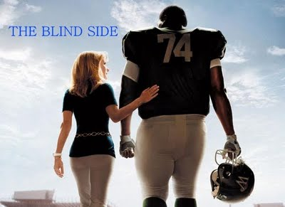

Religion 9

“The Blind Side”
Assignment: Choose one of the Beatitudes, identify the Beatitude within the film “The Blind Side” and create a visual representation that expresses your chosen Beatitudes.

VISUAL: must express your thoughts and feelings on the film and its relation to one particular beatitude. You may draw, use images from online to make a collage etc. Be creative!
*Be sure your chosen beatitude is written somewhere on or under your visual.

Marking Guide

Thought and Detail (effectively explores a Beatitude) /20
Creativity and Imagination /15

Total /35

