Each cube has edge length 1 unit.
Determine the surface area of each object.
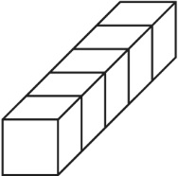
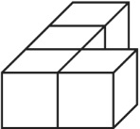
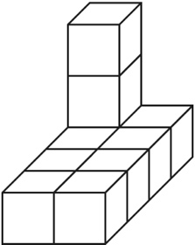
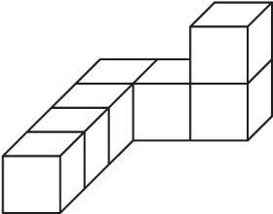
a) b) c) d)

Determine the surface area of this composite object.
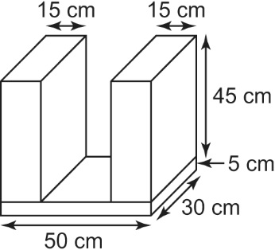

Determine the surface area of each composite object to the nearest tenth of a square centimetre where necessary.
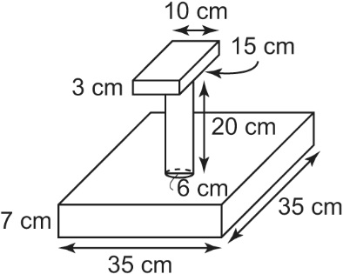
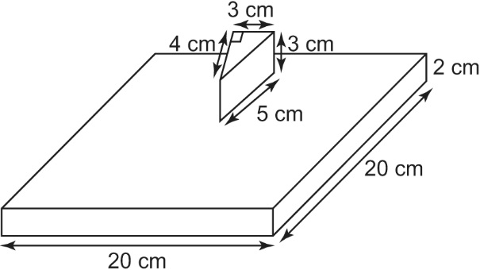
a) b)

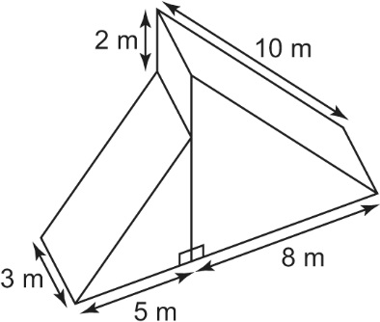
Determine the surface area of the composite
object at the right to the nearest square metre.

Suppose the diagram part of a structure at a snowboarding park.
- What changes, if any, would you make in calculating the surface area of this object?

b) The structure is to be covered on the top sections (where a boarder would be riding) with a special “carpet for summer sliding.” Calculate the area of carpet that would be needed.

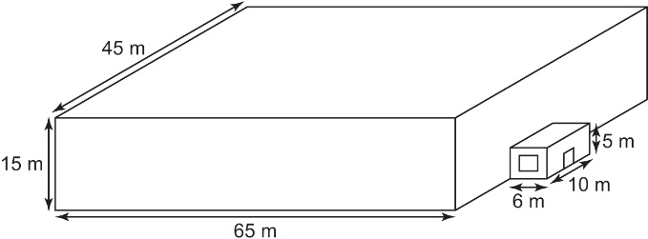
The local curling rink is shown in the diagram. It is to be painted.
- Determine the surface area of the structure.

- The roof, windows, and door are not to be painted. The door is 1 m by 2 m and the window is 4 m by 2 m. Determine the surface area to be painted.

- A can of paint covers 300 m² and
costs $45. Determine the cost of the paint needed.

