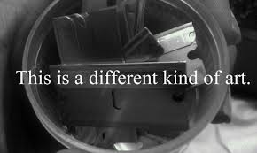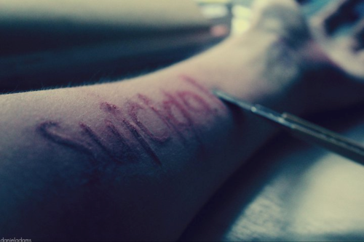

Suicide

It is the way people are treating them or some disorders makes people feel so much pain that they don't think of any other solutions such as to kill themselves

-They are in so much mental pain They are really depressed

* They are physicotic
* They are impulsive
* They've made a mistake
* They're crying out for help
* They want to die.

Reasons

Suicide is the feeling that you are not good enough for anybody and that you want to physically want to leave the present earth. It is pain many people feel and it takes over your mind.

Warning signs

Drawing or writing about suicide.

Withdrawing from family and friends.

Appearing depressed.

Feeling hopeless and helpless.

Abusing drugs or alcohol.

Loosing interest in activities.

Change in sleeping habits.

Change in eating habits.

Giving away prized possessions.

Writing a will.

Self- harming.

Burn/Cut marks.

How can you help:

-Listen carefully -It is usually from crisis-recover

-Take it seriously. -Ask questions

-Suicide is a cry for help. - Don't ignore it

-Have no secrets

-Get professional help

-Do not leave them