Name:_________________

Probability and Statistics Project
This project is to be done individually
and will be worth10% of your final grade
within the course.

Curriculum Objectives:

- Demonstrate an understanding of the role of probability in society.
- Describe the effect of:

    - bias
    - use of language
    - ethics
    - cost
    - time and timing
    - privacy
    - cultural sensitivity

on the collection of data.
- Select and defend the choice of using either a population or a sample of a population to answer a question.
- Develop and implement a project plan for the collection, display and analysis of data by:

    - formulating a question for investigation
    - choosing a data collection method that includes social considerations
    - selecting a population or a sample
    - collecting the data
    - displaying the collected data in an appropriate manner
    - drawing conclusions to answer the question.

In order to effectively cover the curriculum objectives listed here, each student will create and carry out a survey that they create and then summarize the results. There will be no unit test for this unit of study. Only the mark obtained on this project will be used to determine the mark for the unit.

What you will need to do:

Create a survey question
In order to complete this project you will need to select a focus question from the list provided (or create your own) and create a survey question that will be used to answer it. The wording of your question should avoid biases, and be culturally sensitive. If the survey question is personal, the participants should be anonymous.
Identify the population and choose a sample
Ensure that your sample represents the population. Consider the makeup of your sample as well as where and when you will conduct the survey.
Collect the data
Consider the timing of your data collection and try to avoid any potential problems.
Analyse and display the data
Choose an appropriate display for the data, circle graph, bar graph, or line graph.
Make a summary or conclusion statement
The statement or conclusion you create needs to be based on the data that you collected and it must address or try to answer the focus question you originally chose.

What you will need to hand in:

Project Plan
Your project plan is contained within this booklet and must be filled out in full. In it you will identify your focus question, provide a copy of your survey question exactly as it was given to participants of your survey, a description of how you choose your sample from the population (must contain at least 50 people), a description of how you actually went about collecting your data, and a description of exactly what it is you want to collect for data as well as how it will be displayed.
All Raw Data
All completed survey forms must be handed in with your project. Failure to do so will result in marks being taken off the final grade of the project. Remember that a minimum of 50 surveys must be completed by participants.
Presentation of Results with a Summary or Conclusion
The findings of your survey need to be presented in a way that is easy to understand and read. This must include your focus question as a title, a graph of some sort that may be accompanied by a table of your findings, and a concluding statement or summary. Your concluding statement or summary needs to be supported by the data you collected and it should at least attempt to answer the focus question you selected.

Examples of how data can be displayed:

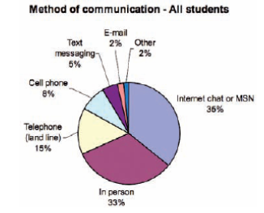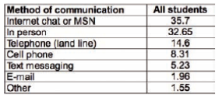

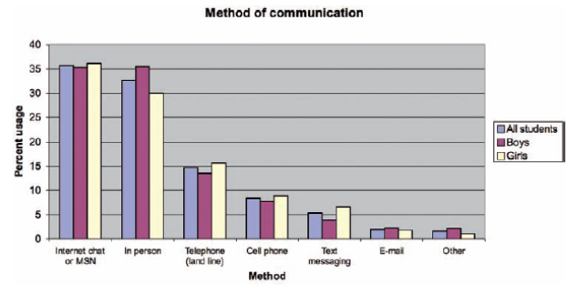

Due Dates:

__________________________
Your survey question must be completed and approved by Mr. Couture. A good copy of your question must be handed in with the number of copies required. Photo copies of your survey will be done for you.
__________________________
Your completed project is due. All components must be turned in at this date (you must hand in your completed project plan, all raw data or survey sheets, and the presentation of your results with conclusion or summary)

Possible Focus Questions:

- What kinds of music do St. Joe’s students listen to?

- What extra-curricular activities are St. Joe’s students involved with?

- What kinds of jobs do St. Joe’s students have?

- What kinds of family pets do St. Joe’s students have?

- What travel destinations have St. Joe’s students been to?

- Where were the parents of St. Joe’s students born?

- By what kind of media do St. Joe’s students watch movies or TV?

- For how many people do St. Joe’s students buy gifts for at Christmas?

- How often do St. Joe’s students send text messages in a month?

- Create your own focus question (this must be approved by Mr. Couture before continuing on with your project).

Project Plan

- Indicate the focus question you have chosen. If you created your own focus question it must be initialled by Mr. Couture.

- Create a survey question that address the focus question above. Your survey question must provide at least 5 choices for participants to select from. A simple yes / no question will not be accepted. Your question must be initialled by Mr. Couture before continuing.

Ex) Acceptable
Indicate how many novels your read in an average month by selecting an appropriate response.

0 1 2 3 4 or more
novels novel novels novels novels

Not Acceptable
Do you enjoy reading novels. Please select a response

Yes No

Please write your survey question in the space below.

- Explain how the wording of your survey question avoids bias.

- How do you plan on displaying the results of your survey? What kind of information do you want to include in your graph? Will your survey question provide the proper data needed to accomplish this?

- Identify the population that you are concerned with in regards to your survey question and explain why it may be difficult to collect data from everyone within the population.

- Explain how you will select a sample from within the population to take part in your survey. Identify the sampling technique you are using. Ensure that your sample represents the population and indicate exactly how you will get your survey out to and back from these people.

- Explain in detail exactly how you will collect the data. How will you get your survey out to the participants? When will this be done? Is the time of day going to be an issue? Does participation in your survey by others cause as little disruption as possible? Have you considered any privacy concerns?

