Square Perfection!

A perfect square is a number that can be written as the product of two equal integers.

For example, 144 is a perfect square because it can be written as 12 × 12.

- Write all the perfect squares from 1 to 100. (Hint: You should find 10 of them.)

- (a) Is 400 a perfect square? Why or why not?

- Is 60 a perfect square? Why or why not?

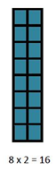
- An array is an arrangement of objects. If we have 16 squares, we can arrange them in a variety of arrays:
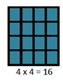
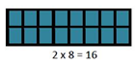

- What arrays can be made for 6 objects?

- What arrays can be made for 36 objects?

- What arrays can be made for 25 objects?

- For which of the numbers 16, 6, 36 and 25 were you able to make a square array?

- Why, then, do you think we call these numbers "perfect squares"?

- (a) A square has an area of 49. What is the side length of the square?

- A square has an area of 81. What is the side length of the square?

- What is the mathematical relationship between the area of a square and its side length?

- (a) In question 1, you listed the first 10 perfect squares. Write them again here. Find a
pattern in the numbers - how do we get from one perfect square to the next?

(b) Challenge: Try to determine how this pattern works.

