- Solve for the missing variable in the following equations.
a) $5-x=-13$ b) $13=m+3$
c) $-13z=-12$ d) $\frac{3c}{7}=12$
e) $\frac{m}{6}-1.5=-7$ f) $5\left(x-7\right)=-15$
g) $8.4= -6\left(a+2.4\right)$ h) $\frac{3}{2}\left(1+3r\right)=\frac{2}{3}\left(2-3r\right)$
i) $\frac{5x}{2}=11+\frac{2x}{3}$
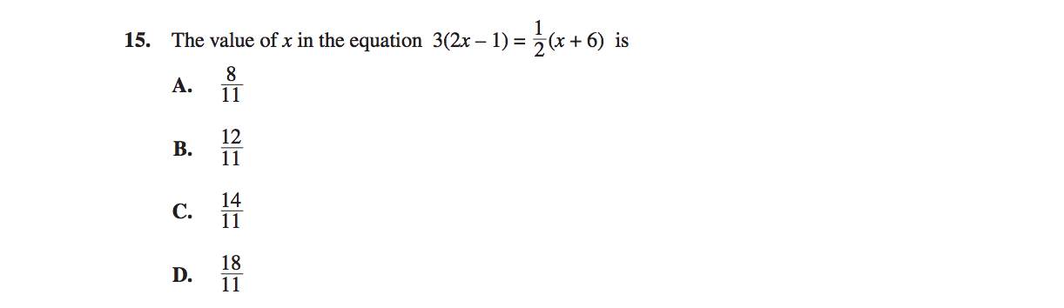
- Solve the following old PAT question:

