Skittles Data Analysis
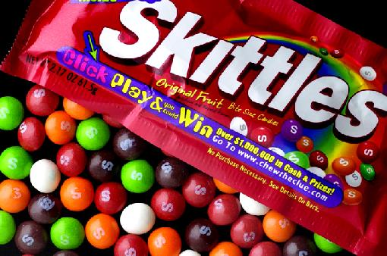
Gr. 8 Unit Project.
Name_______________________ Date____________________________
Name______________________

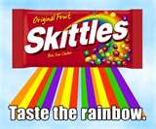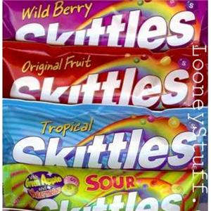

Challenge
The Skittles Company fills skittles bags by weight, not by numbers of skittles. They do have a specific percentage for each of the colours they try to put in the bags. But each bag does not have the exact percentage for the different colours. What is the percentage for each colour:
Red;
Blue;
Yellow;
Green;
Purple;
Orange;

How can the data from all students be organized to find the percentage that the skittles company uses for each colour?

Organize the Class Data
- Find the mean (average) for each colour based on the class data.
- Find the mode for each colour based on the class data.
- Find the median for each colour based on the class data.
- Find the range for each colour based on the class data.

Questions:
- Do all groups have the same average for the Total skittles? Why or why not?

- Do all groups have the same average for the Red skittles? Why or why not?

c. Based on the average you found for the total number of skittles in a bag, what
number of skittles would you expect to find in a new bag of skittles?

d. Based on the averages that you found for each color, what number of each
color of skittles would you expect to find in a new bag of skittles?
• Red ___________________________ • Green__________________________
• Blue ___________________________• Brown__________________________
• Yellow_________________________ • Orange_________________________

e. Even though you might expect to find this number, why might you find a different
number when you opened a new bag?

f. What percent of each color of skittles do you think the skittles company uses
when bagging its candies?
ACTIVITY 1: COLLECTING Skittles DATA
Skittles Data Record Sheet

Student Name:_______________________________________
- Describe the contents of one bag of skittles before opening it!

2. Open your bag of skittles but DO NOT EAT YOUR DATA! Record the data from
your bag of skittles in the table.
Color | Number of  skittles | Fractional  Representation of skittles of this Color | Decimal  Representation of the Fraction | Percent  Representation  of the Decimal
Total

- Questions to answer:

a. Will everyone in the class have the same total number of candies in a bag of
Skittles? Why or why not?

b. Will the number of red candies be the same in all bags? Why or why not? What
about the other colors?

- Does the company purposely try to have a certain number of each color in each bag?

When finished, you may eat your data
ACTIVITY 2: ORGANIZING SKITTLES DATA

Student Name:___________________________________________________

Skittles Data Group Record Sheet

Record the group data:

NAME | RED | BLUE | YELLOW | GREEN | Purple | ORANGE

uestions

- What was the most number for each color? What was the least?

Color | RED | BLUE | YELLOW | GREEN | BROWN | ORANGE
Most

Least

ACTIVITY 2: ORGANIZING SKITTLES DATA

Student Name:___________________________________________________

Skittles Data Group Record Sheet

Record the group data:

Name | RED | BLUE | YELLOW | GREEN | BROWN | ORANGE

- What was the most number for each color? What was the least?

Color | RED | BLUE | YELLOW | GREEN | BROWN | ORANGE
Most

Least

- What measure of central tendency gives you the most information about the different colours of skittles?

