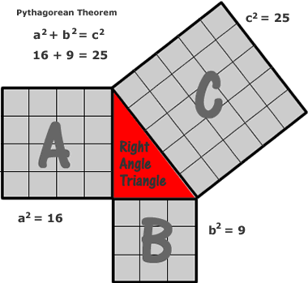
Pythagorean Theorem
Deb Russell

a²+b²=c²
That's what comes to mind when someone asks what the Pythagorean Theorem is. Simply put 'The hypotenuse of a right triangle is the side opposite the right angle', sometimes referred to by students as the long side of the triangle. The other 2 sides are referred to as the legs of the triangle. The theorem states that the square of the hypotenuse is the sum of the squares of the legs. In this image, the legs would be the sides of the triangle where A and B are. The hypotenuse is the side of the triangle where C is. Always understand that the Pythagorean Theorem relates the areas of squares on the sides of the right triangle. To see the application of the

Pythagorean Theorem
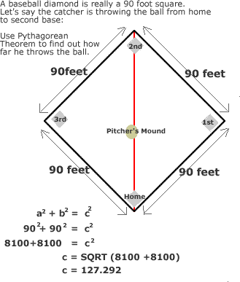
Applying Pythagorean's Theorem
Deb Russell

We all know that a baseball diamond is really a 90 foot square. So, if a catcher wanted to throw the ball to 2nd base, how far would he have to throw the ball? You know the dimensions of the square which is all you need to apply Pythagorean's Theorem. However, what if you don't know the measurement of the leg and you have the measurement of the hypotenuse? See next.

Pythagorean Theorem - Hypotenuse Known
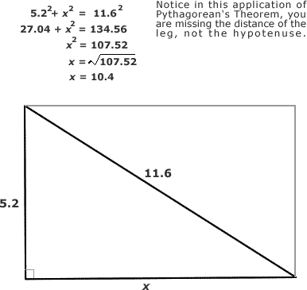
Applying Pythagorean's Theorem
Deb Russell

Let's say you are faced with a problem like: Normally you swim diagonally across the rectangular pool which is 11.6 However, today the pool is busy so you must swim the length of the pool. The width of the pool is 5.2 and the diagonal is 11.6 but you now need to determine what the length is. The image information shows you how to solve this problem using Pythagorean's Theorem.

http://www.math-videos-online.com/easy-pythagorean-theorem-proofs.html

