Polynomial Project

Project Assignment:
1. Must be in booklet form only
2. Be sure to include all parts.
3. You will need to do some mathematical calculations in order to complete all the parts! All work must be shown to receive credit.
4. Project is due Friday, February 17th
5. Be sure to start early so you have plenty of time to ask questions!
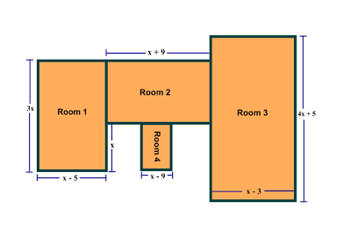

Project Details:
You are building a house with the above floor plan.
•Perform the appropriate operations on the polynomial dimensions to determine a simplified formula for the area of each room and of the entire house.
•Determine the actual square footage [i.e. area] of the each room and of the entire house using the following values of x: 15, 18, and 20 feet.
•Perform the appropriate operations to determine a simplified formula for the area of the entire house if Room 1 is removed.
•Determine the actual area of the house if Room 1 is removed using the following values of x: 15, 18, and 20 feet.
•Complete a booklet with the layout of the house (see above), your work showing the calculations of the required areas, and completed dimension and area charts (see next page).

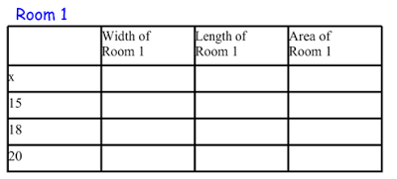

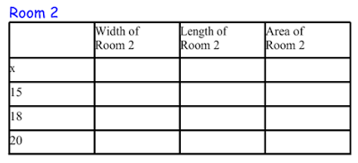

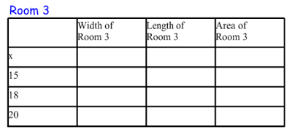

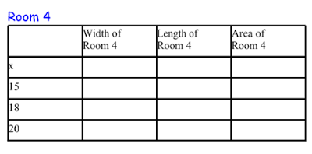

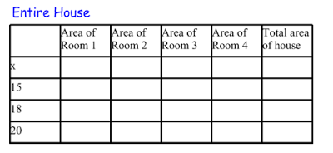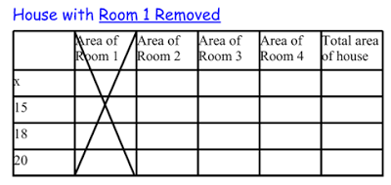

Rubric:
Rooms 1- 4 (Total of 72 points)
• Each x-value is 3 points (width, length, and area) = 9 points for each room
• Each numeric value is 1 point (width, length and area) = 9 points for each room
Entire House (14 points)
• Total area using x is 8 points = 8 points
• Total area using numeric values are 2 points each = 6 points
Entire House without Room 1 (14 points)
• Total area using x is 8 points = 8 points
• Total area using numeric values are 2 points each = 6 points

