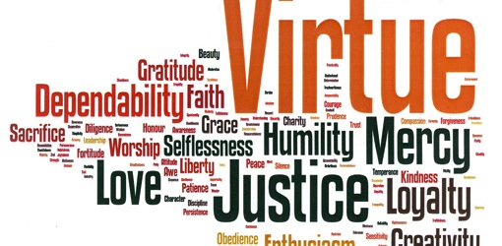
Religion 35
Shawn Allison shawnallison@gpcsd.ca
Goal of the course: To recognize and understand our personal responsibility in moral choices as believers. To mature in your faith through the study of theorists, Tradition, tradition and Scripture. To become aware that God desires for us to be abundantly happy. To study the solutions to the tensions that arises through justice, human relationships, ecology, community and political life.
Why? Completion of nine high school religion credits is a requirement to participate in the graduation ceremony. To question what you value in life and commit more deeply to those values.
**Participation in School celebrations is a curriculum objective-be in attendance and check in at conclusion of each celebration.

What will you study?
- Understand oneself as critical thinkers in moral issues
  - Differentiate and discern ethical and moral experiences
  - Examine Aristotle, Kant and Levina’s as their theories apply to your personal experience.
  - Understand and restate the nature of human action
  - Describe how one’s life choices creates you
  - Appreciate the call to service as a means to grow as moral agents.
  - Define and understand a formed and unformed conscience

- Understand that God has revealed himself to us through Moses and the Exodus story as well as through the lives of the prophets.
- Identify the role of Scripture and Tradition in ethics and in moral decision-making
- Appreciate Scripture as a source of life for the Church
- Recognize the self-revelation of God in the book of Exodus and the prophetic call stories

- Recognize revelation and the Tradition of the Catholic Church as a guide to moral living

  - Explain the ethical and moral implications of the Kingdom of God
  - Explore the stories of contemporary community leaders who are witnesses to God’s love
  - Articulate a Catholic understanding of Grace
  - Summarize the values/expectations of members the early Church as described in the letters of Paul and Acts of the Apostles
  - Appreciate the Church as a source of moral formation

- Explore and respect how other World Religions understand their sacred texts as guides to moral living
- research how other world religions understand their sacred texts as guides to moral living
- compare and contrast the Catholic understanding of Scripture with sacred texts from other World Religions

- Understand the spiritual dimension of relationships, marriage and family life
- Understand the religious significance of marriage, particularly its sacramental nature
- Reflect on the commitment necessary for a faithful marriage
- Explore the Church’s understanding of the vocation of a Catholic family as the Domestic Church

- Examine how other World Religions approach current moral issues
- research how other world religions approach current moral issues
- compare and contrast the Catholic understanding of morality and ethics with how other World Religions approach current moral issues
Evaluation
Study IT 70% | Study IT’s will include all assignments and major projects. Larger projects will weighted heavier then daily assignments. To be determined by your classroom teacher.
Pray IT 15% | Pray IT includes all class prayer activities. You must be present to earn these marks. Unexcused absences will result in 0’s.
Live IT 15% | Live IT involves a service project to be organized by your class. You must participate to earn these marks.

