Open Book Assignment
- Figure 1 Figure 2 Figure 3

- Draw figure 4.

- Fill out the chart c) Make an equation for this situation?

Figure # | Number of Parallelograms
1
2
3
4

- The sum of two numbers is -1

- Fill out the chart with at least three points
x | y

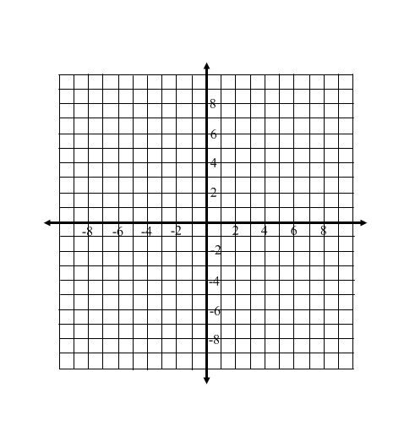
- What is an equation for this data

- Graph this data

- Is this data discrete or continuous? Why?

- Is this data linear?

- Draw each of the following graphs

- 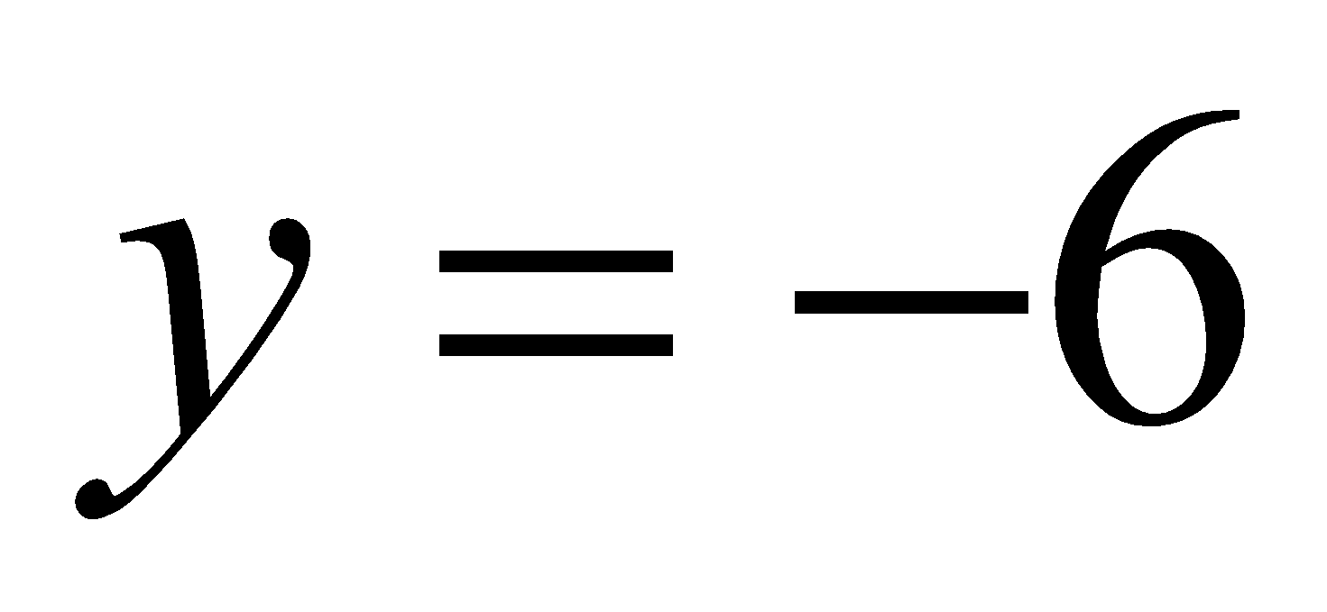 b) 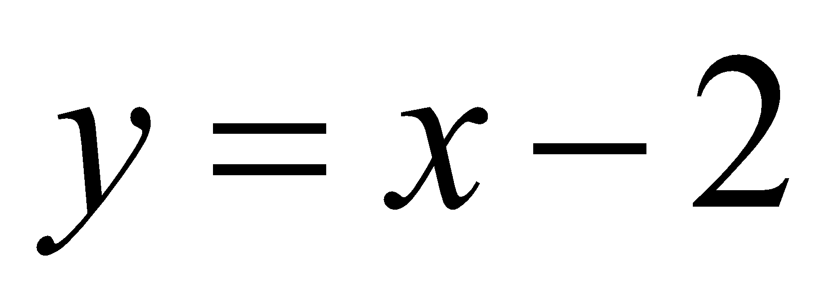

- Use the following graph to answer the next questions

- What is the value of x when
y = 2?

- Is part a interpolation or extrapolation?

c) What is the value of y when x =12?

d) Is part c interpolation or extrapolation?
5. Match the following equations with the correct graph

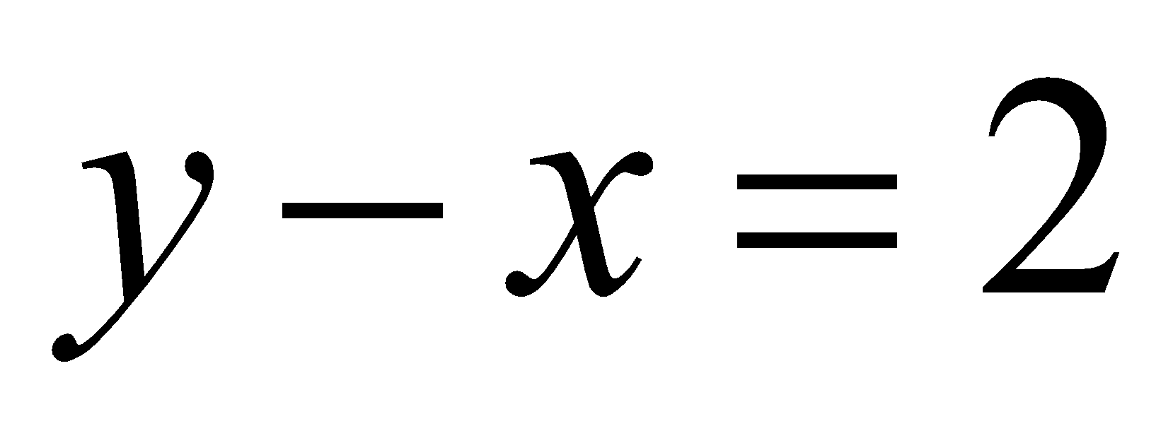

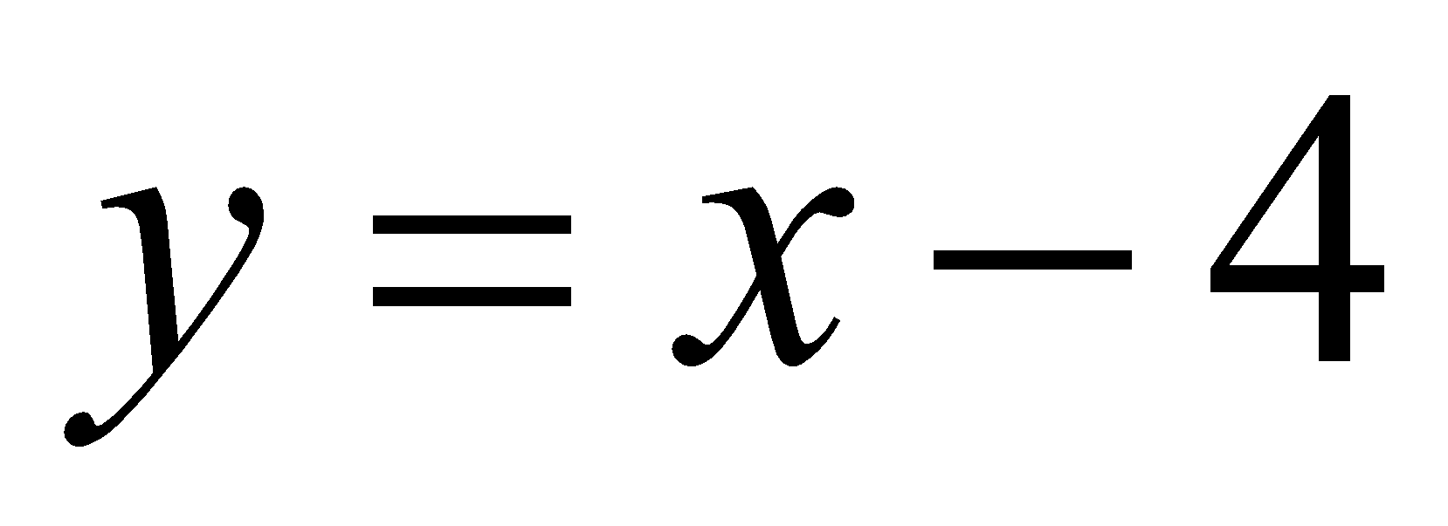

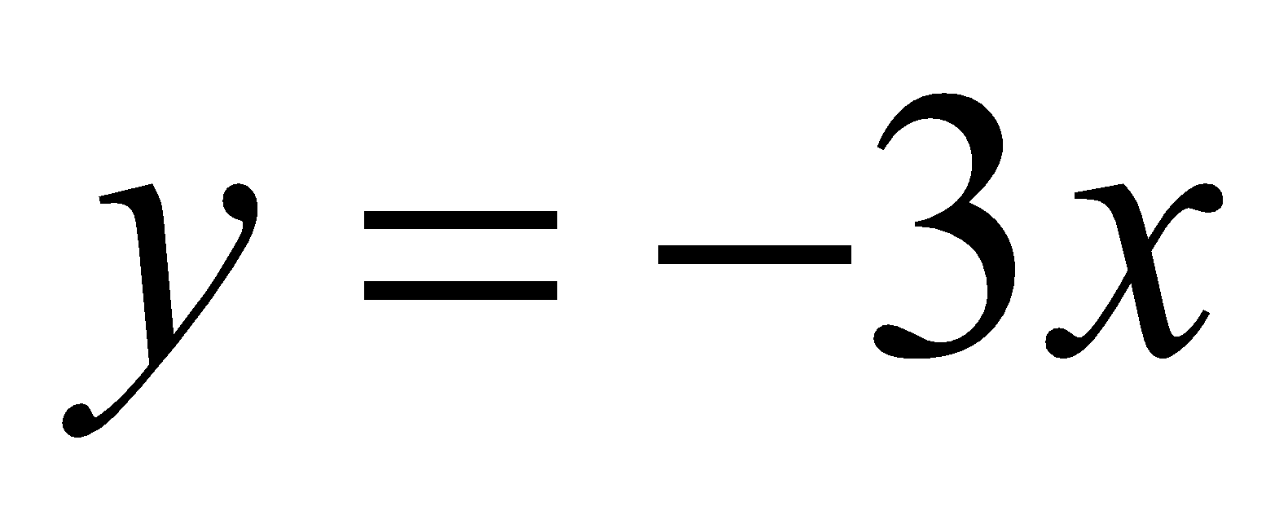

- Write an equation for each of the following statements.

- The sum of a number and 5 is 9.

- Seven less than two times a number is 3.

- A third of a number is 4.

- Solve each equation.

- 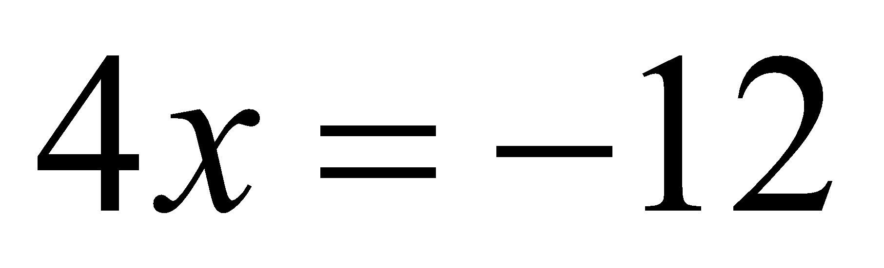 b) 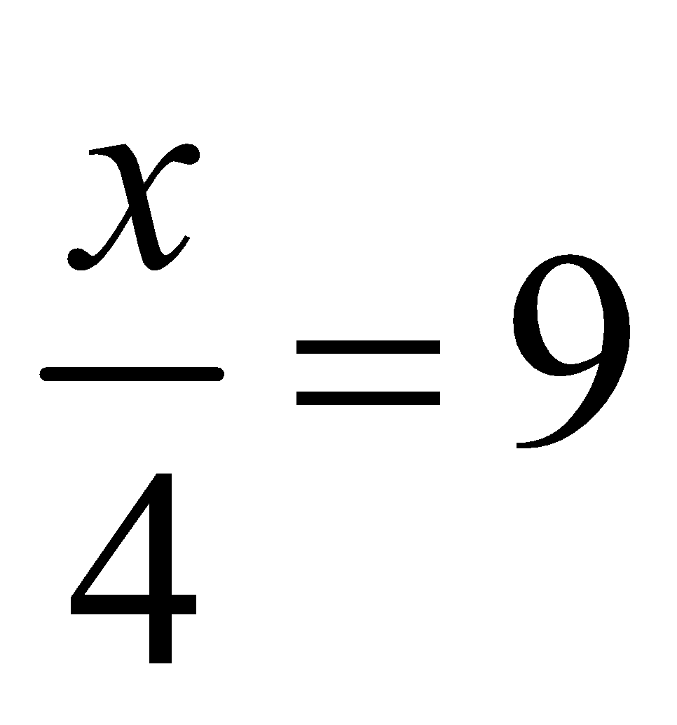

c) 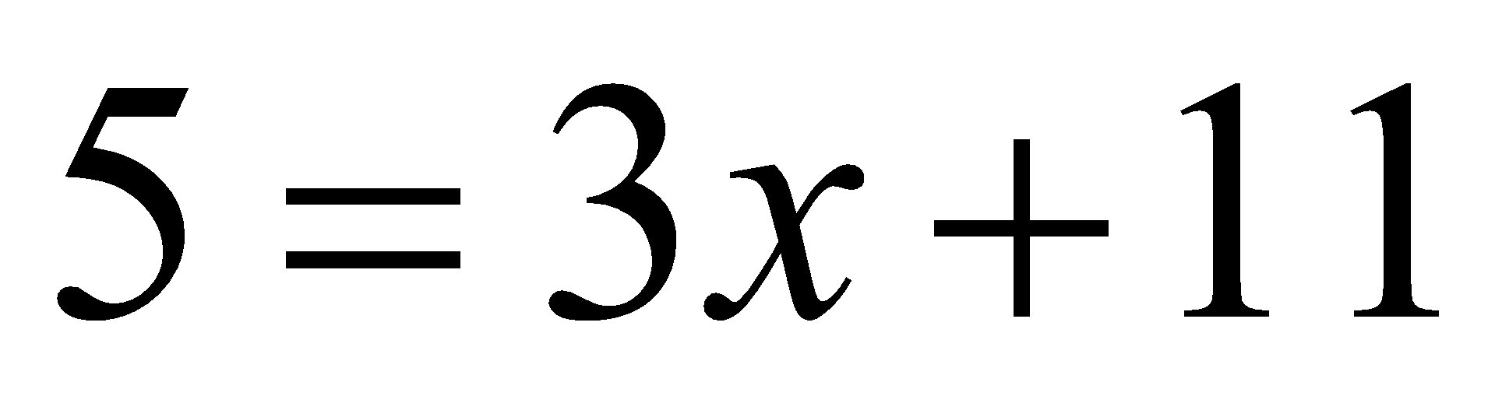 d) 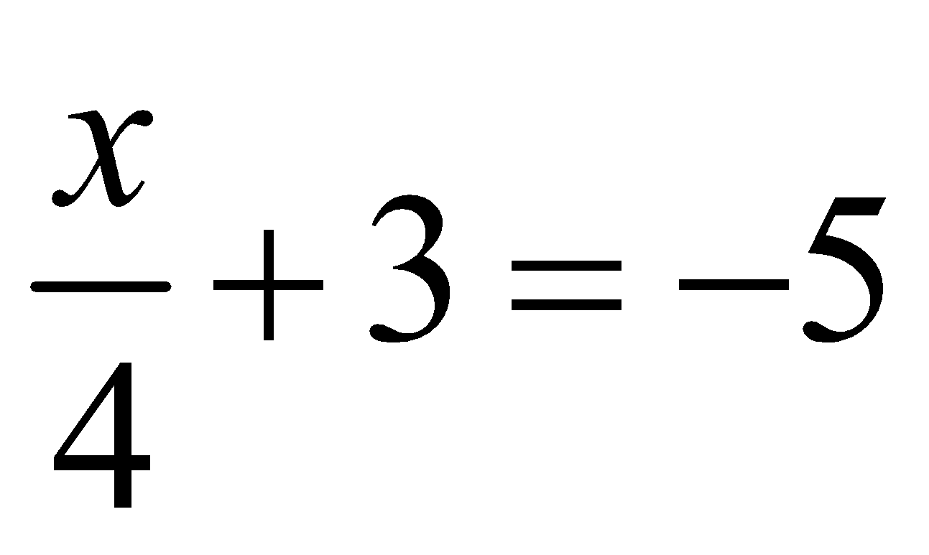

- 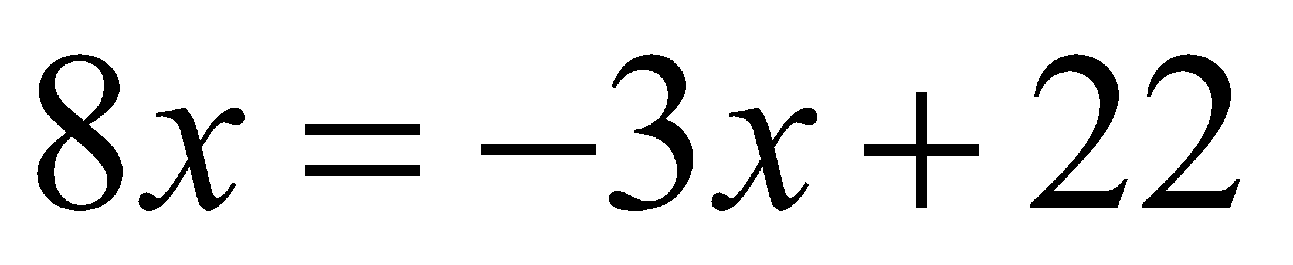 e) 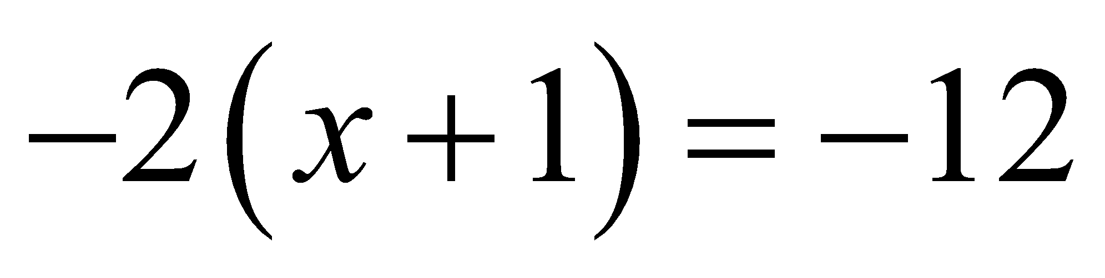

f) 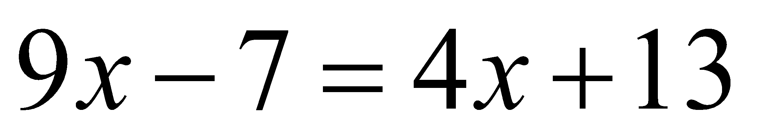 g) 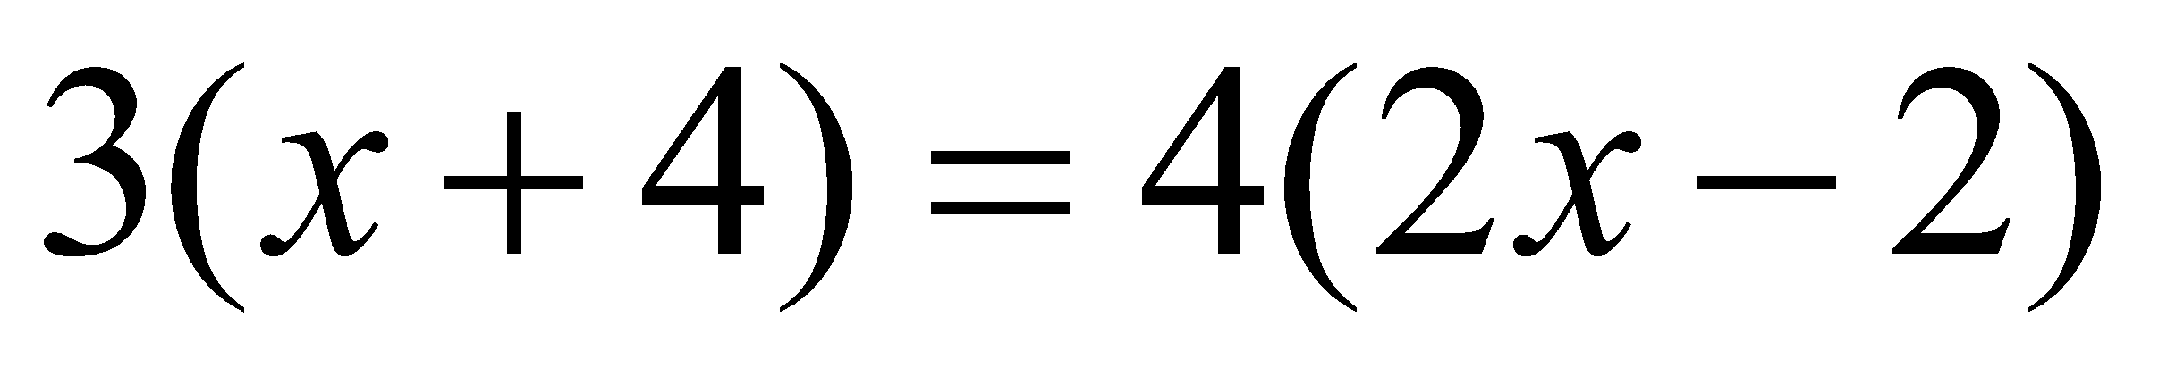

h) 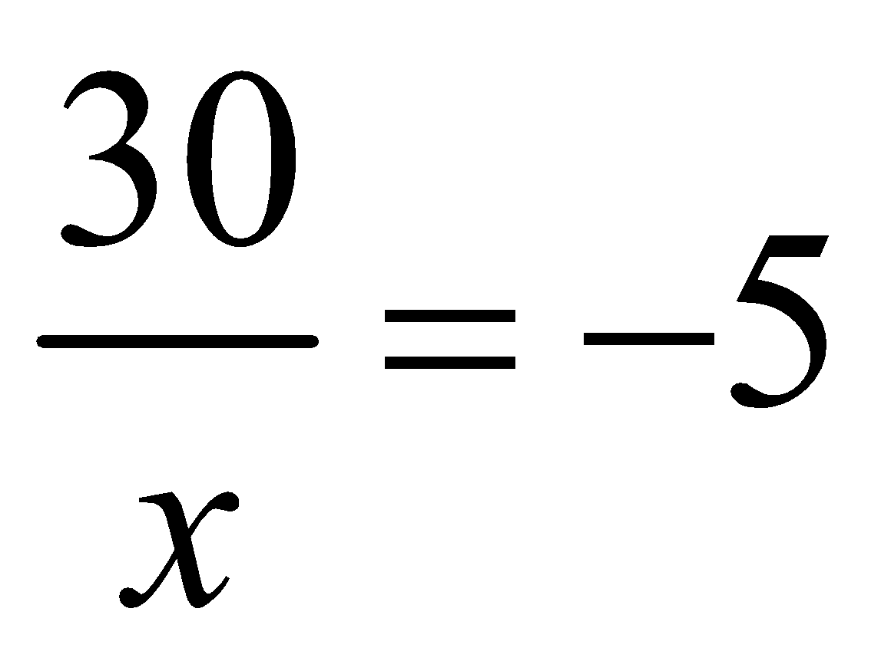

- Bill and Mark road their bike for 23km. Bill road 7km more than Mark. How far did each ride?

- The perimeter of the rectangle is 40m. What is the value of x?

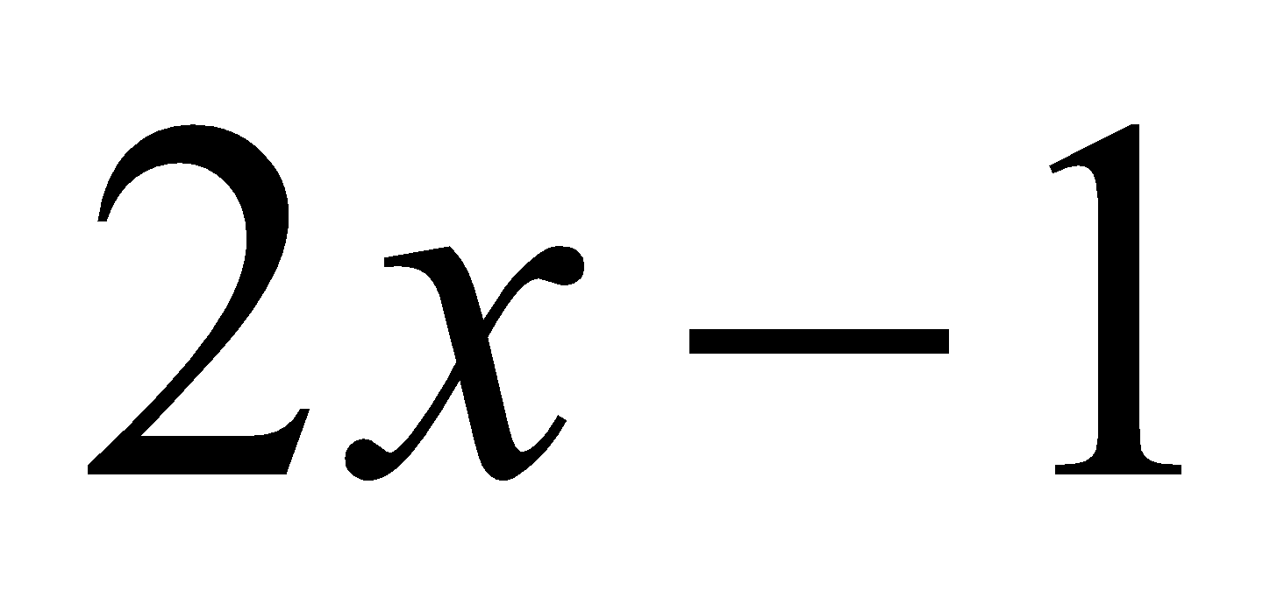
x

- Solve and graph each inequality

