CHAPTER 8 |  | BLM 8–10
INFORMATION HANDOUT/ SKILL BUILDER | Oil Pump Technology

{AB.Sc24.B.K.4.iii}

Name: Date:
Use this worksheet to assist you with Find Out Activity: Model Lift Pump.
- Use this information to help you answer the questions that follow.
- This worksheet begins with a discussion of a simple lift pump. A beam pump used on many oil wells uses the same basic plan to lift oil to the Earth’s surface.
- File this worksheet in the correct section of your notebook.

Part 1 Simple Lift Pump
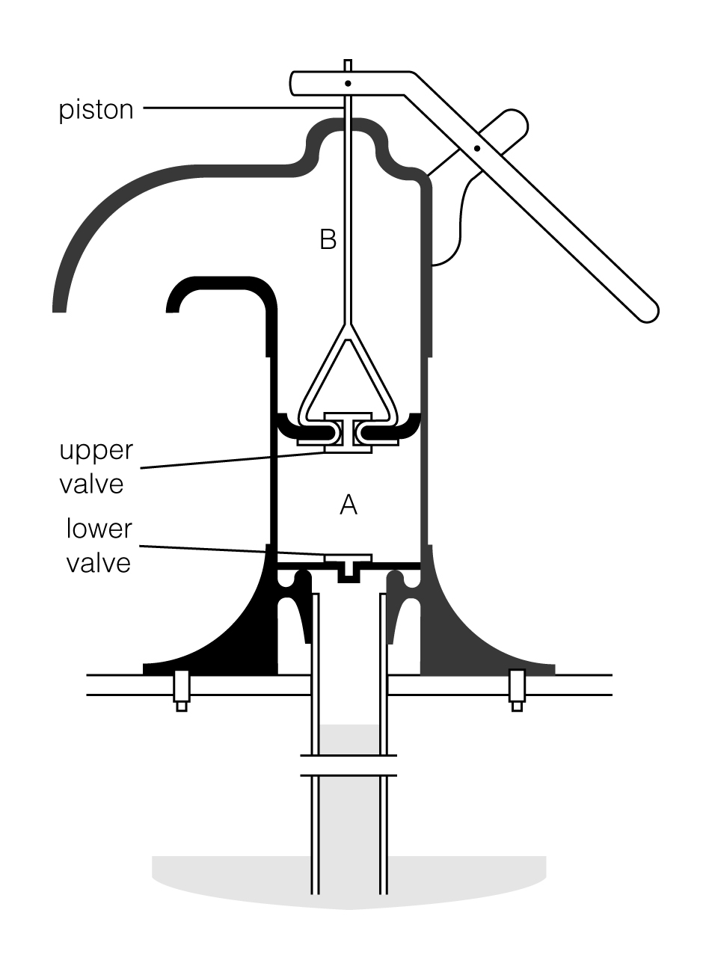
Simple lift pumps can be used to raise water about 6 metres. This is about the depth of many hand-dug wells.

The figure here shows a cross section of a simple lift pump used for water.

Step 1
The pump handle is lowered. This raises the piston, creating a region of lower pressure at A.

The lower valve opens and the top valve closes. This allows fluid to move into the lower chamber.

Step 2
The pump handle is raised. This lowers the piston, increasing the pressure at A.

The lower valve closes and the upper valve opens. Water is forced into the chamber at B.

The next time the piston is raised, the water in the upper chamber spills out of the outflow tube.

Analyze
1. Describe the position of both valves when the piston is raised.

2. Describe the position of both valves when the piston is lowered.

CHAPTER 8 |  | BLM 8–10
INFORMATION HANDOUT/ SKILL BUILDER | Oil Pump Technology (continued)

Part 2 Pump Jack
A pump jack is commonly used to provide the energy to get the oil to the surface. This illustration shows a pump jack system, which consists of:
- a pump jack;
- a pump; and
- a sucker rod and tubing.

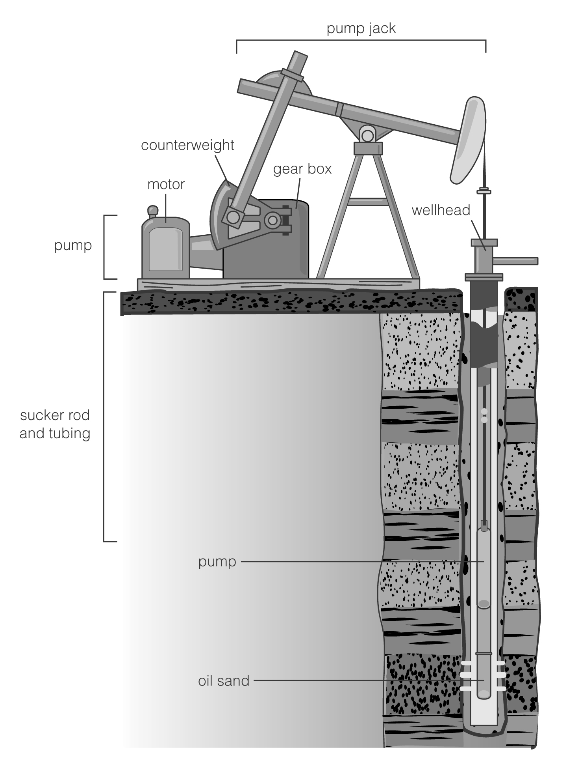
Pump Jack
A motor turns a gearbox which, in turn, moves a lever. The lever pushes and pulls a series of rods up and down the well casing.

Pump
The rods are attached to the plunger located in the underground pump. The pump consists of two valves that open and close like the valves in a simple lift pump.

Sucker Rod and Tubing
The pump system creates suction that lifts oil to the surface.

Counterweights help to balance the system. Without counterweights, the pump jack would require a much larger gear and much more power to move the pump.

Analyze
1. Circle the lever used in this type of lift pump.

2. Add arrows to the diagram to show the path of the oil.

3. On the back of this page or in your notebook, describe the function of each component of the pump jack.
(a) motor (d) counterweights
(b) gear box (e) rods
(c) lever (f) pump

CHAPTER 8 |  | BLM 8–11
OVERHEAD MASTER | Water Pump and Pump Jack

{AB.Sc24.B.K.4.iii}

