CHAPTER 8 |  | BLM 8–1
SCIENCE INQUIRY | Oil and Water

Name: Date:
Group Members:
Use this worksheet to assist you with Starting Point Activity: Oil and Water. Compare the cost of oil and water, and how much of each we have to use. Look at the concerns we have for each.
- Use information available in your classroom and on the Internet to complete the following chart.
- Answer the questions that follow.
- File this worksheet in the correct section of your notebook.

Water | Oil
• Cost per litre: ______ | • Cost per litre: ______
• Approximate amount of available reserves:  ________________________________ | • Approximate amount of available reserves:  ________________________________
• Location of available reserves:  ________________________________ | • Location of available reserves:  ________________________________
• Concerns: | • Concerns:

What Did You Discover?
1. Which liquid — motor oil or drinking water — is the most expensive? ______________________

2. Which liquid is more abundant? _______________________

3. Which liquid is more important to your life? Use the space on the back of this worksheet to explain.

Extension
4. On the back of this worksheet, explain what you think might happen if we run short of motor oil or fresh water.

CHAPTER 8 |  | BLM 8–2
OVERHEAD MASTER/  SKILL BUILDER | Map of Alberta

{AB.Sc24.B.K.4.i}{AB.Sc24.B.S.3.i}

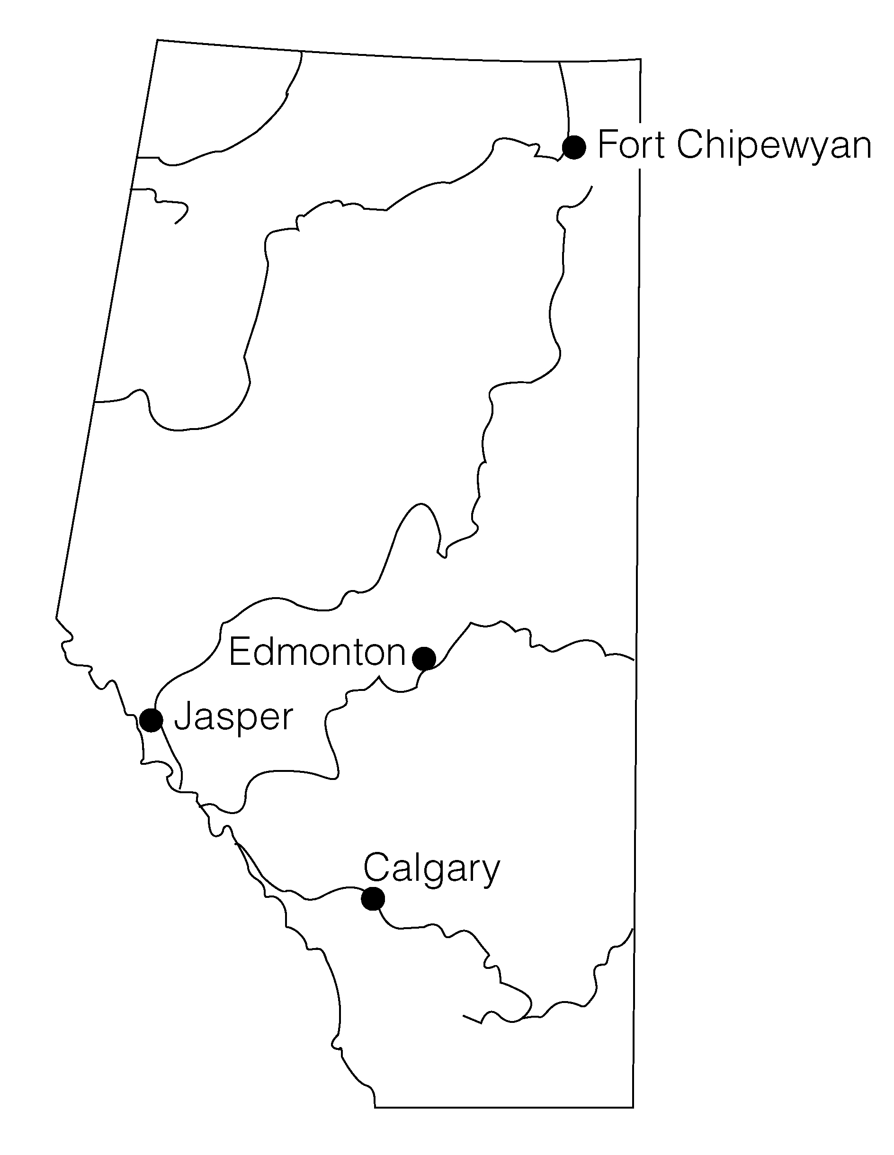

CHAPTER 8 |  | BLM 8–3
OVERHEAD MASTER | Earth’s Reserves of Oil and Water

{AB.Sc24.B.K.4.iii}{AB.Sc24.B.K.4.v}{AB.Sc24.B.S.2.ii}{AB.Sc24.B.S.3.i}

Earth’s Water Supply
(includes fresh water, salt water, ice, and water vapour)

Earth’s Water Supply
(%)
oceans | 97.3
ice | 2.19
ground water | 0.5
soil moisture | 0.005
atmosphere | 0.001
inland lakes | 0.018
rivers | 0.000096

World Oil Reserves
(as of December 2000)

Location of Oil Reserves | Amount  (billions of barrels)
East Asia and Pacific regions | 30
Africa | 80
Middle East | 690
Eastern Europe and former USSR | 65
Western Europe | 15
Central and South America | 100
North America | 55

CHAPTER 8 |  | BLM 8–4
OVERHEAD MASTER | World Map

{AB.Sc24.B.S.2.ii}{AB.Sc24.B.S.3.i}
