Unit 2: Exponents and Polynomials Assignment #2

1. Write a polynomial to match the following conditions.
3 terms, degree 2, with the coefficient on the 2nd degree term –2

2. Identify the equivalent polynomials. Justify your responses.
a) –5y² – 3y – 4 b) 10x – 1
c) 1 + x – x² d) 2y² – 4 – 16 – 7y² – 3y + 16
e) –7 + 5x – 7x – 8 + 14 + 12x f) 5x² + 7 + 4x – 6x² – 6 – x – 2x
a with ____ c with ____ e with ____

3. For each shape below, write an expression for perimeter using polynomials and then simplify the expression.
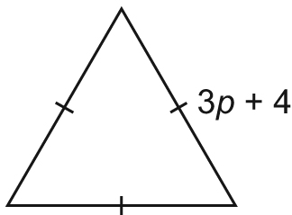
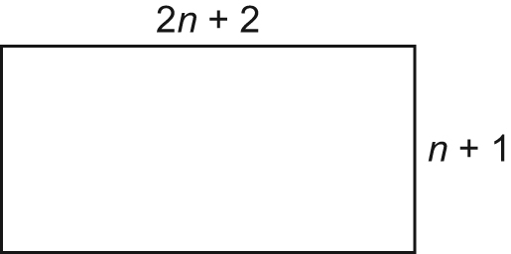
i) ii)

Expression Expression

Perimeter Perimeter

4. Subtract.
a) (xy – x – 5y + 4y²) – (6y² + 9y – xy) b) (2a + 3b – 3a² + b²) – (–a² + 8b² + 3a – b)

5. Determine each product.
a) 4(3a + 2) b) 2(4c² – 2c + 3)

5. Determine each quotient.
a) (16v + 16) ÷ (8) b) (20 – 8n) ÷ (–4)

6. Write the multiplication sentence modelled by each set of algebra tiles.
Eg (_____) x (_____) = _______
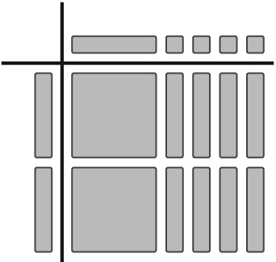
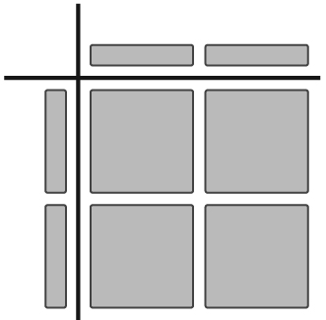
a) b)

7. Multiply.
a) v(3v + 1) b) 3c(5c + 2) c) (7k – 3)(–m)

8. Divide.
a) (6x + 3) ÷ 3 b) (12c² – 6c) ÷ 3c c) (9xy – 6x) ÷ (–3x)

9. Here is a student’s solution for a division question.
(–12x² – 9x – 12xy) ÷ (–3x)
=
= 4x² – 3 + 4xy

a) Explain why the student’s solution is incorrect.
b) What is the correct answer?

10. Write an area expression, using polynomials for each rectangle. Simplify the expression.
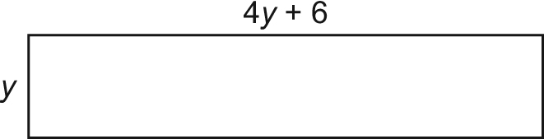
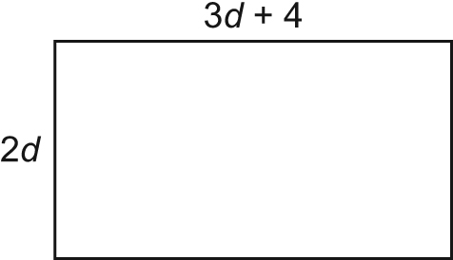
a) b)

Expression Expression

Area Area

