Lesson 1-9: Properties of Cords

Definitions
Radius:

Diameter:

Cord:

Perpendicular lines

Bisect

Paper Circle activity

Properties of Cords
Property 1: The perpendicular from the centre of the circle to a chord bisects the cord.

Property 2: The perpendicular bisector of any chord passes through the centre of the circle.

Eg Find the radius if AB=12cm

A

8cm

B

Find AB

10

6

A B

Find x

x

7

8

10

Find x

10

7 x
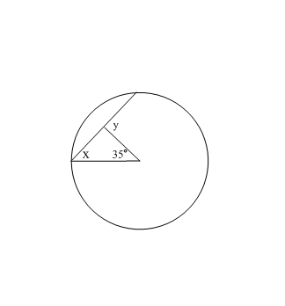
Find the missing angles

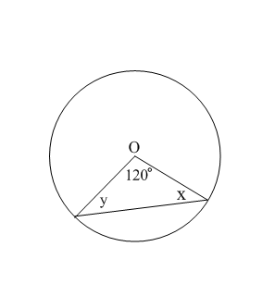
O

Homework Pg 397 #3-7, 10, 14, 17

