Math 9 Lesson 5-9: Isometric Dot Diagrams
Draw the following shape that I’m holding up in 3D

For some people it’s rather hard to draw block figures in 3D so we use what is called isometric dot paper to help us.

Draw a 4 cubes

When we draw an object there are 6 different views that we are concerned about.

Top

Left Side Front Right side

Bottom

Back

Eg Draw all 6 views of the stapler

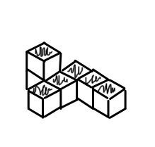
Draw all 6 views of

