L9 Solving Equations With Fractions

When you have both variables and fractions in an equation you must look at the denominator of all the fractions (remember whole numbers have a denominator of 1). Then you must find a common multiple of each denominator. It doesn’t have to be the LCM but if it is it will save you some work.

Then you must multiply each term in the equation by that multiple which will end up eliminating the denominator.

Then solve the equation.

Eg Solve each of the equations

a) 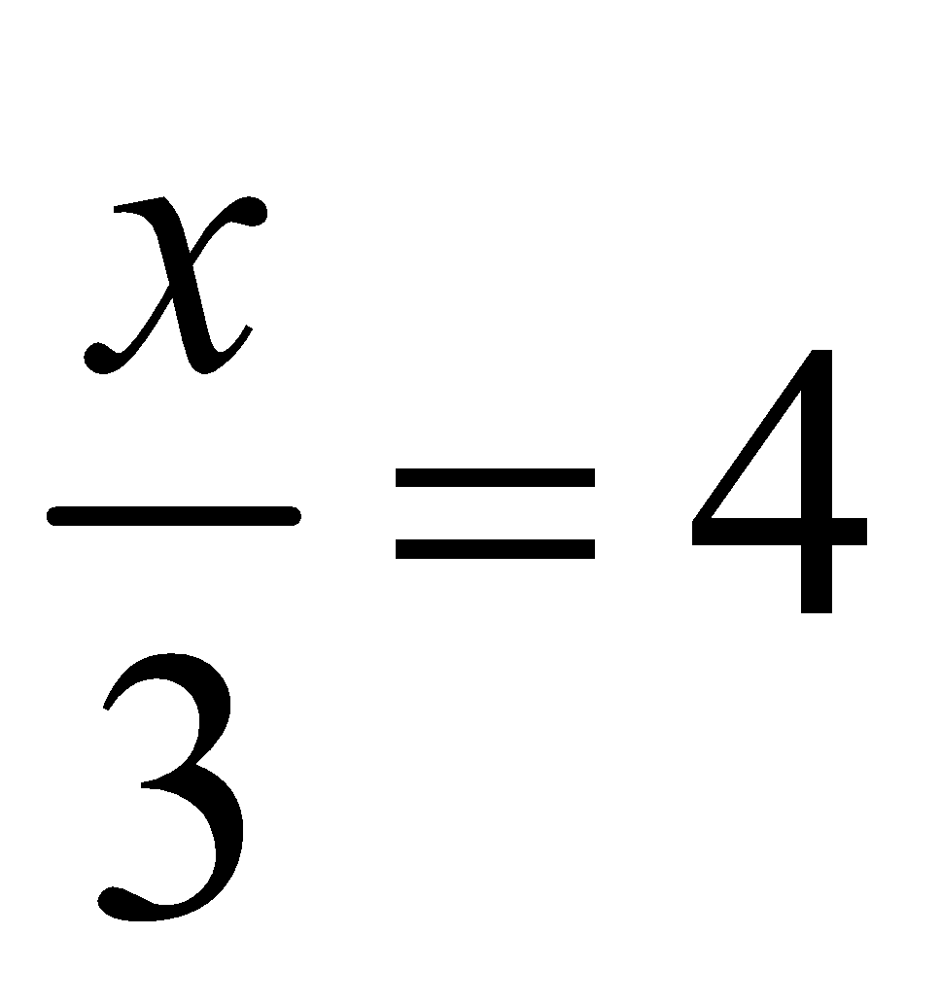

b) 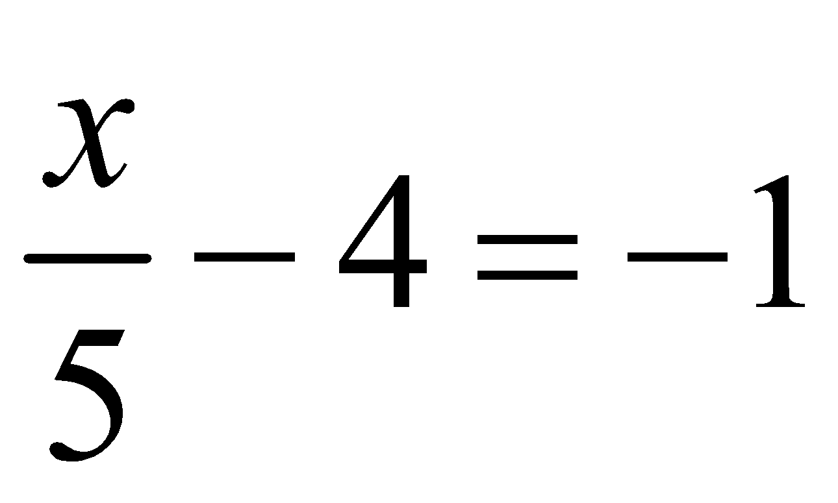

c) 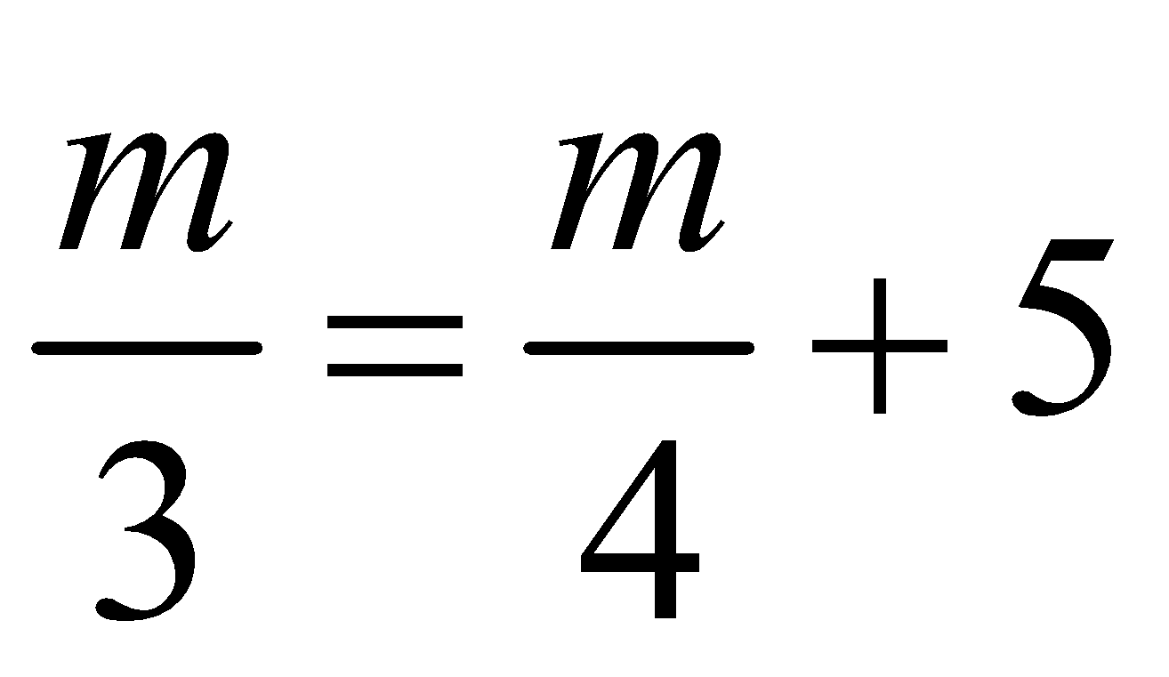

d) 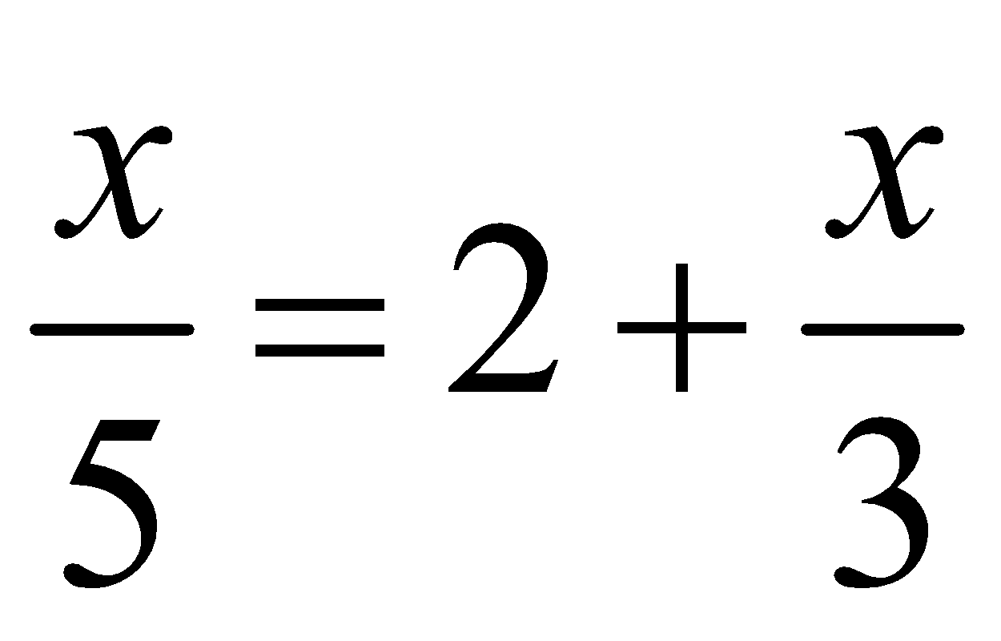

e) 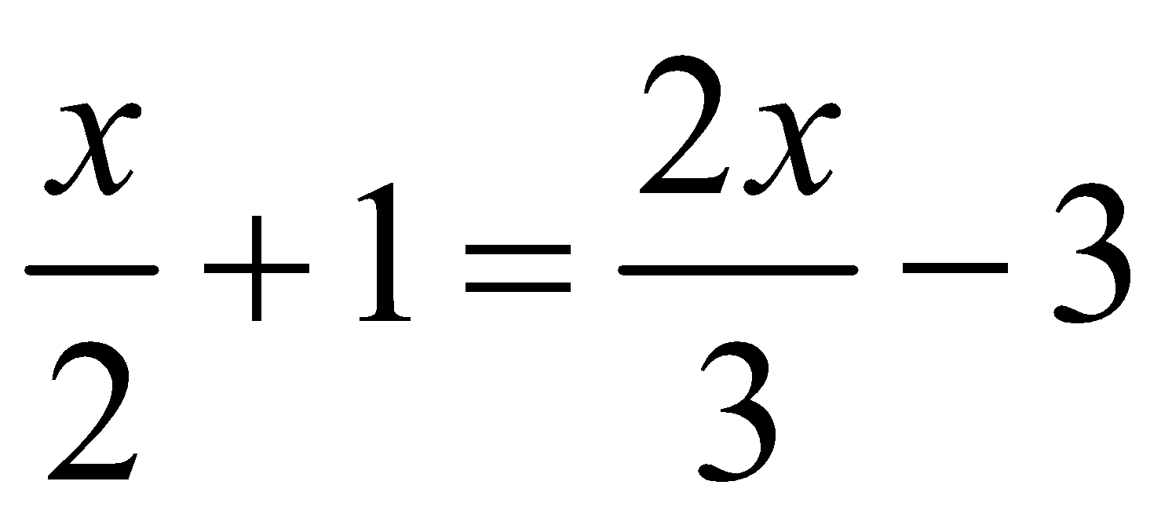

f) 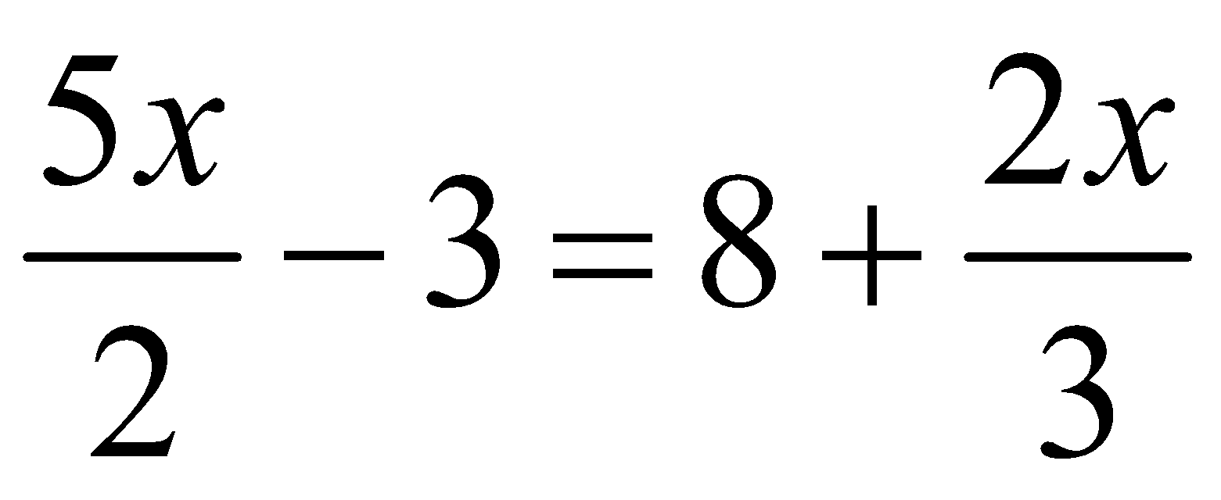

g) 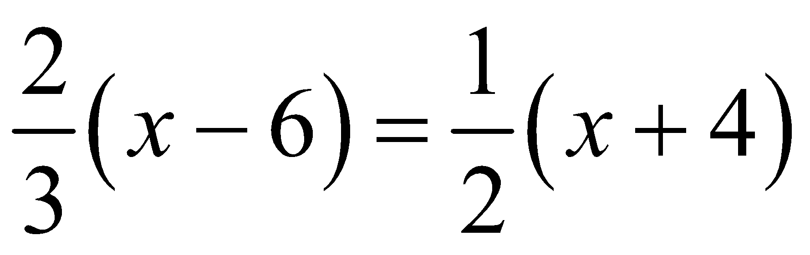

h) 