Lesson 1-8 Tangent lines in Circles

Review: When you have a right angle triangle and are given 2 of the 3 sides we can use Pythagoras Theorem to find the other.

$a^{2}+b^{2}=c^{2}$ where a and b are the two sides that form the $90°$ and c is the side across from the $90°$

c
a

b

Eg: Find the missing side

- 6cm

x 8cm

5m
14m
x

Try on your own:

x 15mm

12mm

x
22cm

17cm

A tangent line is a line that touches a circle at only one point. This point is called the point of tangency.

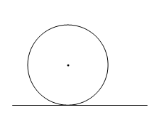

If we draw a line from the center of the circle to the point of tangency, what is the angle that is formed?

Tangent-Radius Property: a tangent to a circle is perpendicular to the radius at the point of tangency.

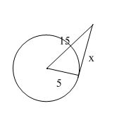
Eg Find the missing lengths to the nearest tenth.

a)

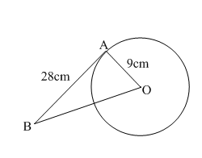
b)

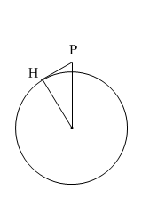
c) A plane is cruising at an altitude of 8000m. A passenger wants to know how far the horizon is that she sees outside her window to the nearest kilometre. Note: the earth has a radius of 6400km.

Find the missing angles
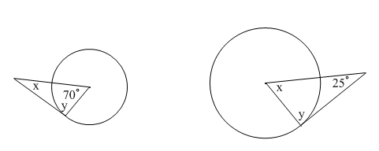

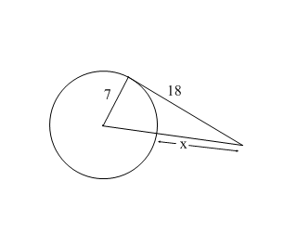

Homework Pg 388 #5-8, 12, 14, 17

