Math 9 Lesson 5-8 More Area

Today we are going to calculate the area of shapes that are different then we are use to. To do this we will have to break the shape into shapes we can calculate the area of and then add them together.

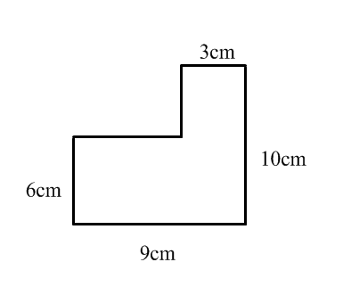
Find the area of each.

