Math 9: Lesson 3-7: Variables on both sides of the equation

From yesterday we saw the steps to solve an algebraic equation symbolically.

- Simplify both sides of the equation
- Add or subtract to get all the variables on one side of the equation
- Add or subtract to get all the constants on the other side
- Multiply or divide to get the variable by itself
- Check

Today we are going to solve when variables are on both sides of the equation pictorially and symbolically.

Solve 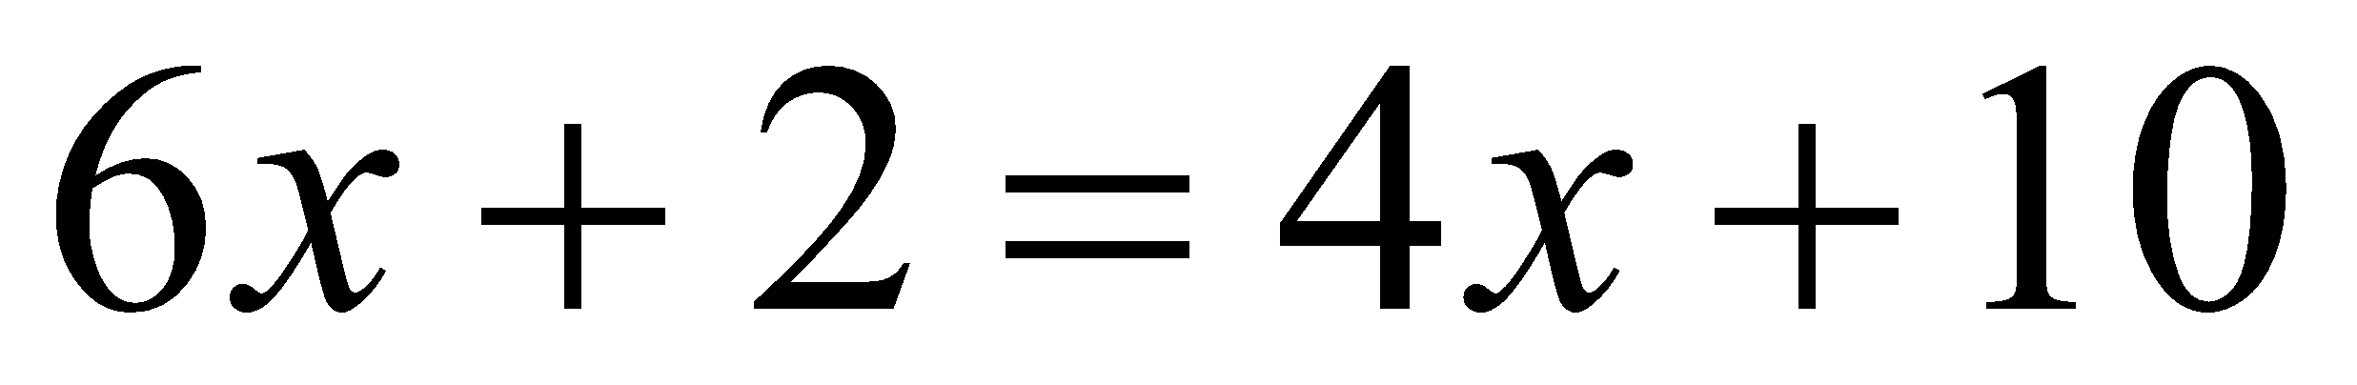 pictorially

Solve 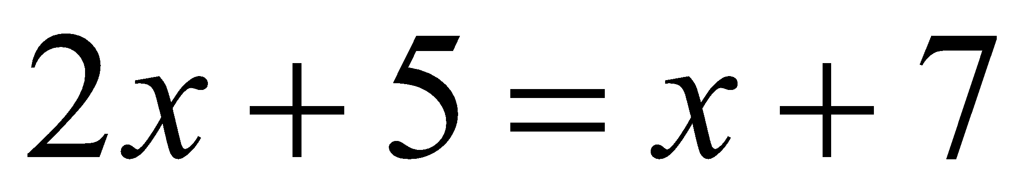 pictorially

We could also use algatiles to solve algebra

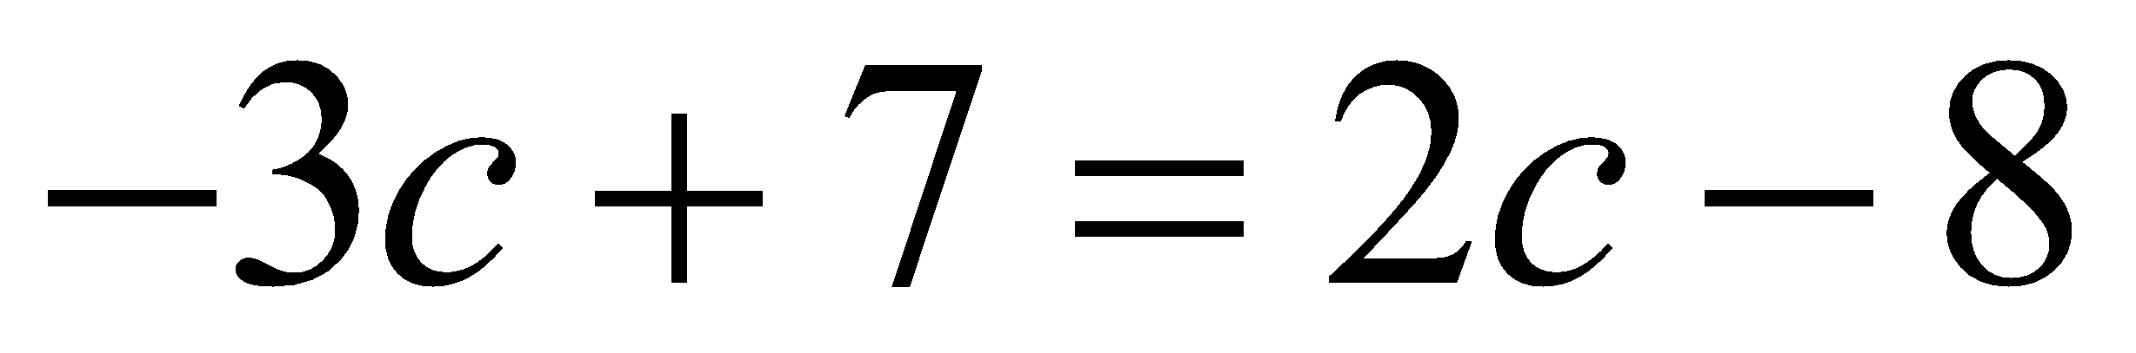

Solve each of the following symbolically
$3x=x+4$

$2x+1=x-3$

$x+3x-3-4=x-1+x$

$4+7w=1-3w-9$

$n+10+n-6=-6+5n-8$

Eg Two rental halls are considered for a wedding.
- Hall A cost $50 per person
- Hall B cost $2000, plus $40 per person
Determine the number of people for which the halls will cost the same to rent.

- Model this problems with an equation
- Solve the problem
- Verify the solution

Eg Hendrik has a choice of 2 companies to rent a car.
- Company A charges $199 per week, plus $0.20 per kilometre driven.
- Company B charges $149 per week, plus $0.25 per kilometre driven.
Determine the distance that Hendrik must drive for the two rentals cost to be the same.

- Model this problem with an equation
- Solve the problem
- Verify the solution

Homework P280 #4, 6, 10-15

