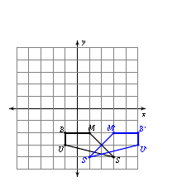
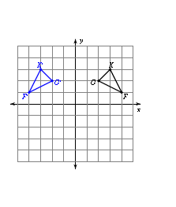
Math 9 Open Book Assignment #1
Reflections
- Describe (in words) the line of reflection in the following diagrams and draw in the line.
- b)

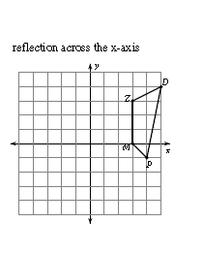
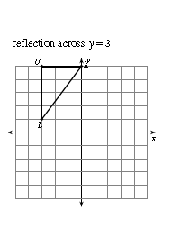
- Draw and label the image after the following reflections:
- b)

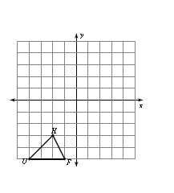
Translations
- Draw and label the image after the following translations
(x,y) (x+5, y+6)

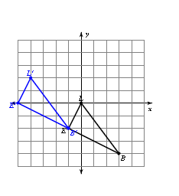

- Identify the translation required to move from image LEB to L’E’B’

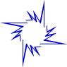
Rotations
- Does this figure have rotational symmetry? If it does, state the order and angle of rotation.

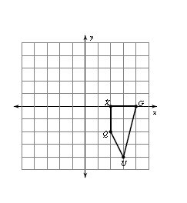
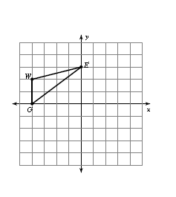
- Draw a rotation of each of the following figures:
- 180 clockwise around the origin b) 90˚ counter-clockwise around vertex Q

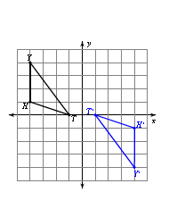
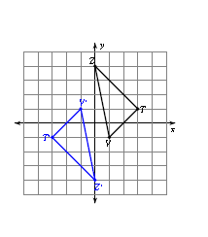
- Describe the rotation shown below:
- b)

- State the order of rotation and angle of rotation for each figure shown below:
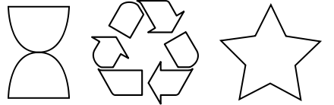

Order__________ Order__________ Order__________
Angle___________ Angle___________ Angle___________

Scale Factor and Similarity
- A right triangle with side lengths 10 cm, 24 cm, and 26 cm is enlarged to the dimensions of a right triangle with sides of lengths 20 cm, 48 cm, and 52 cm. Calculate the scale factor of the enlargement.

- A model house is 12 cm wide. If it was built with a scale factor of 3cm : 4m, then what are the dimensions of the real house?

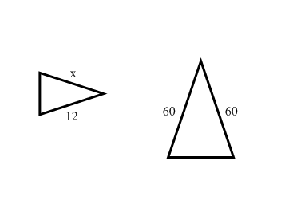
- Calculate the value of x in each of the following diagrams:

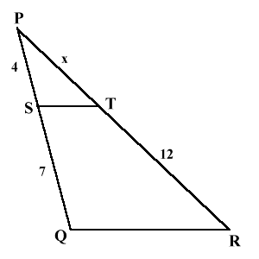
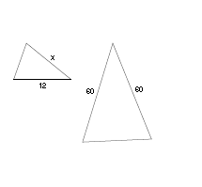
- b) ***this one is a challenge***
x
4

9
6

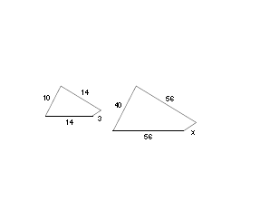

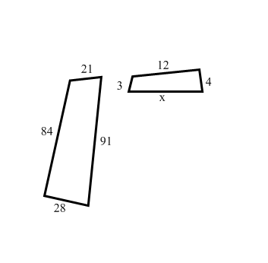
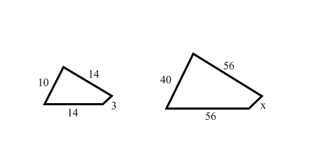

c) d)

- a) Which of the following four houses are similar?

______ and _______
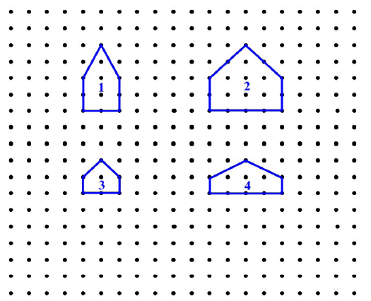

- On the grid above, draw a house that is an enlargement of figure 1with a scale factor of 2.

- On the grid above, draw a house that is a reduction of figure 2with a scale factor of 0.5

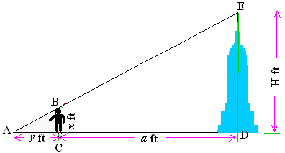
- A man 6 ft tall casts a shadow 12 ft long. He stands 168 ft away from the building of height H ft. If the shadows that are cast land (end) at the same point, then what is the height of the building?

