Math 9 Lesson 5-7 Area

Common area formulas

Square Rectangle

Triangle Circle

Parallelogram Trapezoid

Calculate the area of each









9*cm d=10mm*

7*cm*

*13cm*

10*m*

7.5*cm* 9*cm 4cm 5cm*

14*cm*

Solve for x

Area = 

x

Area = 

3*m*

x

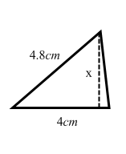

Area = 

Area =

