Math 9 Lesson 5-6 Estimating Square Roots

To estimate square roots we must remember our perfect squares.

Eg Estimate each of the following square roots to one decimal.

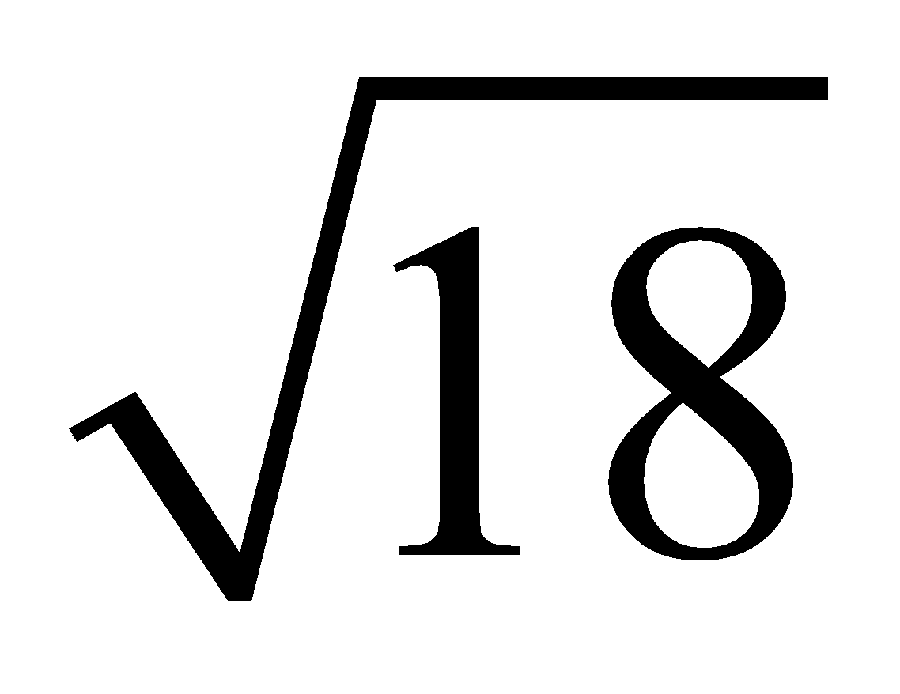

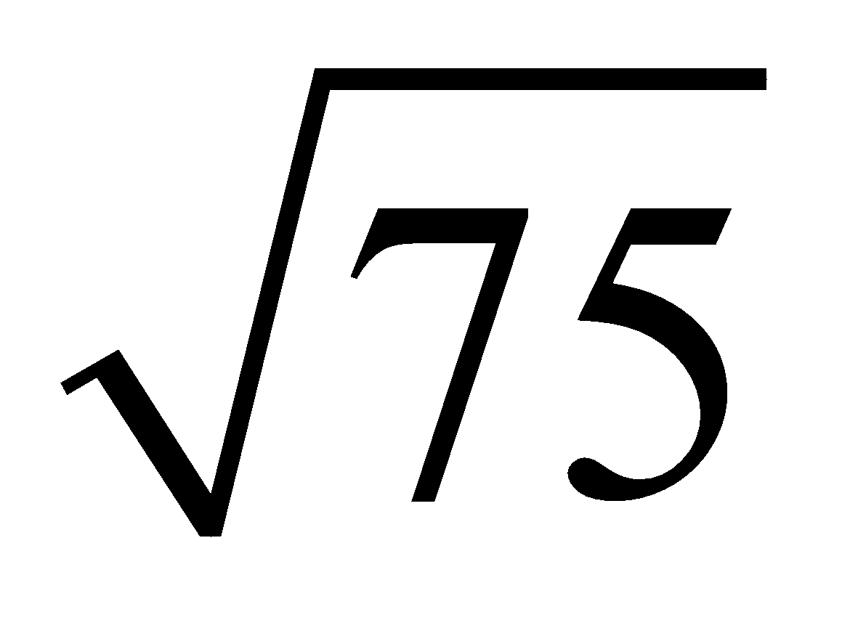

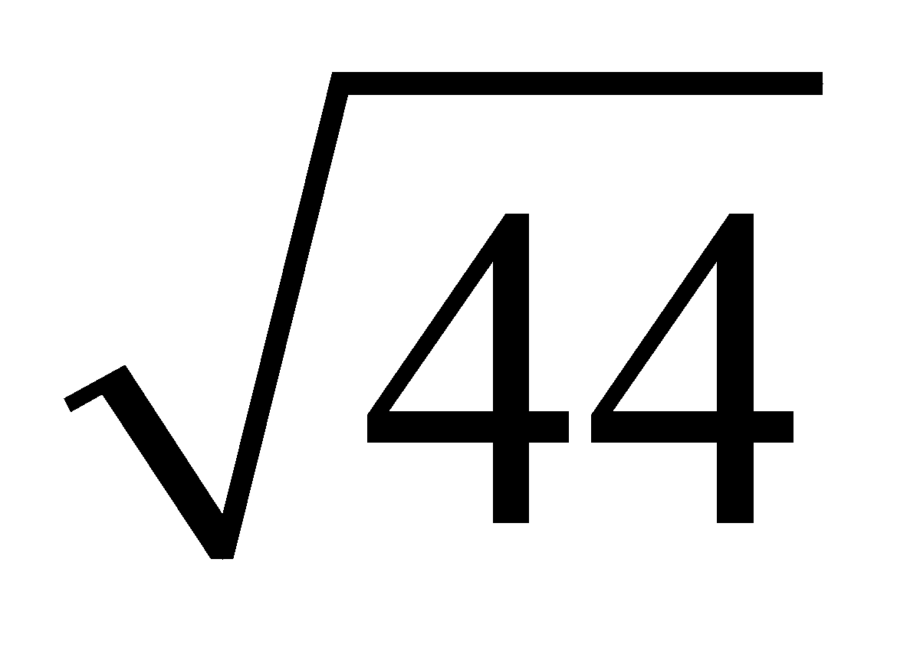

We can also use this to estimate the square roots of rational numbers

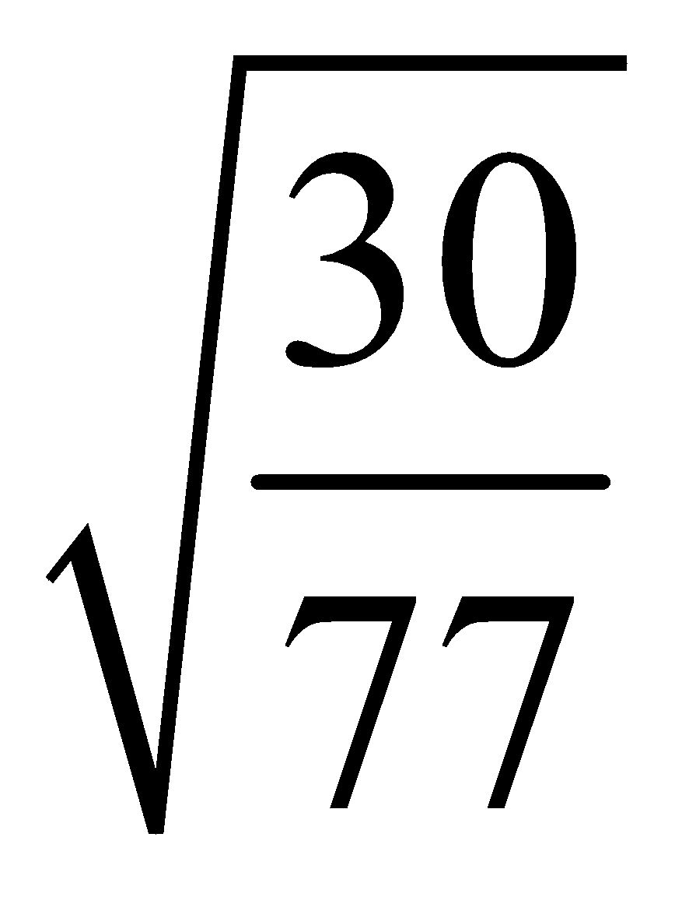

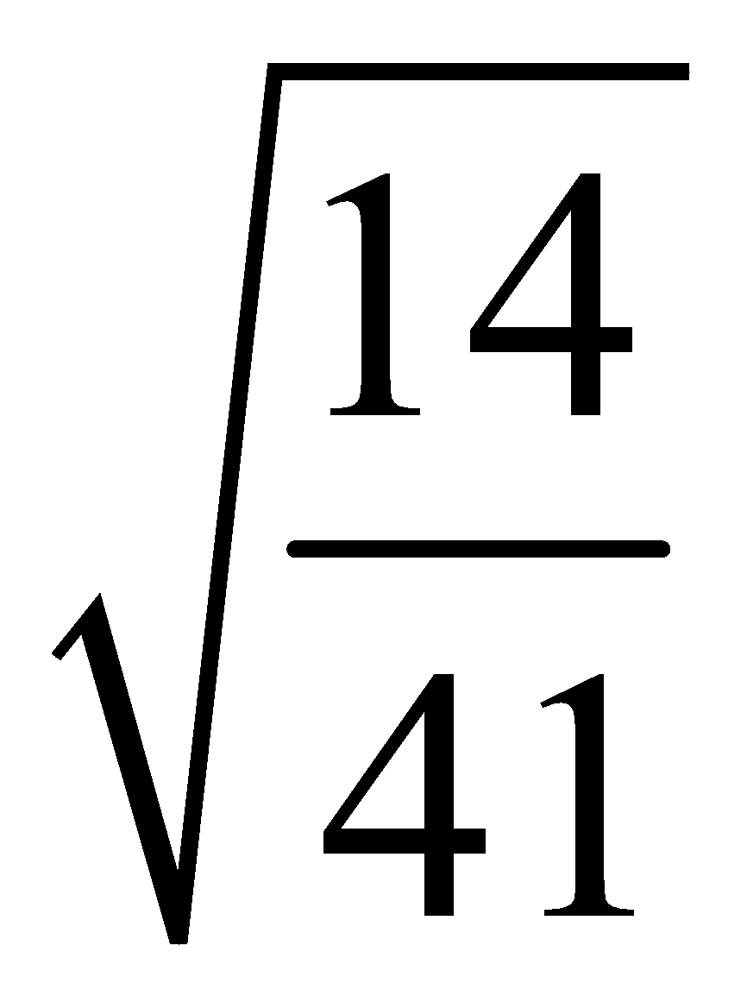

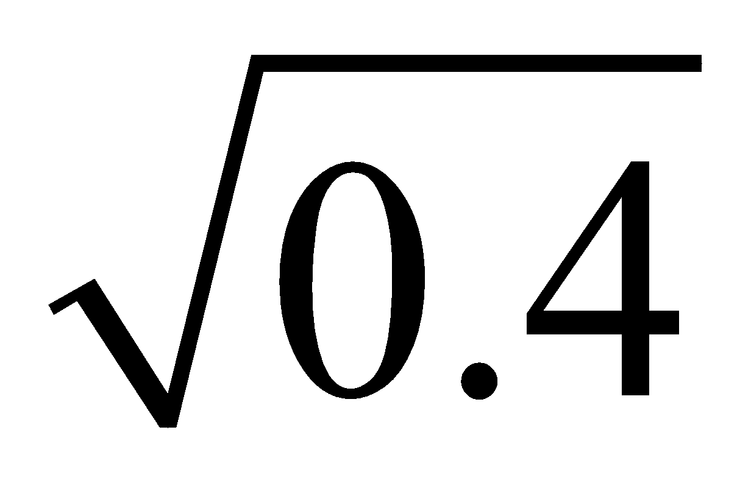

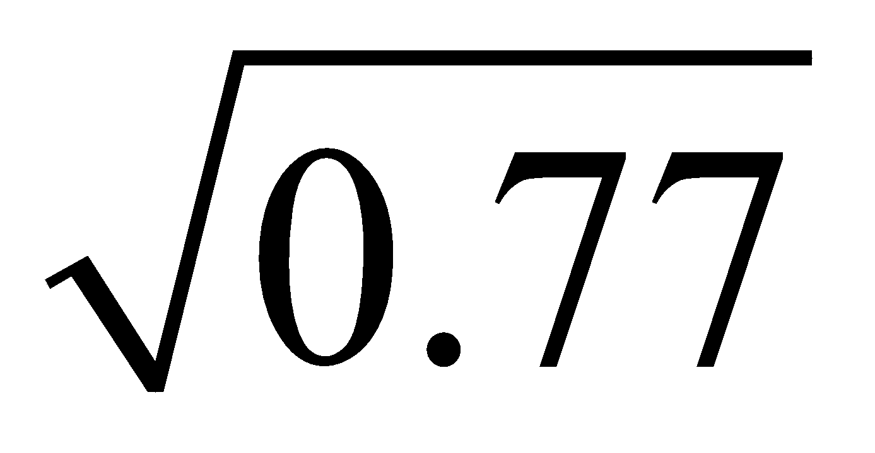

What number has a square root between 4 and 5?

What number has a square root between 12 and 12.5?

Homework Pg 18 #6, 7, 10, 11, 13, 16a, 17, 24

