Math 9 Lesson 5-5 Square Roots

When we are taking the square root of a number we are trying to find what number times itself will give us the number being square rooted.

Eg 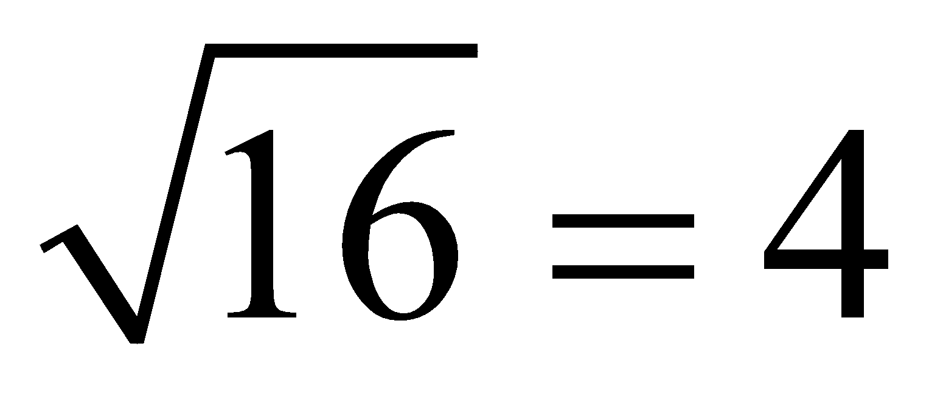 because 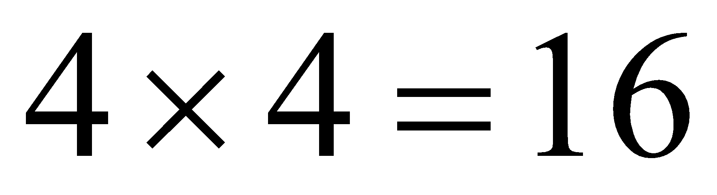

Any number that can be square rooted where you get a number that ends or a decimal that repeats is called a perfect square.

Eg which of the following are perfect squares?

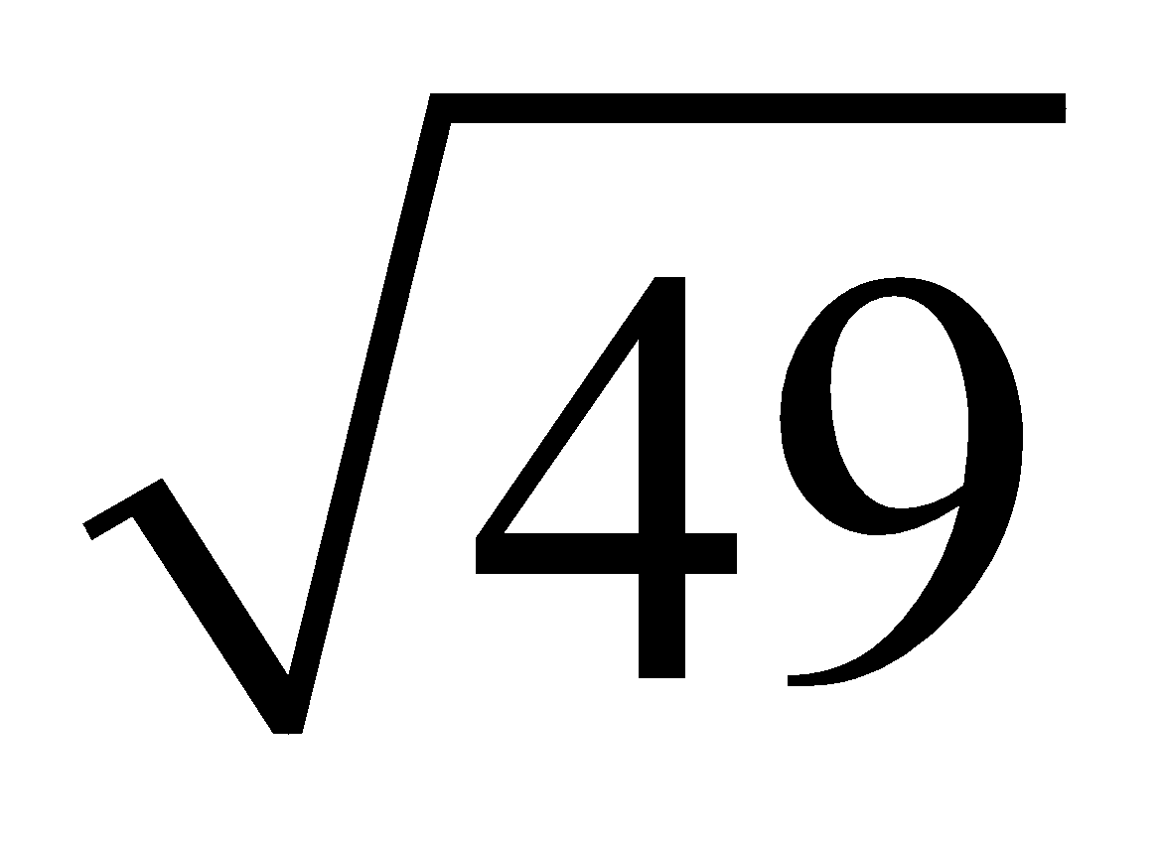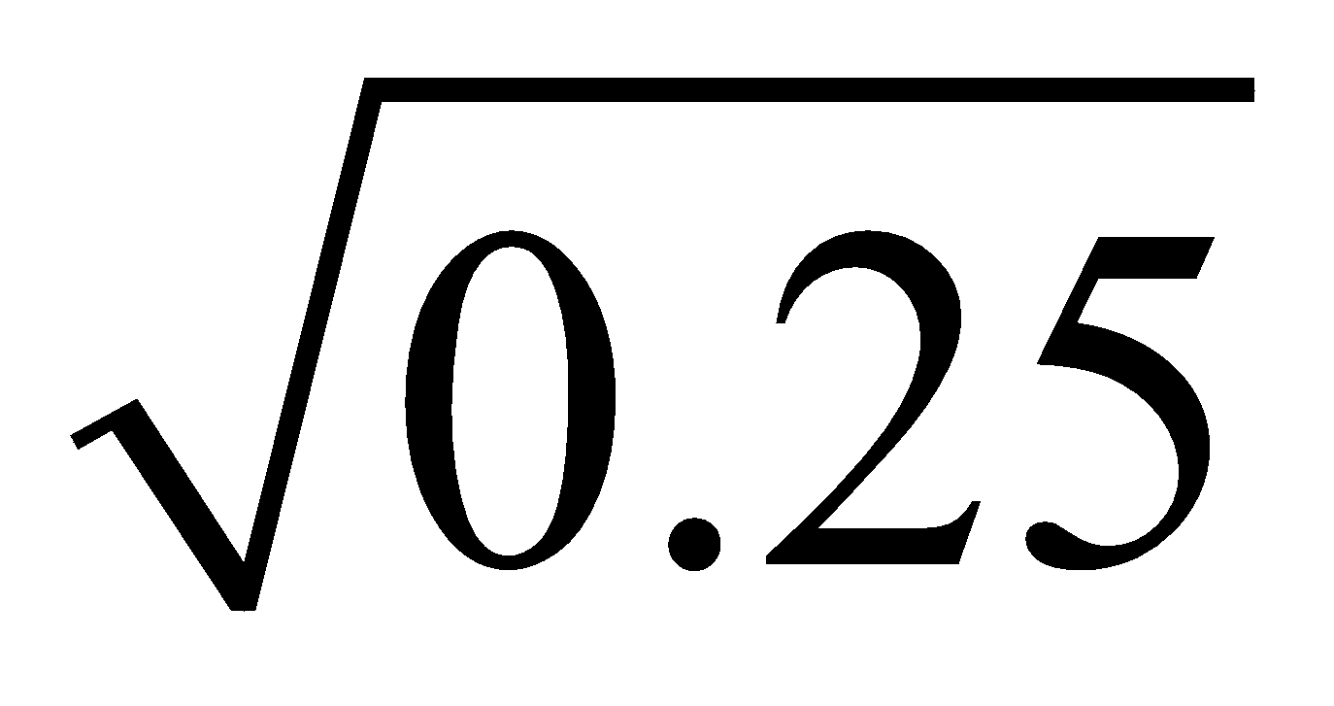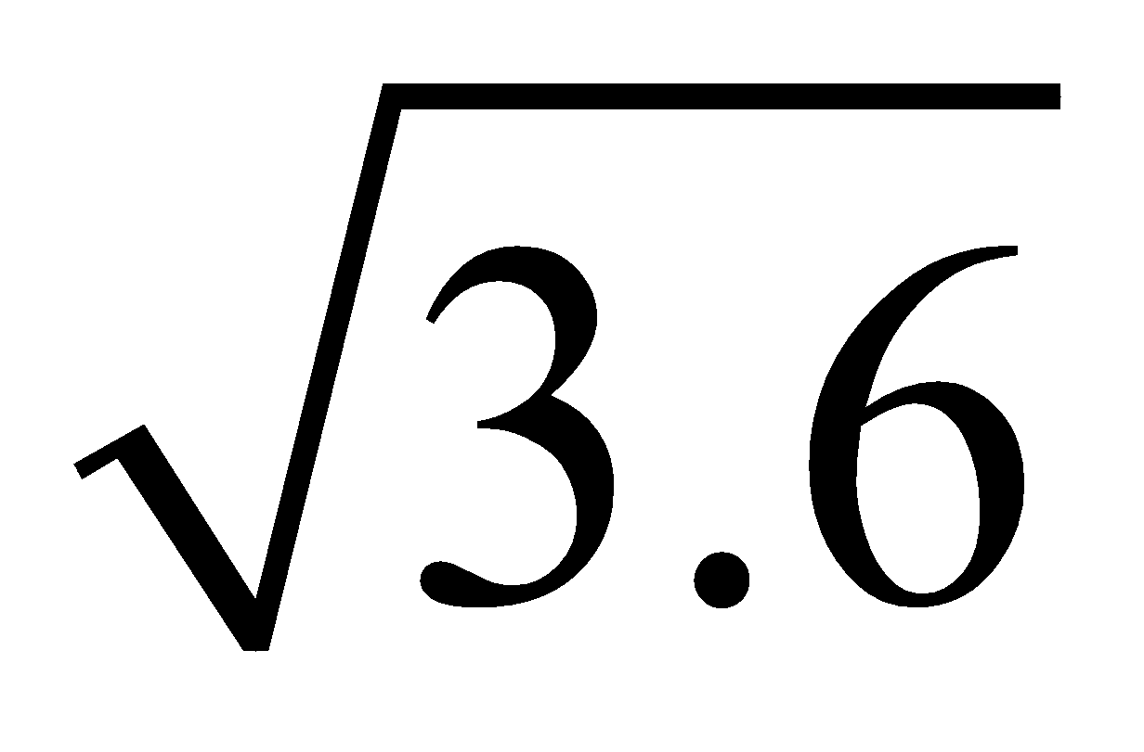

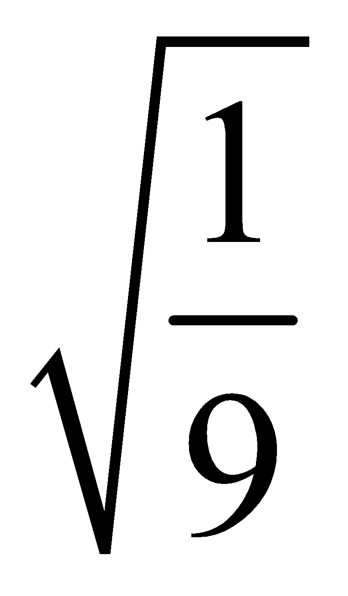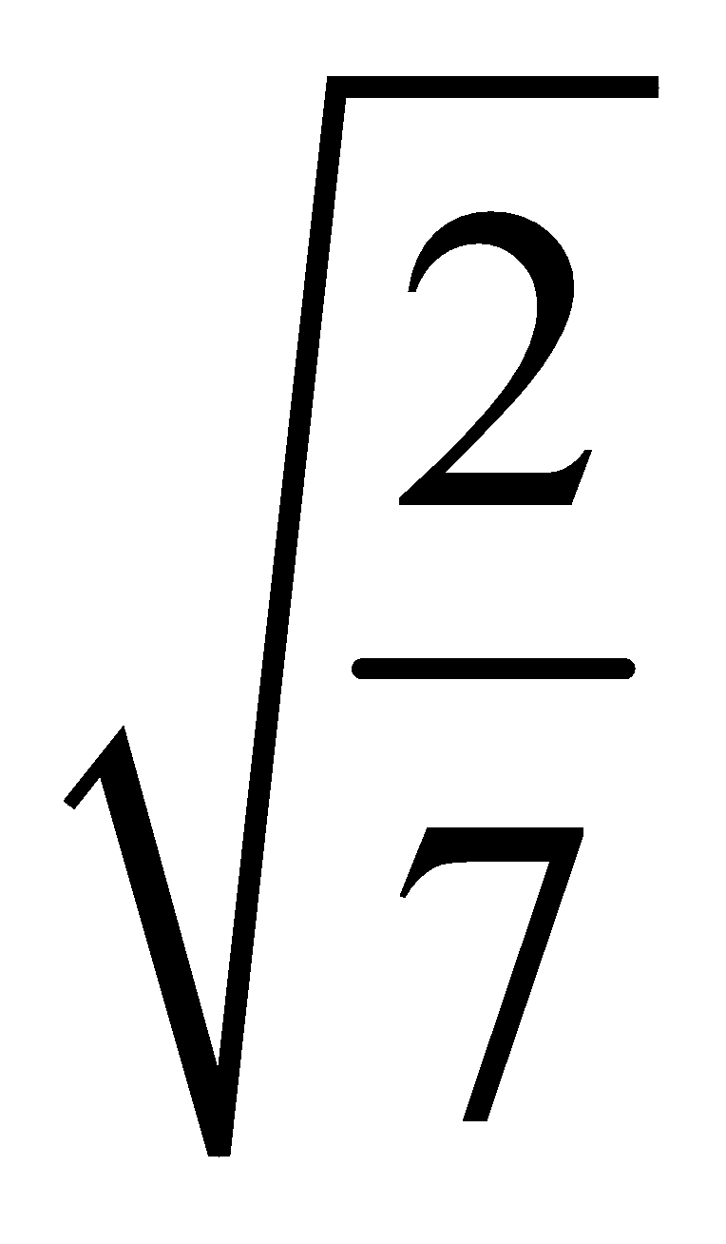

Eg What are the first 15 perfect squares?

The place we usually see square roots or squares is in the area of squares

Eg

The area of the square is 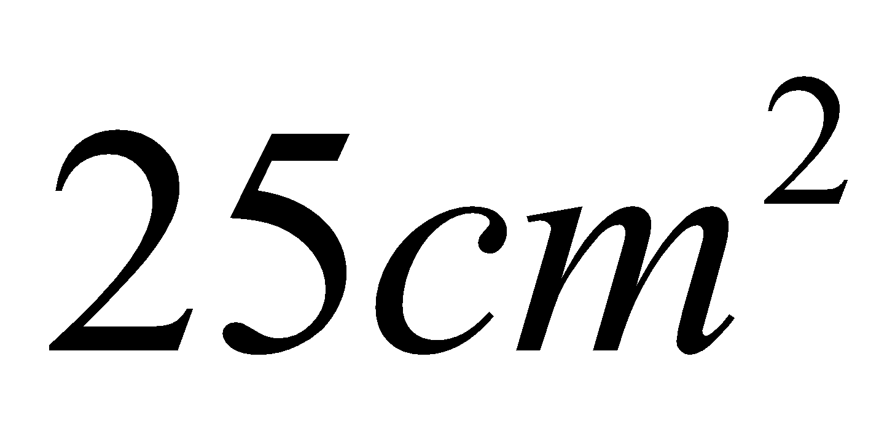 what is the
length of each side.

For each of the following state the area and the length of each side.

Area =

Side length =

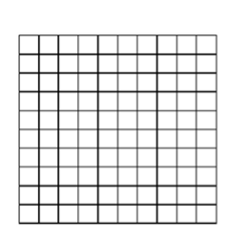

Area=

Side Length=

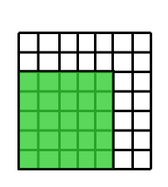
Now for each state the area of the shaded part and calculate the side length of the shaded part.

Area of shaded part =

Side length of shaded part =

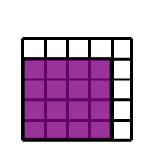
Area of shaded part =

Side length of shaded part =

As you just seen to square root fractions first reduce it if you can. Then you just take the square root of the denominator to make your new denominator and square root your numerator to get your new numerator.

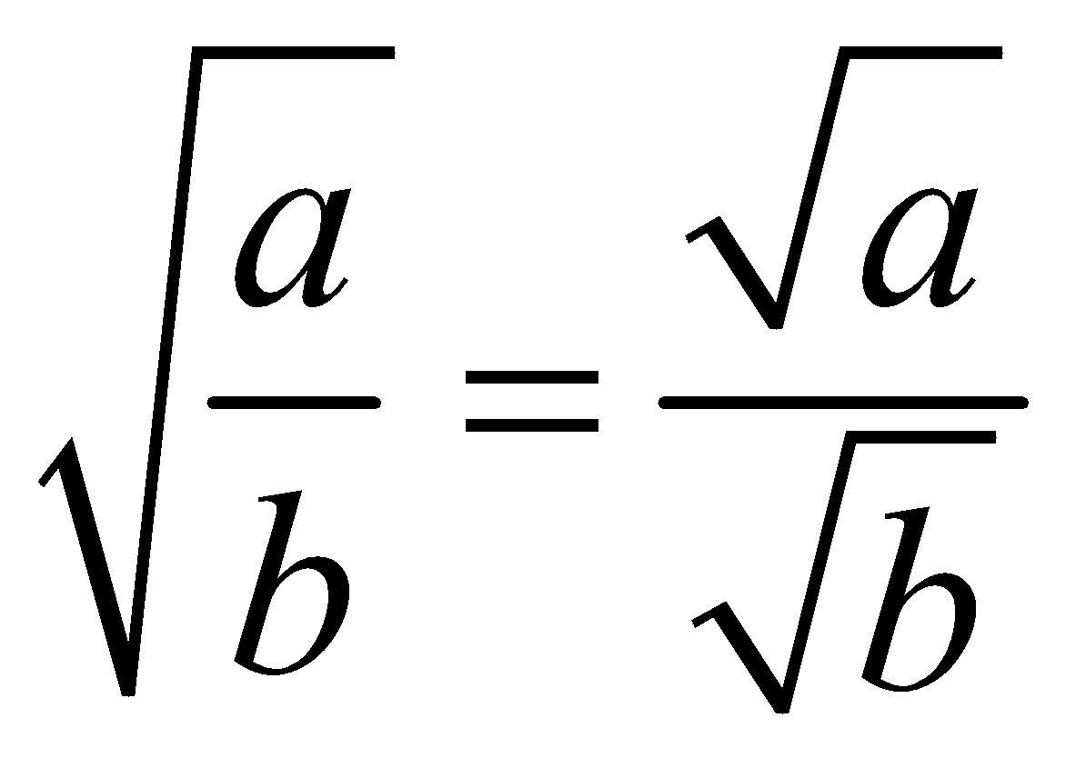

Eg 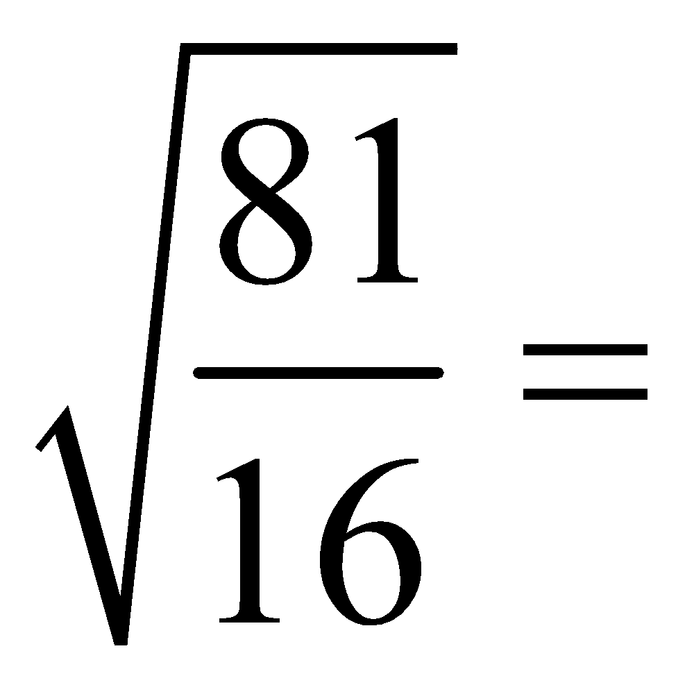 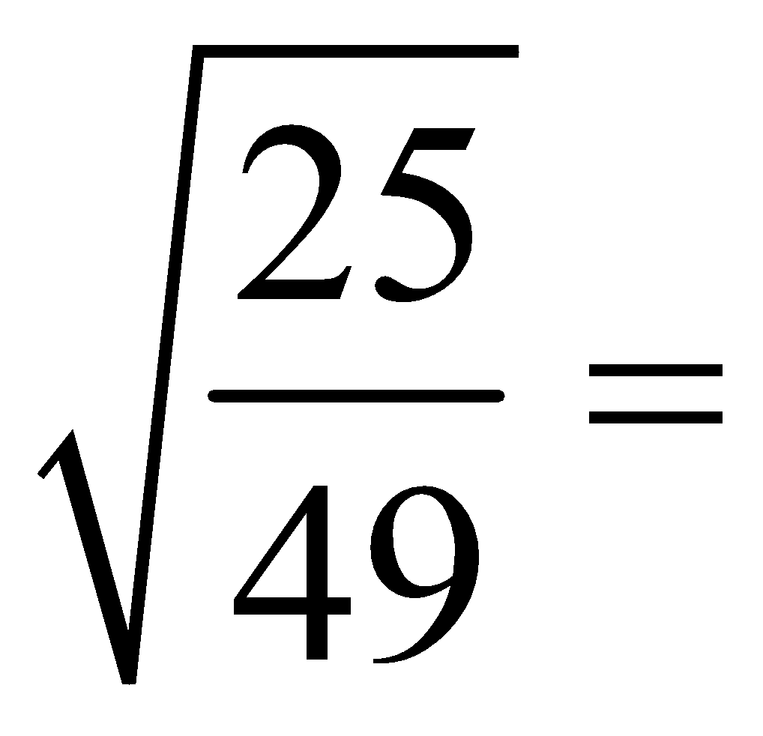

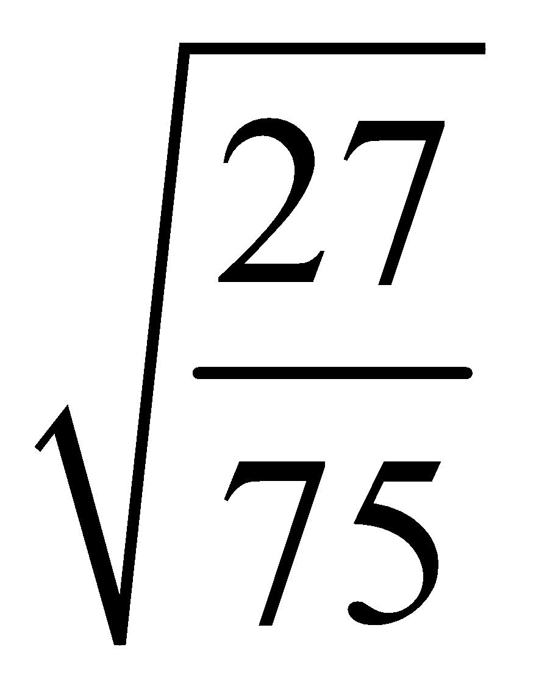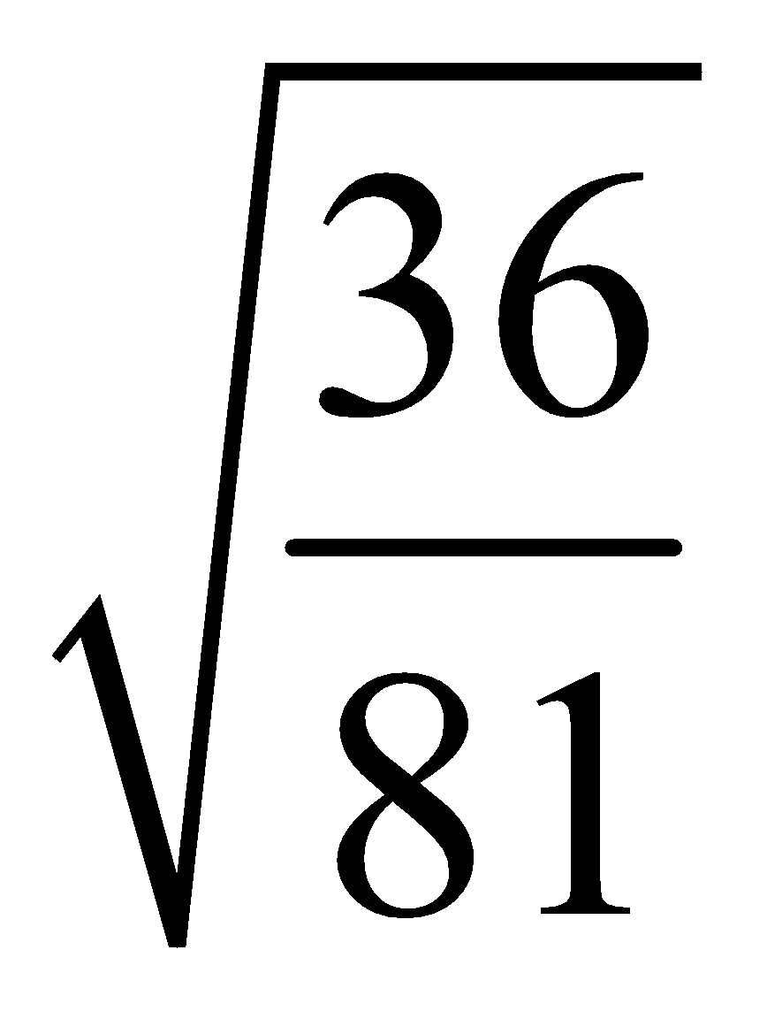

Eg Find the number that has a square root of

7 0.12 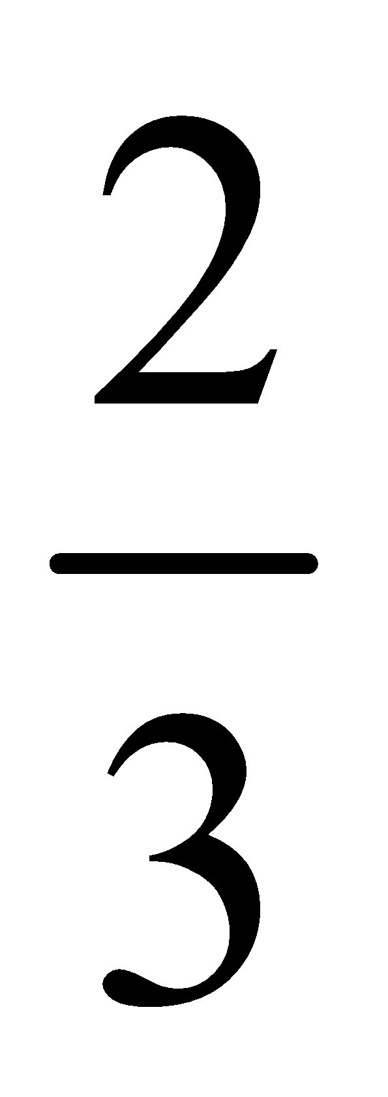

Homework P11 #3-10, 14, 16

