Lesson 1-5: Similar Polygons

Similar figures gave the same shape but not necessarily the same size. But the sides of each figure will be proportional. In other words it must be a scaled diagram.

To do this you look at the ratio of each figure.

Eg Are the following similar?

2m 1m

3m 1.5m

Eg Are the following similar?

2cm

4cm

4cm

5cm

Eg Are the triangles similar?

A E

2 3

3 4.5

B 4 C

F G

6

Notation: If ABC is similar to EFG we write 

This means that A and E correspond, B and F correspond and C and G correspond.

If two figures are similar then you can use the info from one figure to obtain info from the other.

Eg The figures are similar. Find the missing side.

5.2cm 3.1cm

x

11.5cm

Eg Find x and y if ABC ~ FDE

A

12 8 D

9

B C E x

15

y

F

In similar polygons we know that corresponding sides are proportional. But what about the corresponding angles?

Corresponding angles are_____________________ for similar polygons.

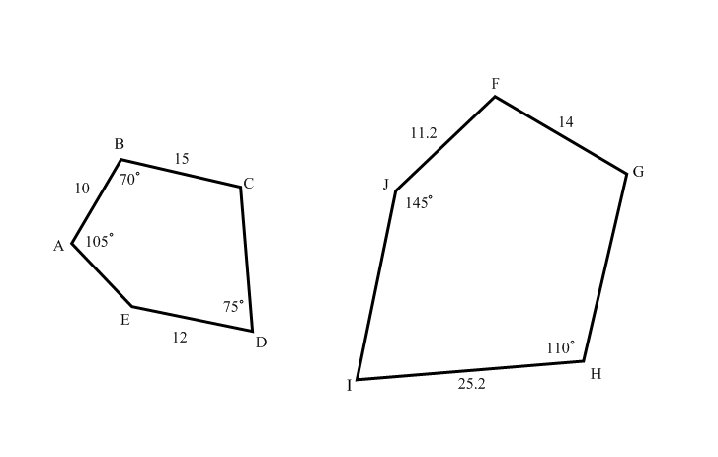Find all missing angles and sides in the figure below if ABCDE~FGHIJ

Homework Pg 341 #4, 9, 11-14, 16