Lesson 4-5 Using Graphs to Estimate Values
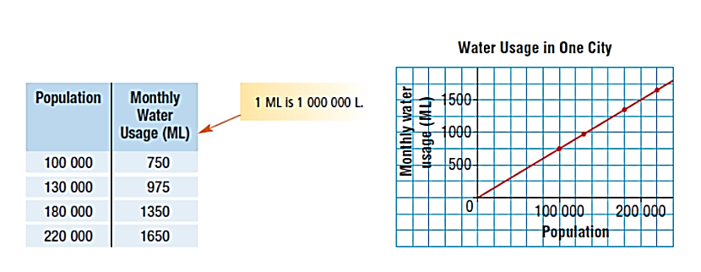
A city has grown over the past few years. This table and graph show how the volume of water used each month is related to the population.

Use these data to:
- Estimate the monthly water usage for a population of 150 000 people.

- Estimate the population when the monthly water usage is 1400 ML

- Predict the water usage for 250 000.

Interpolation and Extrapolation
When are asked to estimate a point that lies between 2 known data points we are using interpolation.
When are asked to estimate a point that lies outside of (or beyond) the known data points we are using extrapolation.

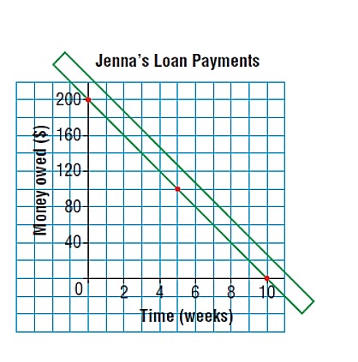
Example 1: Jenna borrows money from her parents for a school trip. She repays the loan by making regular weekly payments. The graph shows how the money is repaid over time. The data are discrete because payments are made every week.
a) How much money did Jenna originally borrow?

b) How much money does she still owe after 3 weeks?

c) How many weeks will it take Jenna to repay
one-half of the money she borrowed?

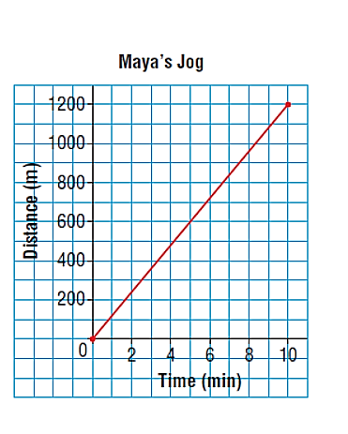
Example 2: Maya jogs on a running track. This graph shows how far she jogs in 10 minutes. Assume Maya continues to jog at the same average speed.
Use the graph:
a) Predict how long it will take Maya to jog 2000m.

b) Predict how far Maya will jog in 14 min.

c) What assumption did you make?

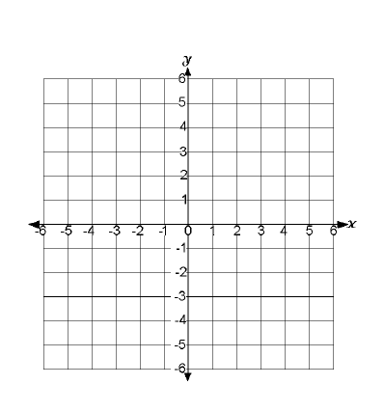
Example 3: Use this graph of a linear relation.
- Determine the value of x when y=3

- Determine the value of y when x=-4

Big Ideas:
- What is interpolation? When do we use it?

- What is extrapolation? When do we use it?

- When we extrapolate, why is it important to know that the data represents a linear relation?

- What problems might there be if you extrapolate far beyond the last data point?

Homework P 196 #4-11

