Math 9 Lesson 5-4: Order of Operations with Rational Numbers

From before we know that the order of operations is BEDMAS

- 0.5 x 2.3 + 12.5 3.2

- 9.8 (-2.4) – 6.9 + 1.3 x 4.5

- 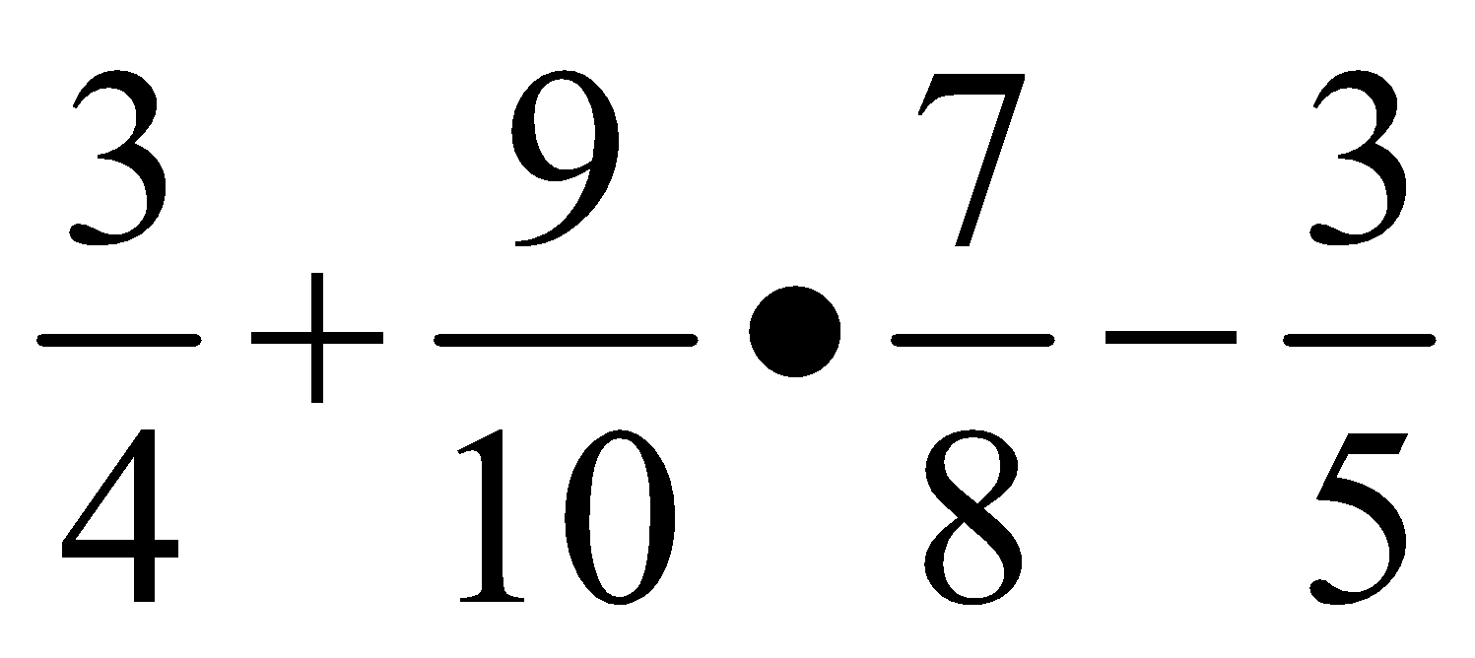

- 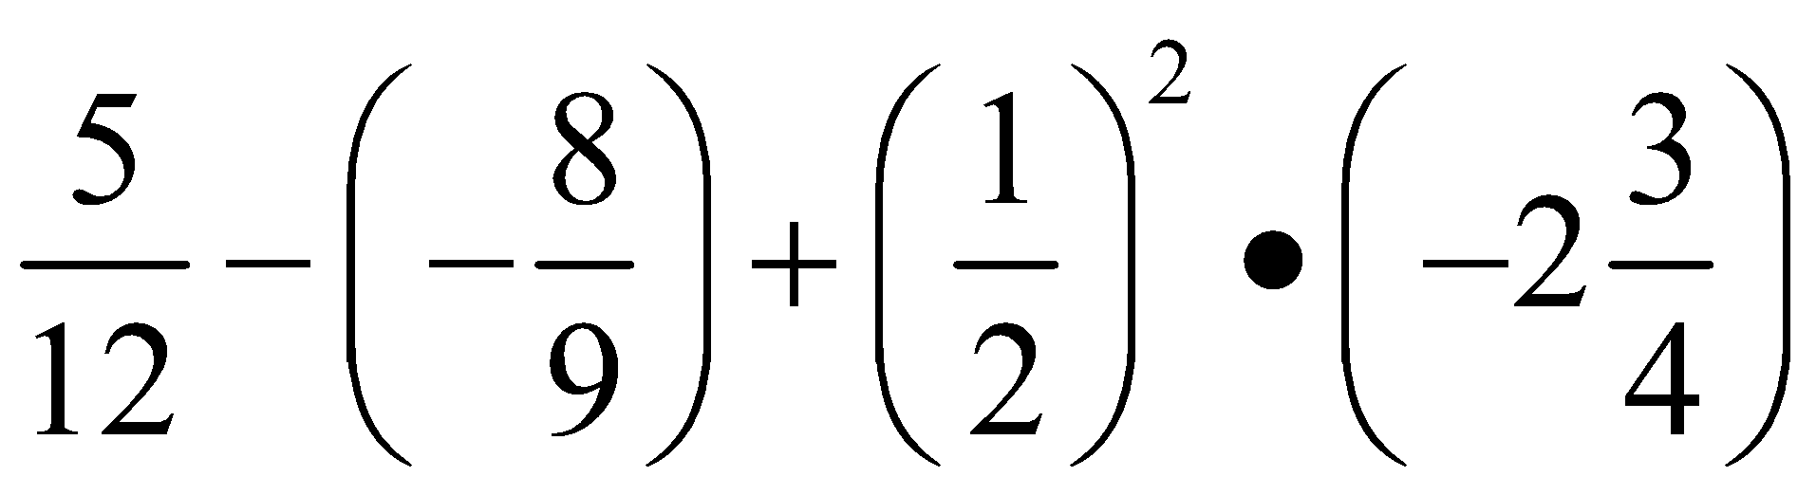

- 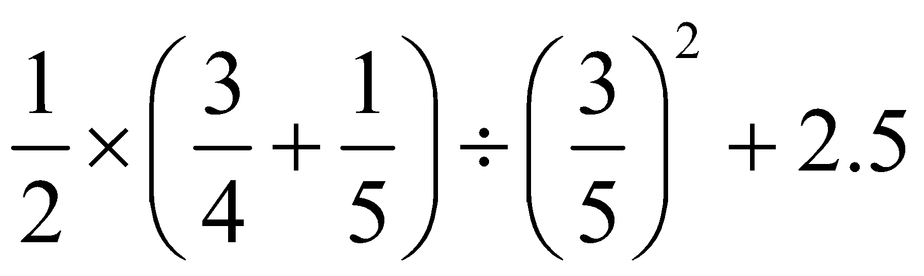

- 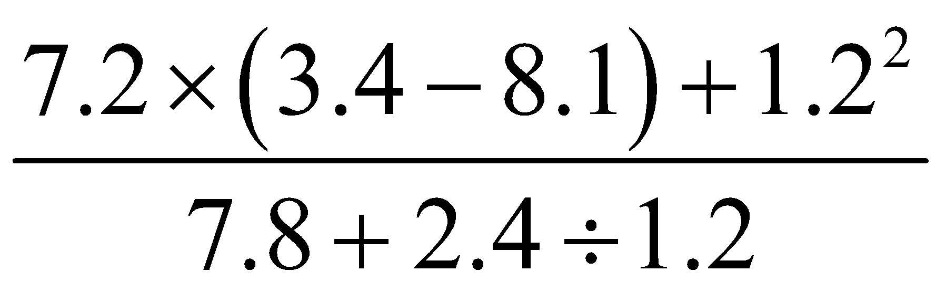

Homework P140 #3, 4, 7-14, 17

