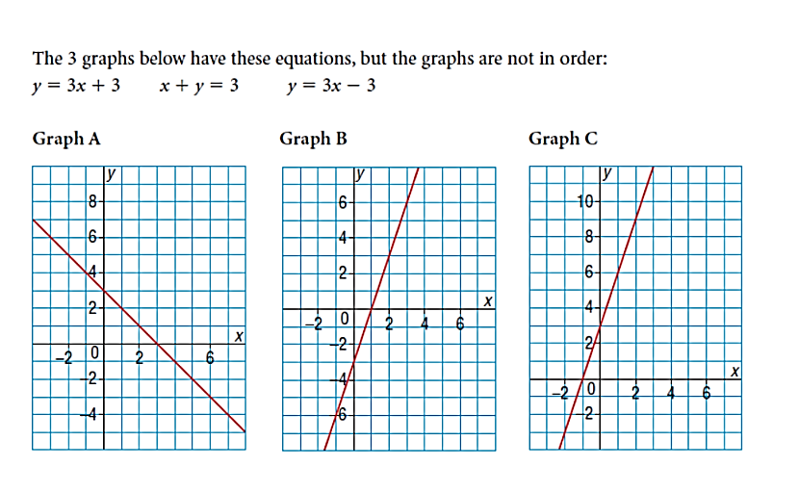**Lesson 4-4 Matching Equations and Graphs**

How can we figure out which graph belongs to which equation?

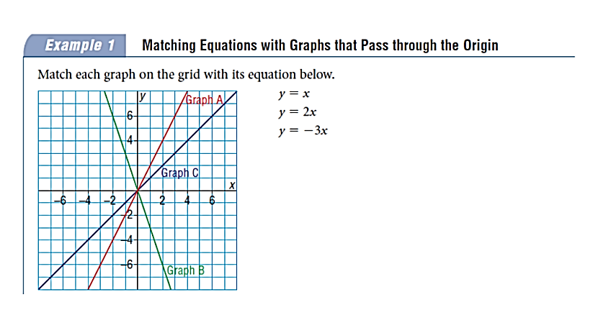

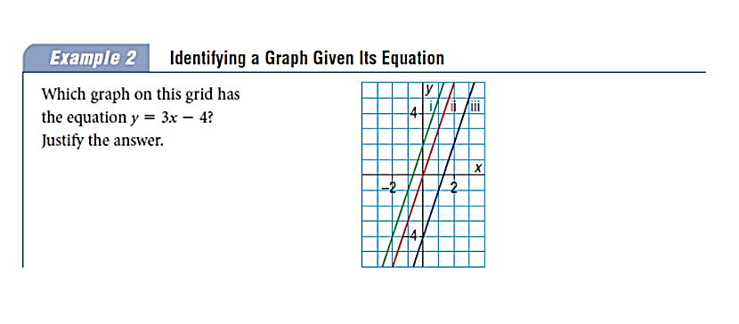

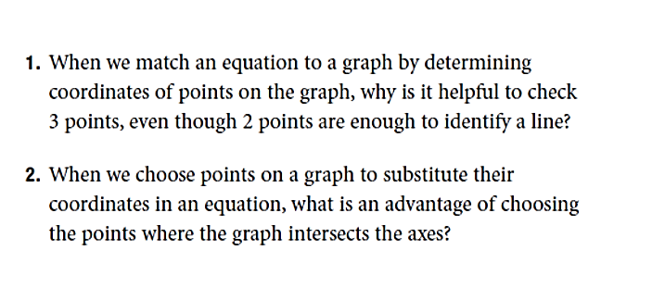

**Big Ideas:**

Homework P 188 #3-8, 11