Math 9 Lesson 1-4 Enlargements and Reductions
Scale Diagrams
A diagram that is an enlargement or a reduction of another diagram is called a ____________________. Can you think of anywhere in real life where we would enlarge an object? Reduce an image?
On a scale diagram, we look at sides that match (ie the same side of the diagram in the original and the scale diagram). These are called ________________________________________.
The measure of how much bigger or smaller the scale diagram is compared to the original is called the ____________________________. Scale factor is always calculated the same way, but can be represented in several different ways on a diagram. (fraction, decimal, ratio)
To calculate scale factor, we create and simplify the fraction below:
Length of side on scale diagram
Length of same side on original diagram

This can be written as a reduced fraction, as a decimal, converted to a percent, or written as a ratio.
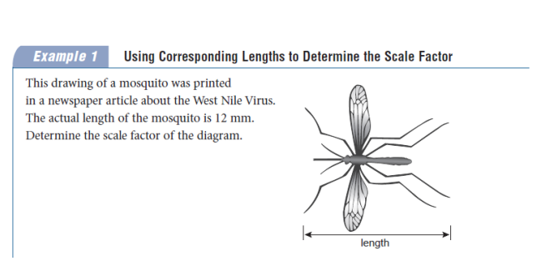
**Be sure that the units are in the same unit before you perform this calculation

Solution:

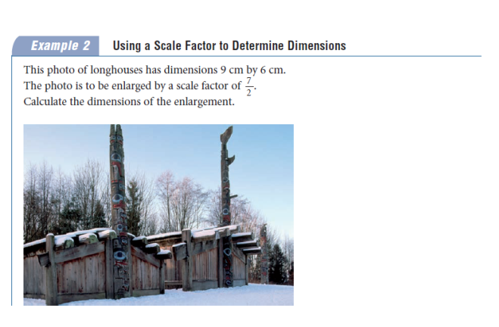

Solution:

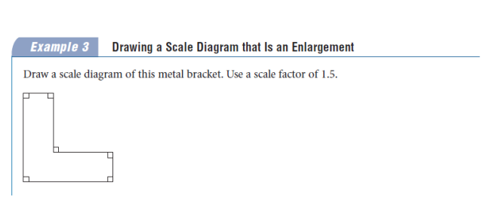

Solution:

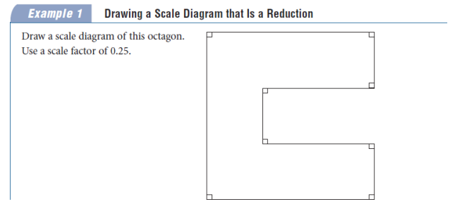

Big Ideas
- To calculate scale factor, we find the fraction
$$\frac{length of side on scale diagram}{length of side on original diagram}$$

- If the scale factor is larger than 1 :

- If the scale factor is less than 1 :

- In order for a diagram to be a scale diagram, all corresponding lengths between the original diagram and the new diagram must have the same scale factor fraction. If the scale diagram is larger than the original diagram it is called an enlargement. If the scale diagram is smaller than the original diagram it is called a reduction.

Homework Pg 323 #4,5,7,8,11,12
Pg 329 #5-8, 10, 12,13, 15, 20

