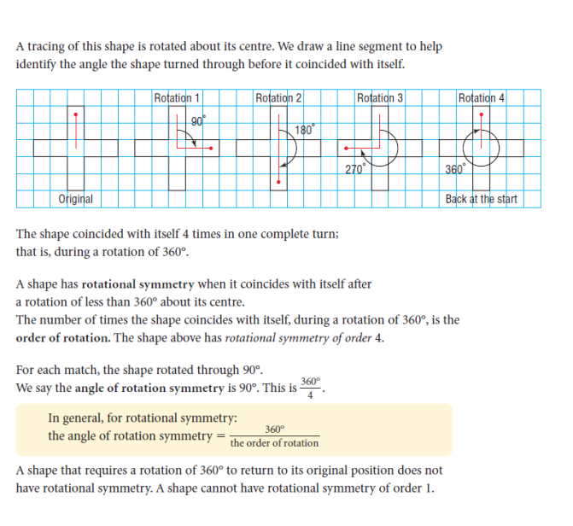
Math 9 Lesson 1-3 – Rotations and Symmetry

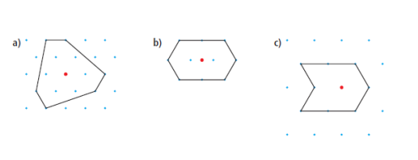
Example 1: Determine which of the following have rotational symmetry. State the order of rotation and the angle of rotation.

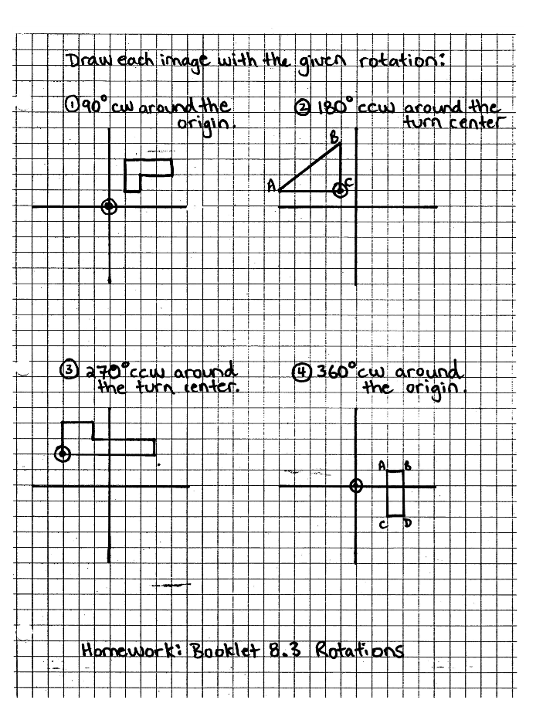
Example 2

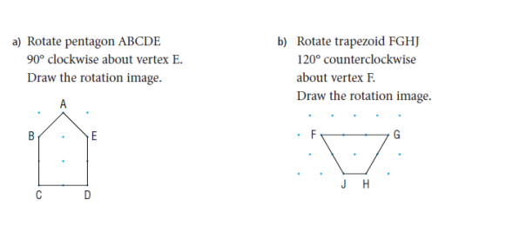
Example 3:

Big Ideas:
Remember, a turn is defined by the degree of rotation, the direction of the rotation and the location of the rotation center (can be the center, or any vertex or a point not touching the object). You must state all 3 pieces of information.
Angle of rotation is the number of degrees an object must rotate before it coincides with itself. (360˚ divided by the order of rotation)

Now try your assignment page 365 #4-10

