Lesson 4-3 Vertical and Horizontal Relations
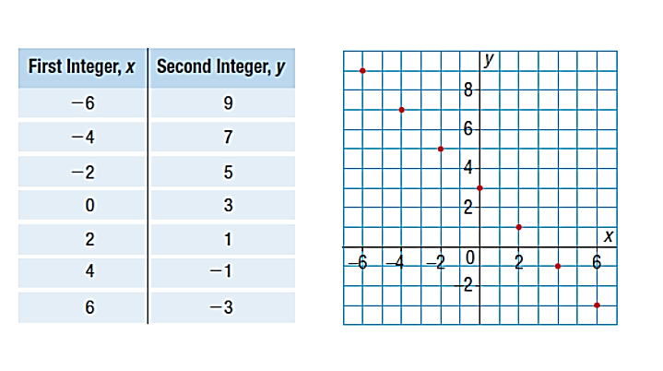
Two integers have a sum of 3. Let x and y stand for the two numbers. Fill in the table below based on this relationship and graph the data points.

The points lie on a straight line so the relation is linear.
We can write this linear relation as: First integer + second integer = 3
Then, the linear relation (or equation) is x + y = 3
This equation has both variables on the left side of the equation. (means the same as y = 3 – x)

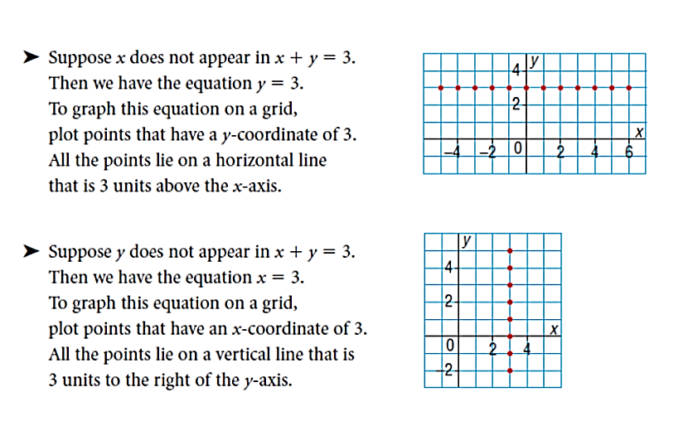
BUT…..
Suppose one variable doesn’t appear in the equation.

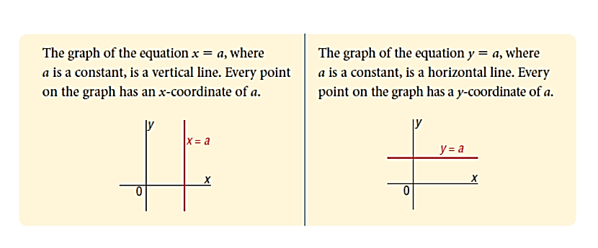
BIG IDEA *****:

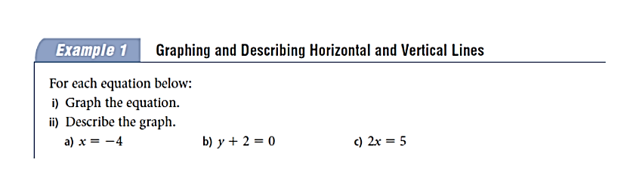

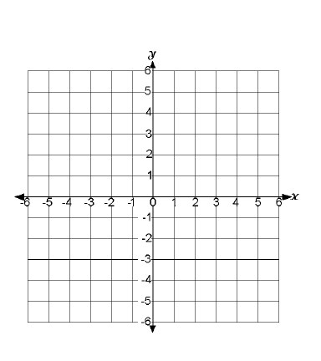

b)

-

c)

Graph each of the following equations

- $2x+y=1$ b) $6x+3y=-12$

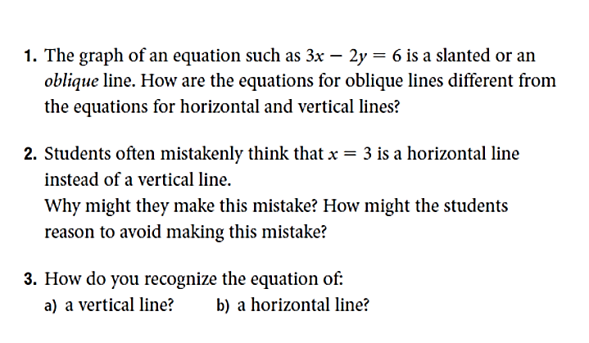
The big Idea:

Homework pg 178 #4, 7, 9, 11

