Math 9 Lesson 1-2 – Line Symmetry
What is symmetry?

How many lines of symmetry do each of the following have?
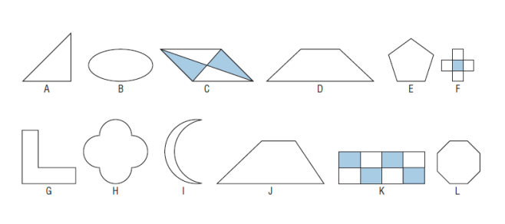

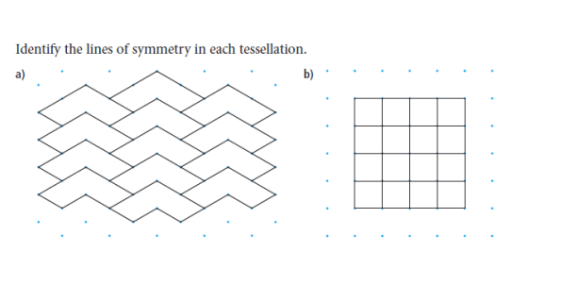
A line of symmetry is also called a line of reflection.
Example 1:

The line of symmetry doesn’t necessarily have to be on a shape. For example, if you were to look in a mirror, the mirror is the line of symmetry. However, you will be standing the same distance away from the mirror in your reflection. Same goes for shapes; we can have a line of symmetry between two congruent shapes.

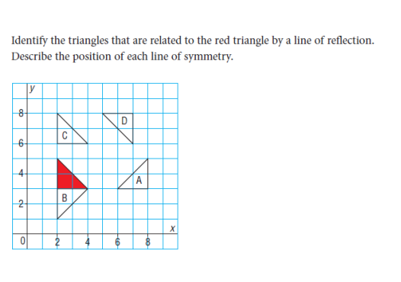
Example 2:

A:

B:

C:

D:

We can also use a coordinate grid to draw shapes and their reflection images. We always label the corresponding vertices in the image with the same letters, but add a little ‘tick’ mark next to it to show that it’s not the original.
Example 3: Draw the image of each quadrilateral after the reflections given below:
- A reflection in the horizontal line through 2 on the y axis

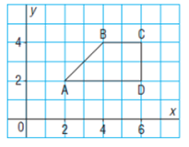

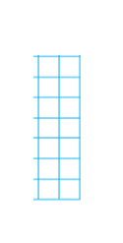
- A reflection in the vertical line through 6 on the x axis

- A reflection in an oblique line through (0,0) and (6,6)

We could also be asked to translate and object which means simply sliding it from one place to another. We typically use mapping notation to tell us where to move to
Example: (xx + 3, yy -4) would mean translate each vertex horizontally 3 units to the right, and vertically 4 units down.
Translate the following image using the directions given :
(xx - 2, yy + 1)

Big Ideas:
- How do you identify whether a shape has a line of symmetry?

- How are a line of reflection and a line of symmetry related?

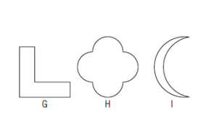
Assignment page 358 # 4, 5, 9, 10

