Math 9 Lesson 5-2 Adding/Subtracting Rational Numbers

Fractions can be written in two ways

- Mixed fraction
Eg 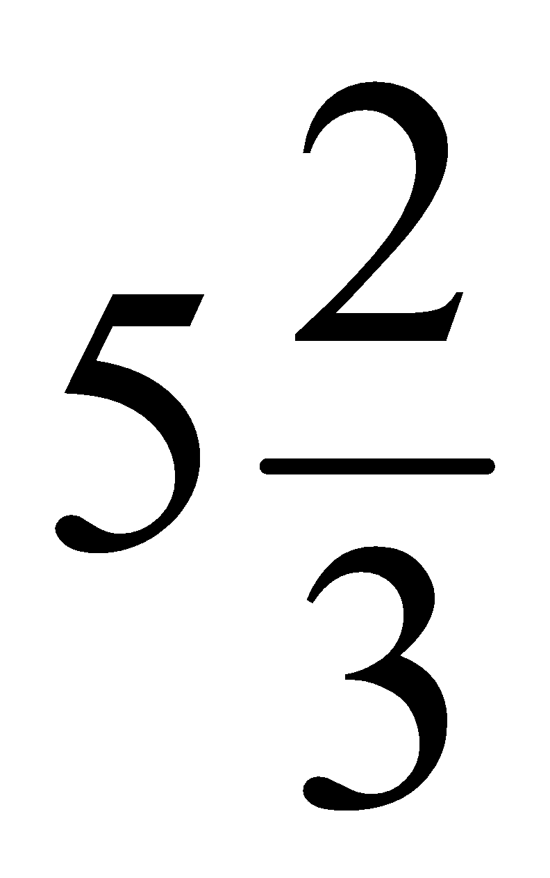 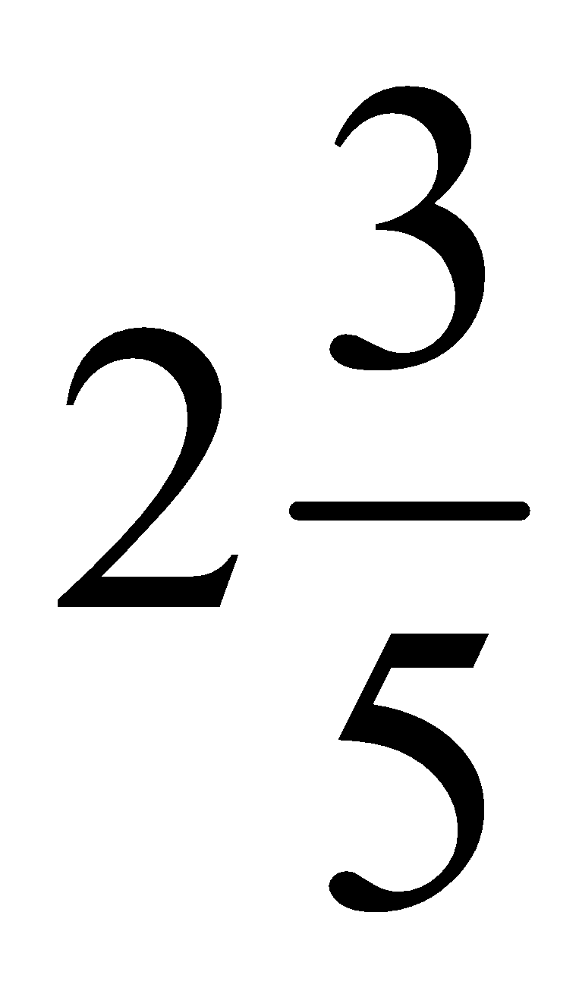

- Improper fraction: the numerator is larger than the denominator.

Eg 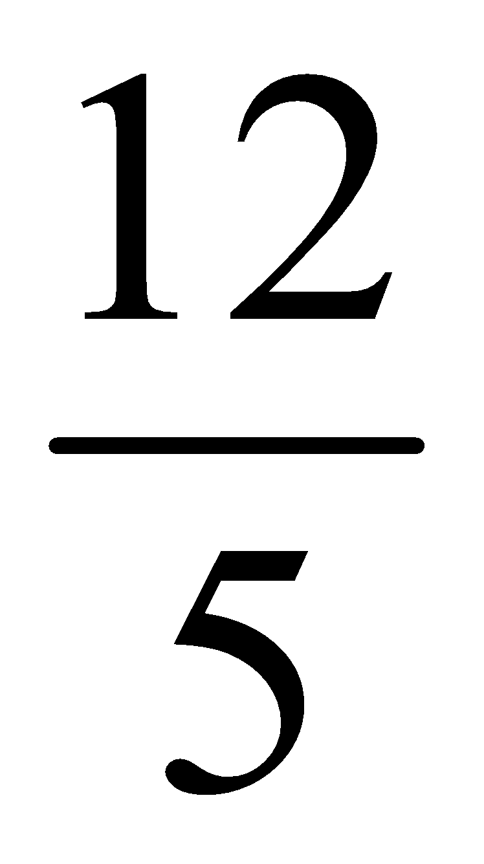

Change each of the improper fractions into mixed fractions

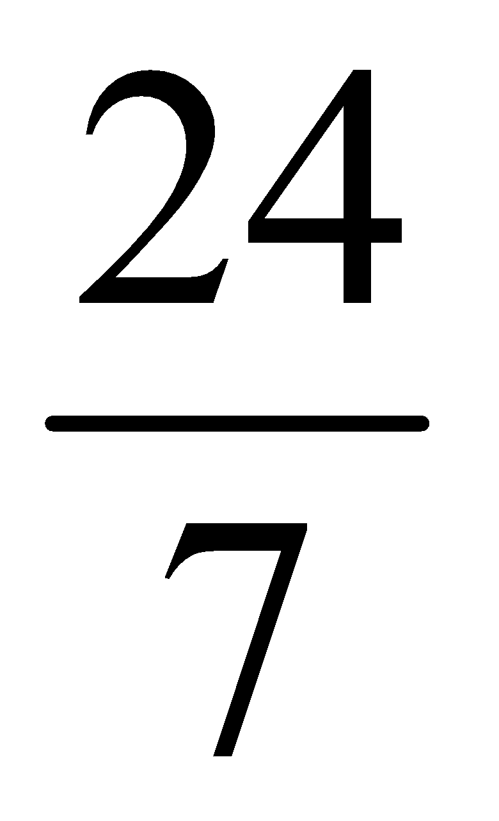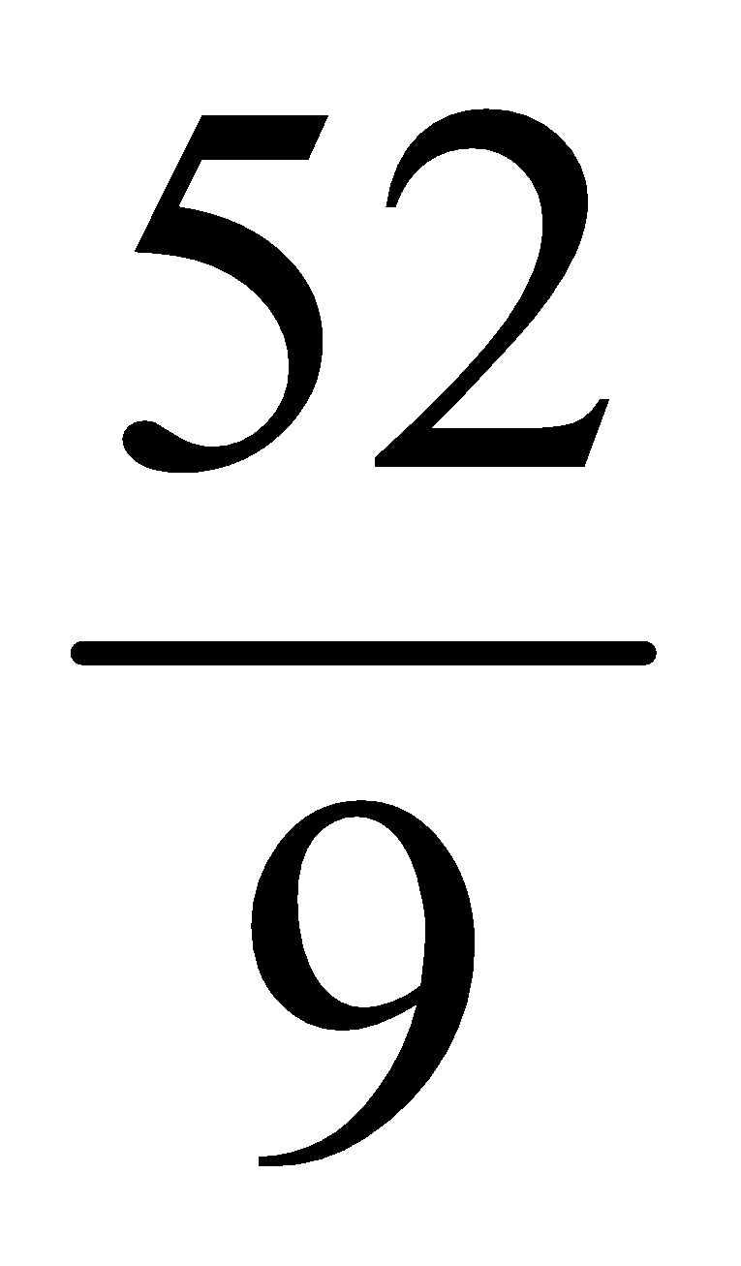

Change each of the mixed fractions into improper fractions

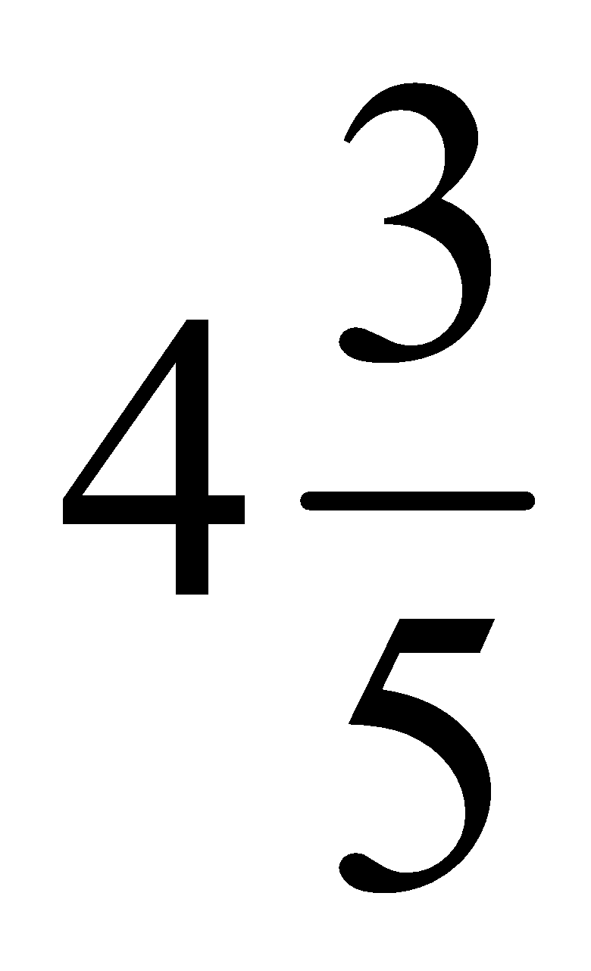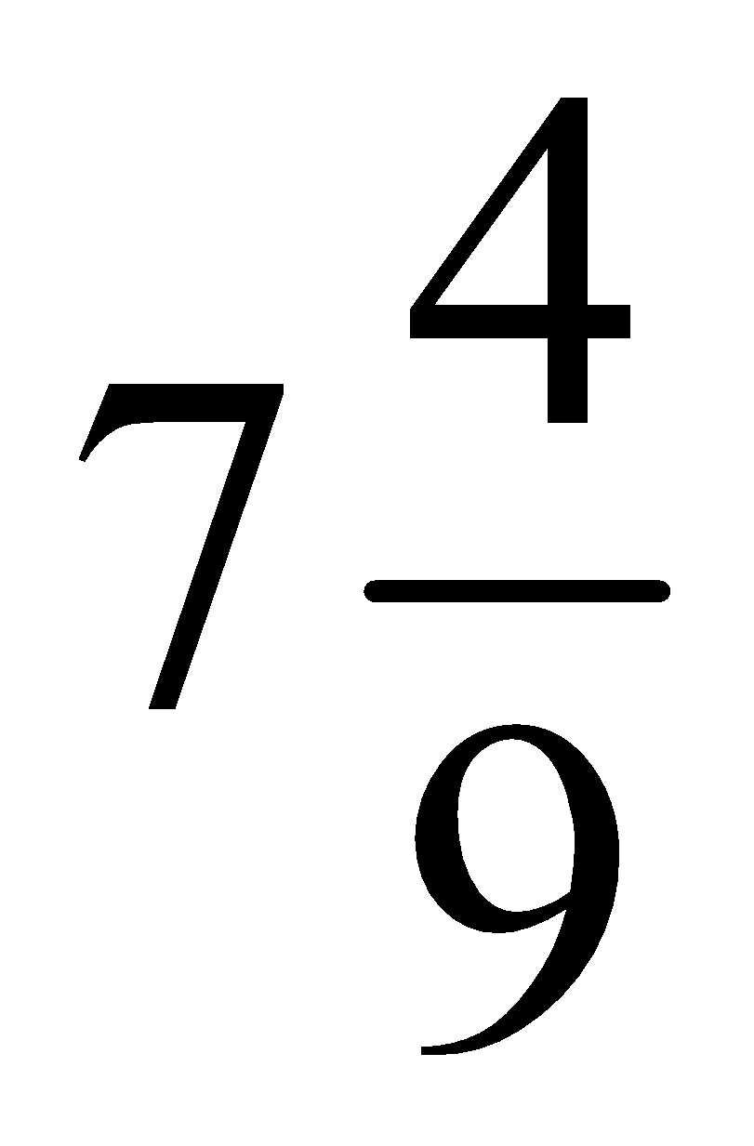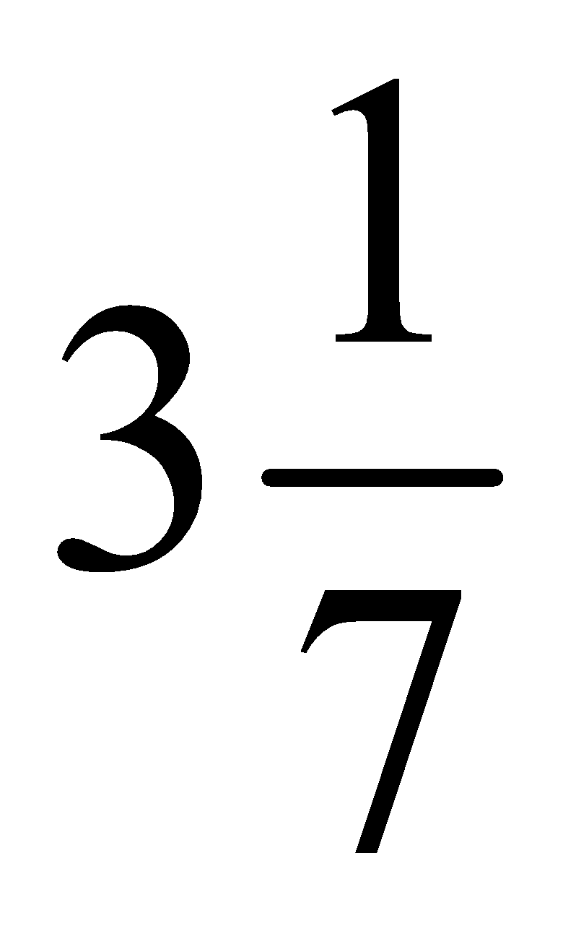

Adding and Subtracting decimals: just make sure you line up the decimals

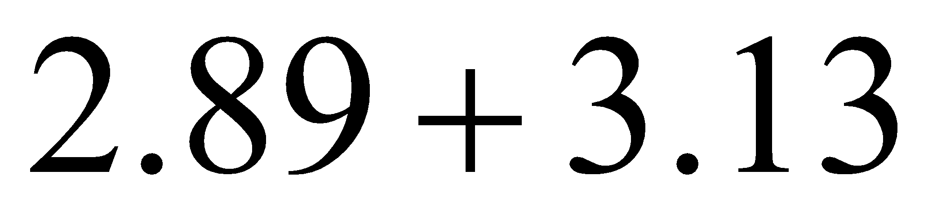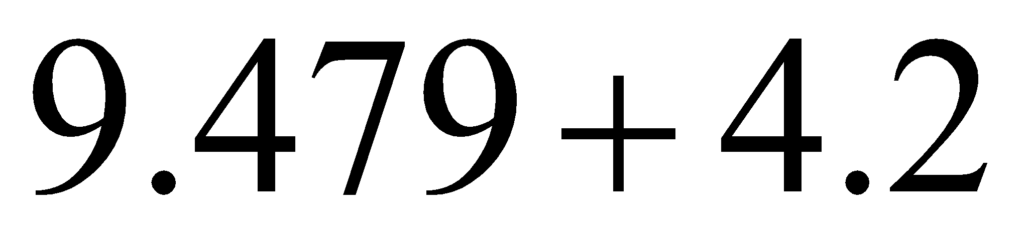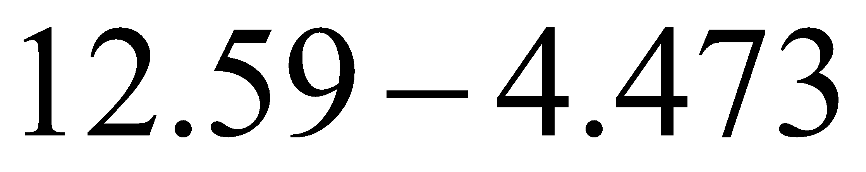

Adding and Subtracting Fractions:
- Find a common denominator
- Make equivalent fractions
- Add or subtract numerators to get new numerator
- Keep the same denominator

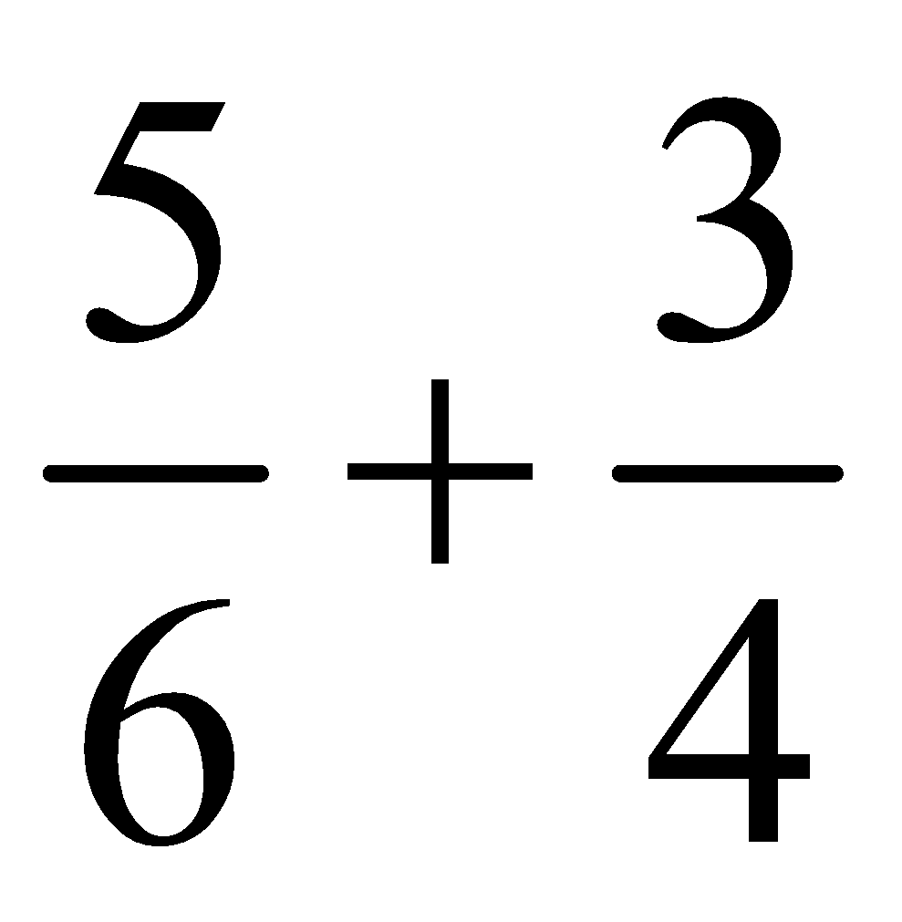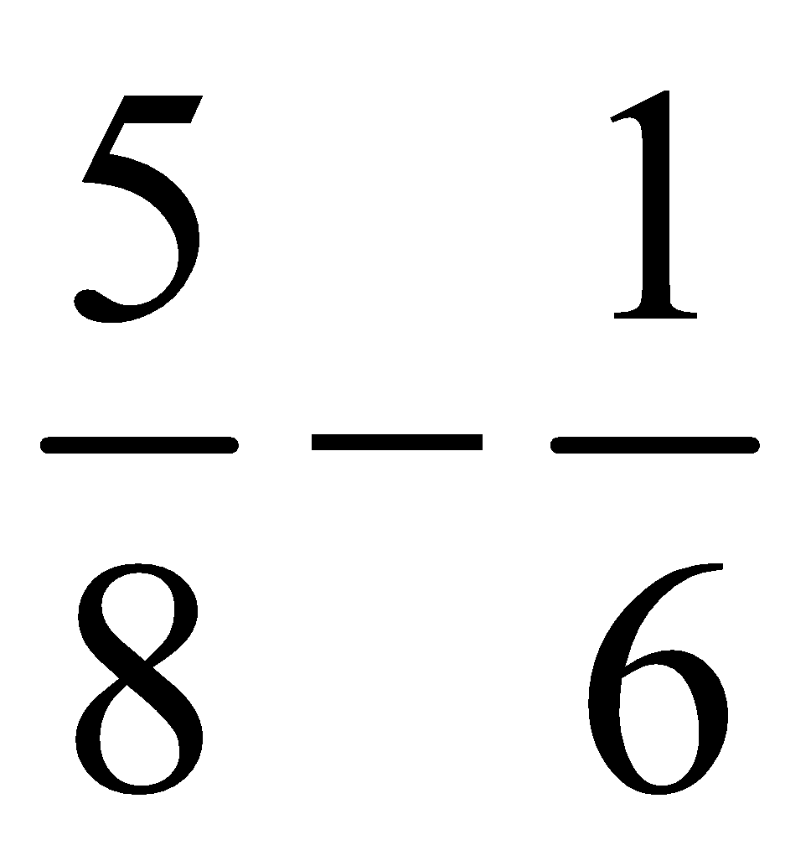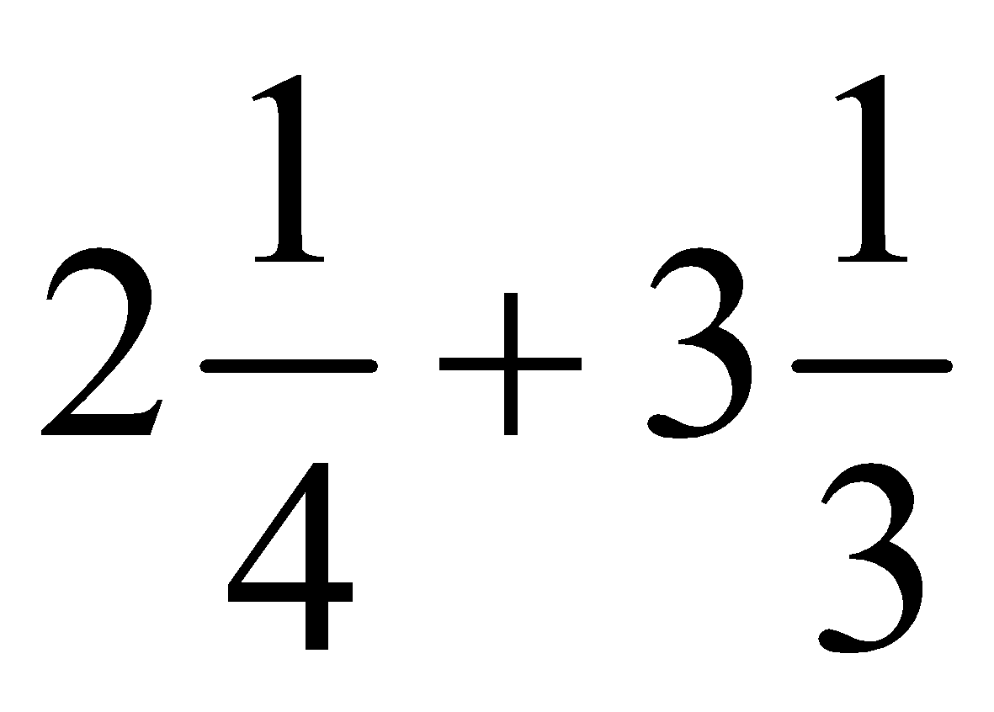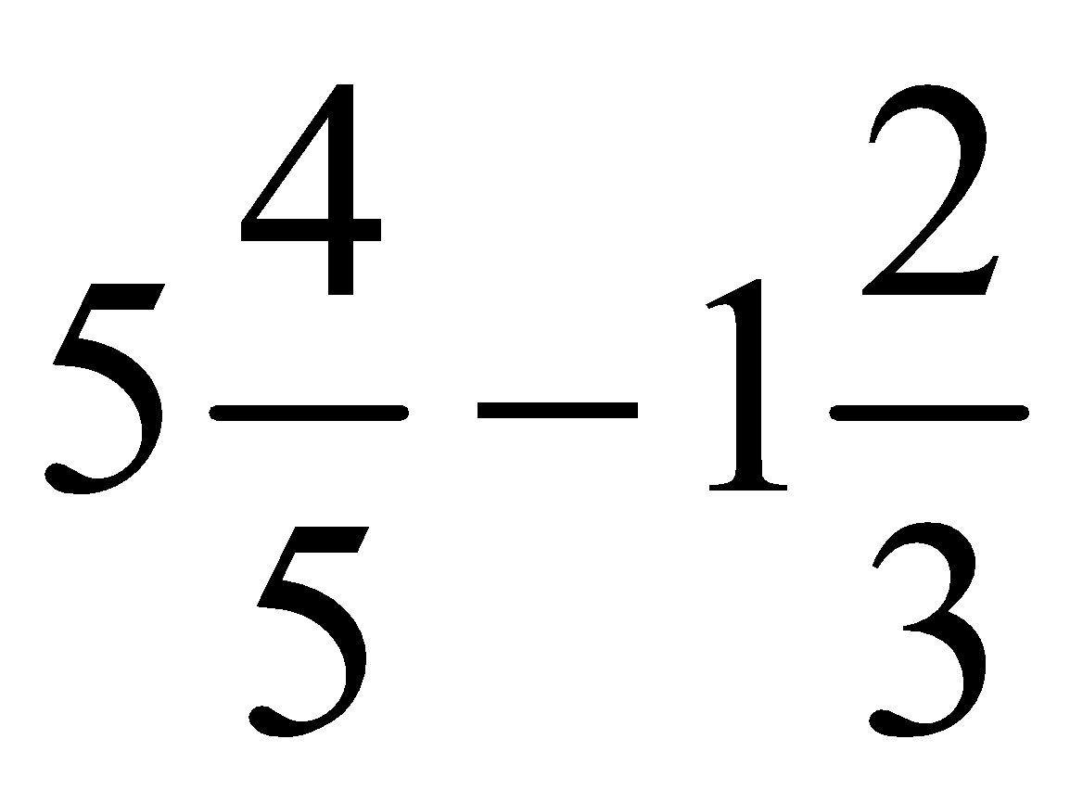

Homework P111 #5-7, 10, 11acegi, 13, 14, 15ab, 17bc
P 119 #3, 5, 7-9, 13

