Math 9: Lesson 5-13More Surface Area of Composite Figures
Today we are going to continue what we did yesterday with more than 2 shapes.

Eg How much icing will you need for this 3 tiered cake?

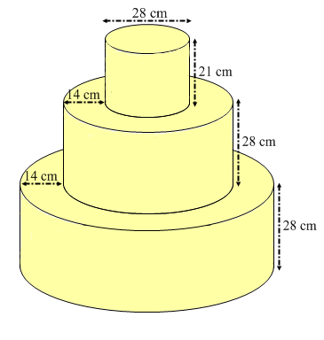

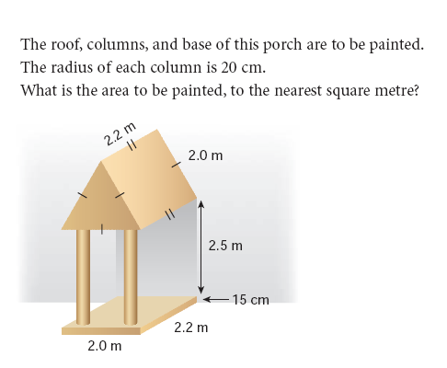

Homework Pg 40 #4b, 9, 12, 15

