Math 9: Lesson 5-12 Surface Area of Composite Figures
A composite figure is a 3D object made of multiple objects. To find the surface area you must add or subtract all the areas together.

Find the surface area of the following composite figures

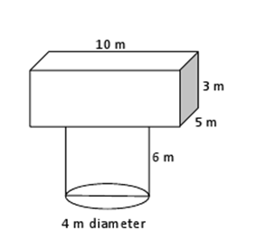

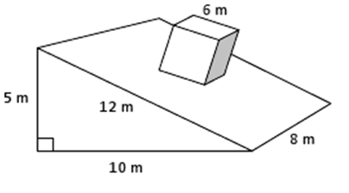

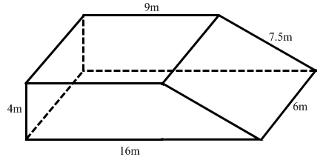

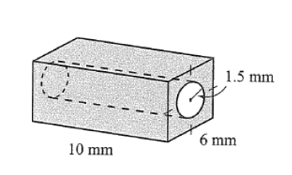

Homework P40 #3, 4ac, 5-8, 11

