Math 9 Lesson 3-11 Solving Linear Inequalities

Review: Graph the following

a) x > 5 b) 11 > b

c) –2 < d+4 d) f - 2< 7

To solve inequalities you must first solve for the variable the same way as you did when there was an equal sign with one difference.

***Whenever you multiply or divide by a negative
number the inequality sign must change.***

Hint: move the variable to the left side of the equation

Solve and graph each

a) 2x < 7x + 15

b) 2 + 3a < a – 18

c) 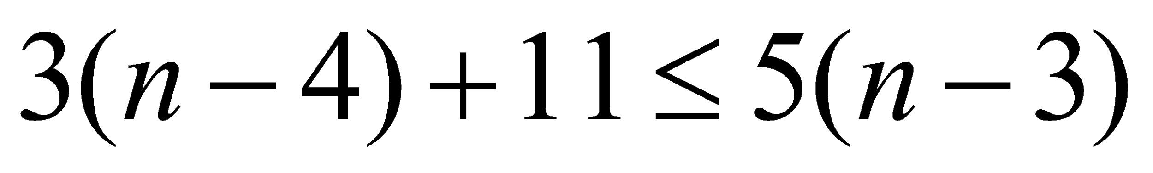

Word Problems

Sound travels through aluminum at 63000m/s. This speed is at least 900 m/s less than 3 times the speed of sound through lead. Solve the inequality 3s – 900 < 6300 to find the speed of sound through lead.

At Friends & Family night at Marks Work Warehouse customers receive 20% off storewide. If you have $200 to spend, how much can you buy at regular price?

Three test scores were 68%, 83%, and 72%. What score would you need to get on the next test to receive honors in this course if all the tests are weighted the same?

A taxi charges a base fee of $5.25 and then $0.15 per min. If bill has $25 how long can he be in the taxi?

Homework Pg 305 #7-13

