Math 9 Lesson 5-10 Surface Area of Prisms
Surface area is the total area of all the sides in a 3D object added together.
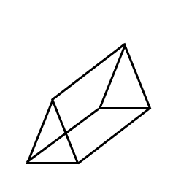
Prisms are geometric figures having bases or ends that are parallel, congruent polygons and sides that are parallelograms

Eg

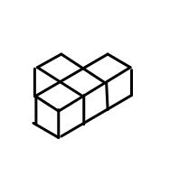
Using blocks where each side is 1cm. What is the surface area of?

Using blocks where each side is 3cm. What is the surface area of?

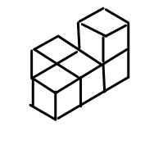

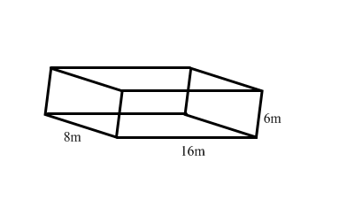
Eg find the surface area of each of the following.

5cm

12cm

2cm

