Math 9 Lesson 3-10: Introduction to linear inequalities
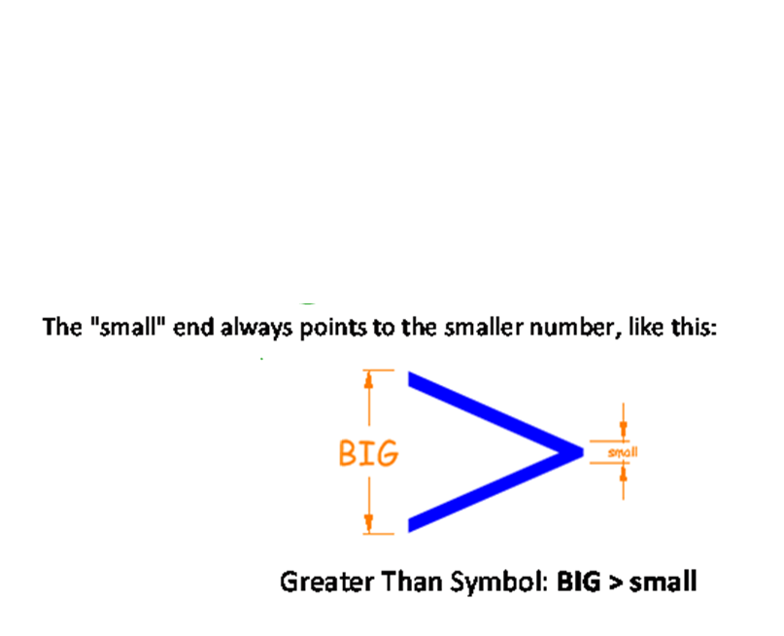
Inequalities signs

Define a variable, and then write an inequality that describes each situation.

You must be 18 years of age to vote.

A person must be at least 90 cm tall to go on an amusement park ride.

Horton can spend a maximum of $50

A game is recommended for players 5 years old.

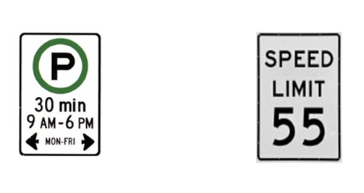

Note: We can illustrate the solutions of an inequality by graphing them on a number line. For $a>3$ , the solution is all the numbers greater than 3. Since 3 is not part of the solution, we draw an open circle at 3 indicates this.
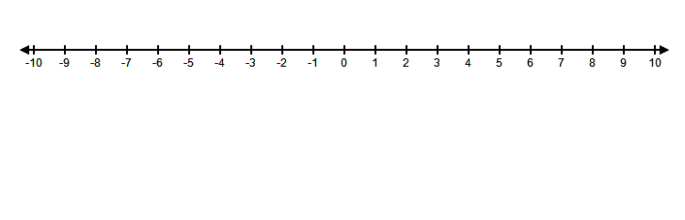
For , the solution is all the numbers less than or equal to . Since is part of the solution, we draw a shaded circle at to indicate this

Write the inequality represented by each number line.
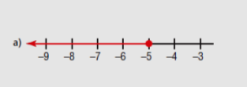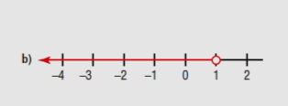
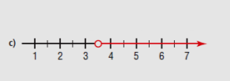
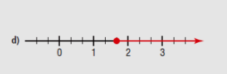

Example 1: Joel currently has a balance of $212.35 in his bank account. He must maintain a minimum balance of $750 in the account to avoid paying a monthly fee. How much money can Joel deposit into his account to avoid paying this fee?

Choose a variable, then write an inequality that can be used to solve this problem.

Solve the problem

Graph the solution

Example 2: Jake plans to board his dog while he is away on vacation.
Boarding house A charges $90 plus $5 per day.
Boarding house B changes $100 plus $4 per day.
For how many days must Jake board his dog for boarding house A to be less expensive than boarding house B?

Choose a variable and write an inequality that can be used to solve this problem.

Solve the problem

Graph the solution
Example 3: Teagan is saving money to buy a snowmobile helmet. One weekend, she earned $20 to add to her savings, but she still did not have the $135.99 she needed for the helmet.

Choose the variable, and then write an inequality to represent this situation.

Solve the inequality. What does the solution represent?

Verify the solution and graph it on a number line.

Home work pg 292 # 3-6 ,8 ,9 ,12

