Name _____________________________ |  |  | Date ___________________

Lesson 10 Assignment

Pg 30 #4-6
Find the surface area of each figure.
1. 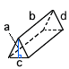 a = 21 cm b = 42 cm c = 40 cm d = 29 cm | 2. 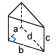 a = 5 mm b = 12 mm c = 9.1 mm d = 13 mm | 3. 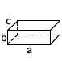 a = 23 in b = 2 in c = 6 in
4. 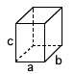 a = 3.4 mm b = 5.8 mm c = 5.8 mm | 5. a = 27 cm b = 32 cm c = 27 cm | 6. a = 4 in b = 16 in c = 6 in d = 5 in
7. a = 35 cm b = 43 cm c = 24 cm d = 37 cm | 8. a = 35 cm b = 15 cm c = 21 cm | 9. a = 33 mm b = 56 mm c = 9.5 mm d = 65 mm

