Lesson 1-10: Properties of Angles in Circles

Definitions

Major Arc vs. Minor Arc

Semicircle

Inscribed Angle Central Angle

Central and Inscribed Angle Prosperity: The measure of a central angle is twice the measure of an inscribed angle subtended by the same arc

Angles in a Semicircle Property: An angle inscribed on a semicircle is a right angle

Inscribed Angle Property: Inscribed angles subtended by the same arc of a circle are equal

Eg

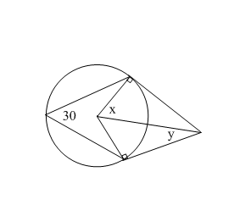

Homework Pg 410 #4-6, 9, 11

