Rational Numbers:

Natural Numbers:

Whole Numbers:

Integers:

Rational Numbers:

Irrational Numbers:

Real Numbers:

Classify each of the following numbers

-7 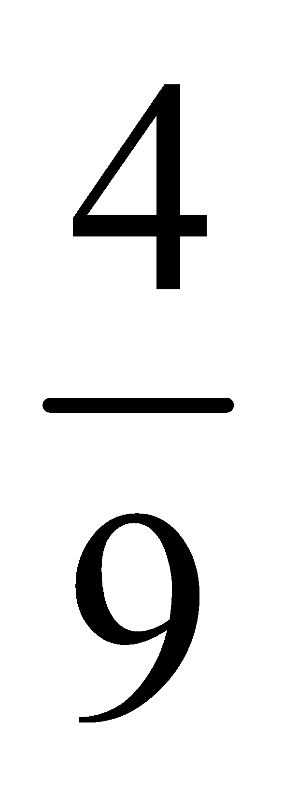

4.87 0

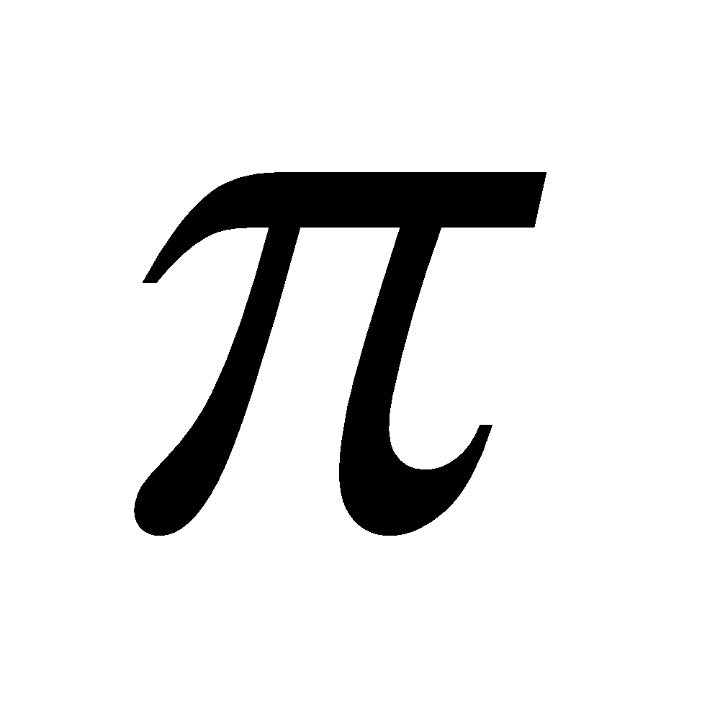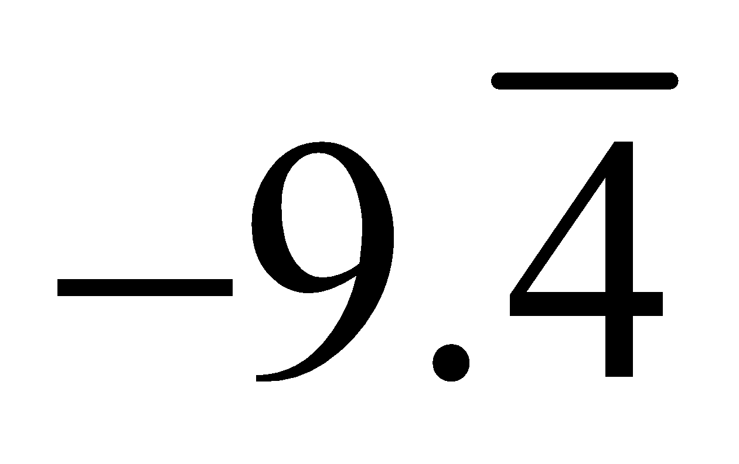

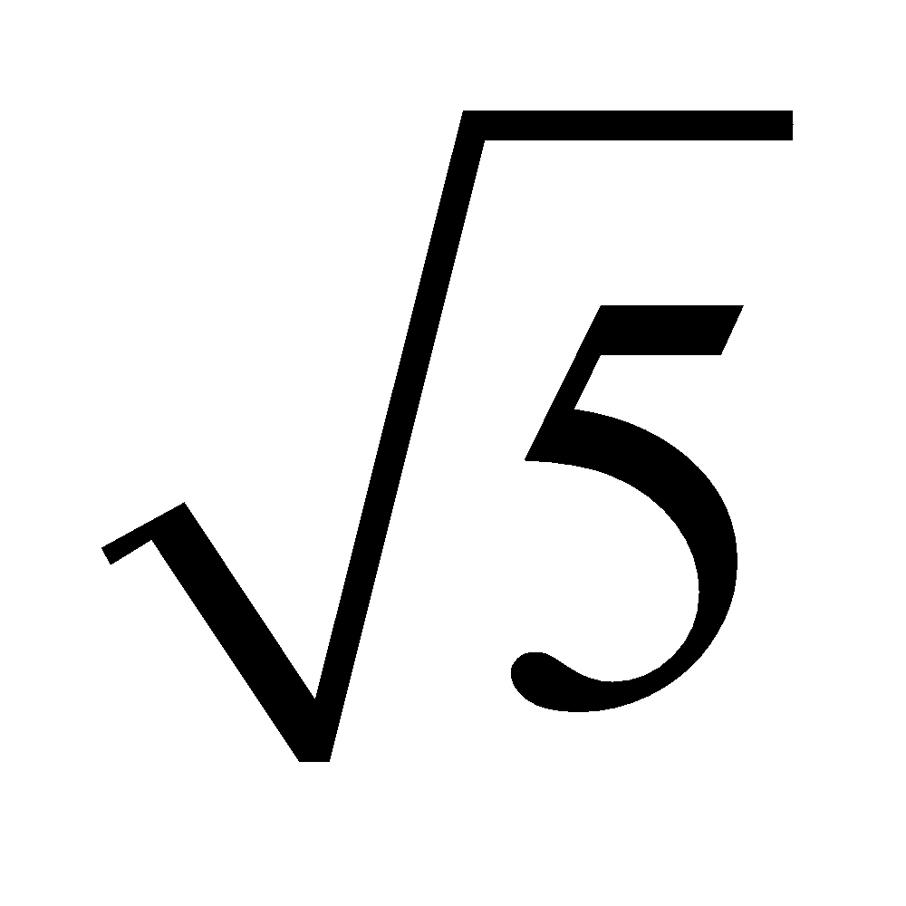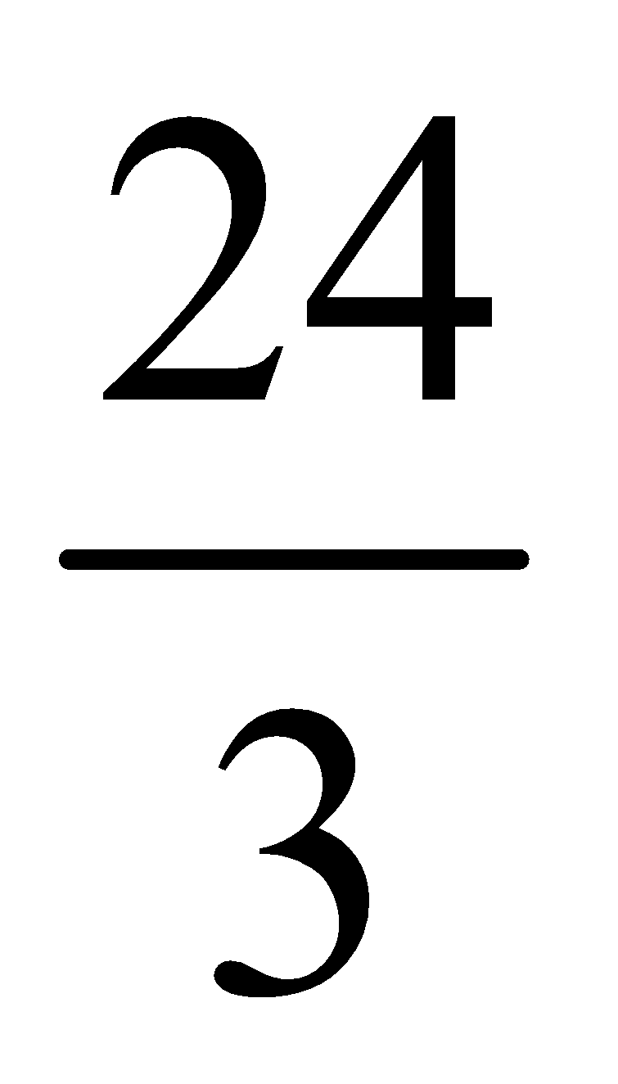

0.112131415…

Reducing Fractions

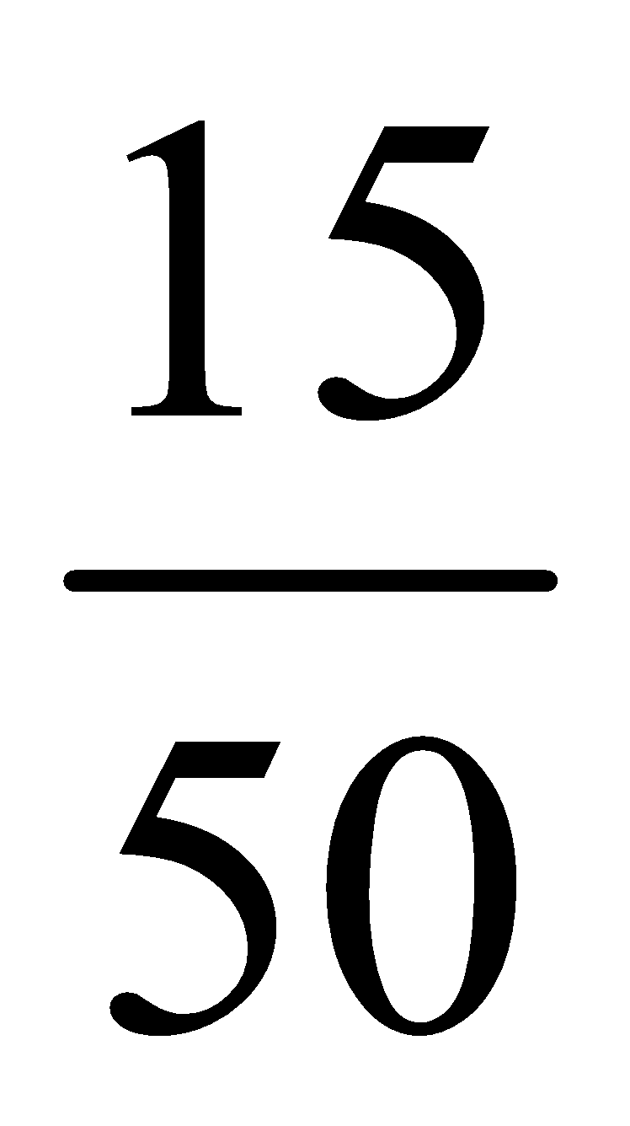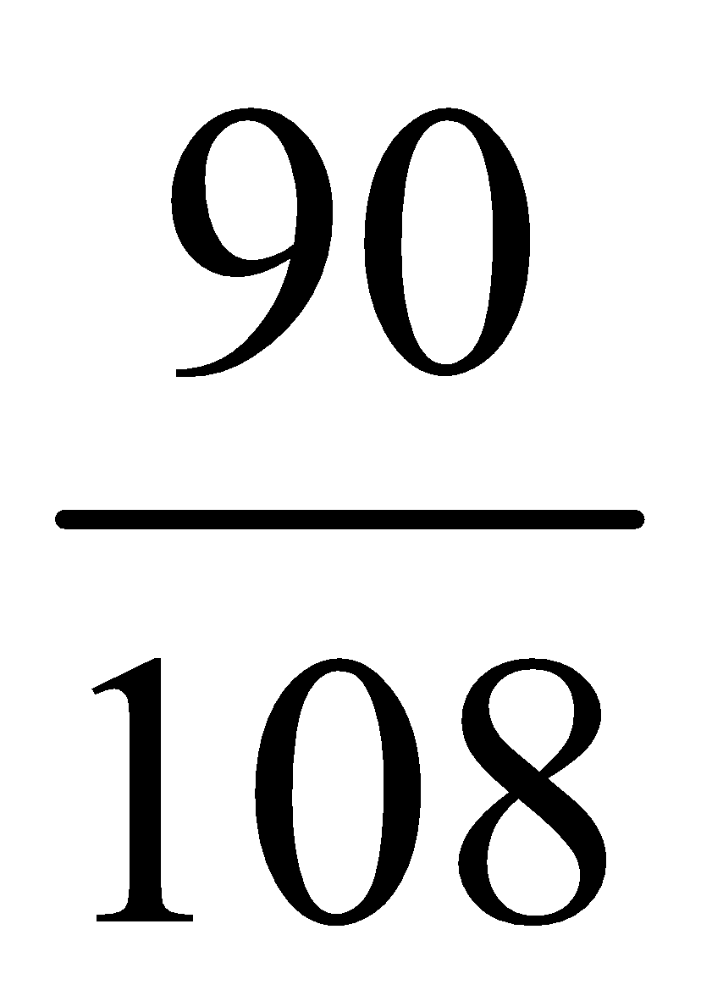

When we put numbers in order we can do it in two different ways.

- Ascending order: lowest to highest
- Descending order: highest to lowest

Put the following rational numbers in ascending order

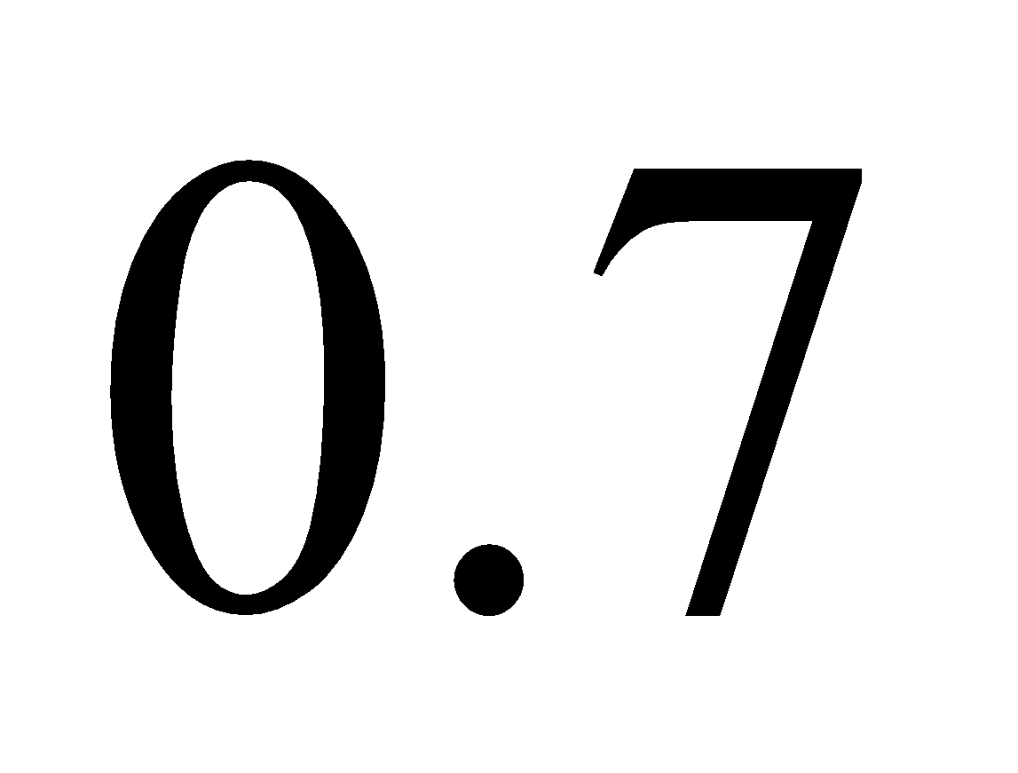 0.84 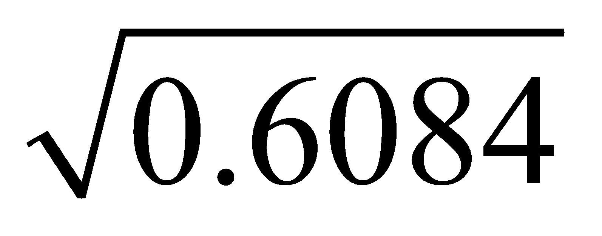

Put the following rational numbers in descending order

2.54 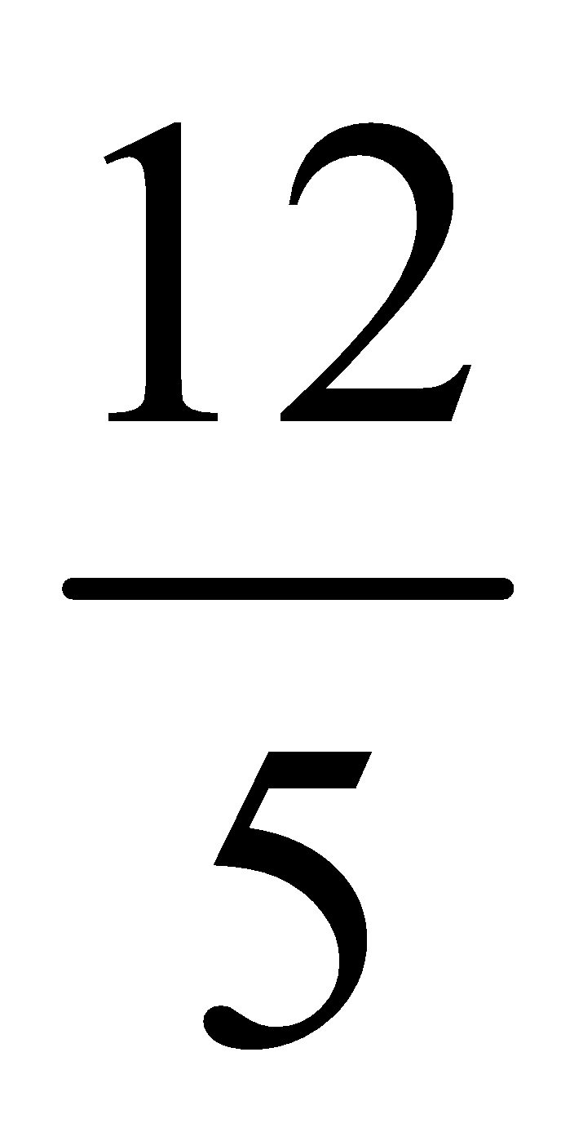 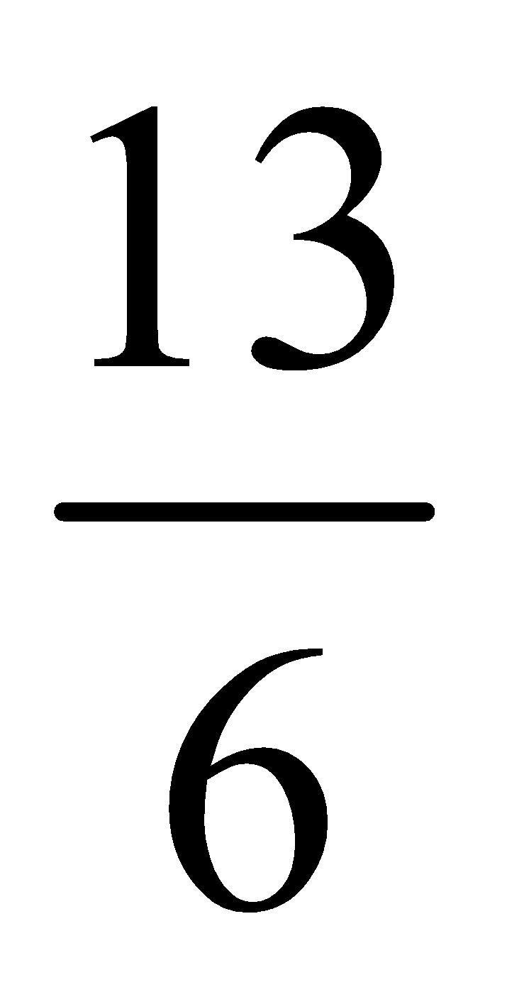 2.66

For each set of numbers write two other numbers that are between them

1.5 and 2.9

-2.84 and -3.02

8.12 and 8.13

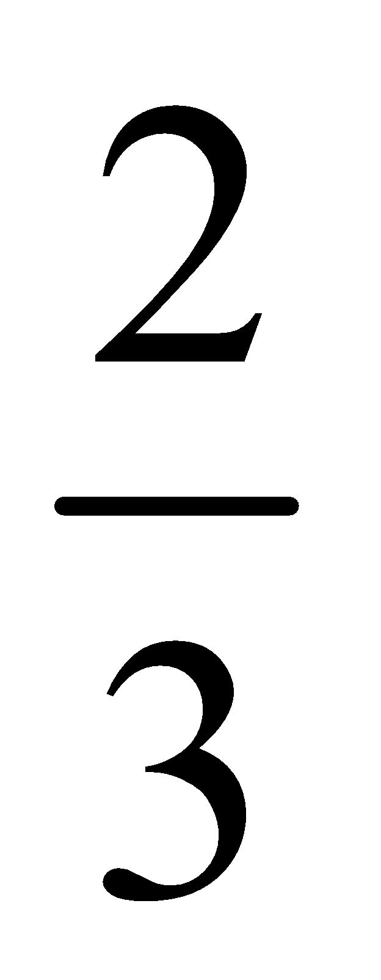 and

Homework P101 #6-8, 10, 12-14, 16-19, 21
For all questions except #13 and 19 only do the odd letters (a, c, e ...)

