Contemporary role models in our world- Irene Sendler
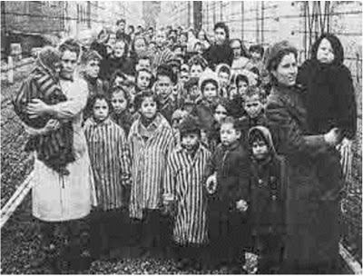

We are invited to search constantly for individuals who model for us the characteristics of Jesus Christ in our world. Once we have found those individuals, we are challenged to follow their example in our interactions in the world.
Research 10 teachings of Jesus Christ and connect Irene Sedlers heroic life to Jesus.
Scripture quote from new testament ( Write or insert the quote and reference the Book, chapter and verse) | Description of the scene or Irene’s action that followed Jesus example. ( Be specific)

